Another Nickel in the Machine

Marc Blitzstein, Roland Hayes and the “Negro Chorus” at the Royal Albert Hall in 1943.

According to Alexander Cadogan, the Permanent Under-Secretary at the Foreign Office, the cabinet meeting at Great George Street on 13th October 1942 was very disappointing:

“Everyone spoke at once while PM read papers. Discussion was on a low level.”

In fact the only contribution Churchill made during the whole meeting was to look up, after Viscount Cranborne, Secretary of State for the Colonies, had pointed out that one of hib black Colonial Office staff had been excluded from a certain restaurant at the request of white American troops, and say:

“That’s alright, if he takes his banjo with him they’ll think he’s one of the band.”

Not Churchill’s finest words. The cabinet, with or without Churchill fully concentrating, agreed that it was important to respect how the US Army treated its black troops (they were completely segregated) and that it would be less problematic for all – concerned by concluding that:

“It was desirable that the people of this country should avoid becoming to friendly with coloured American troops”

Less than a year later on September 28th 1943, the Daily Express, who had recently been running a pretty strong anti-segregation and anti- colour bar campaign, put on a show at the Royal Albert Hall that was for and on behalf of the visiting “Coloured American troops”

At the beginning of the evening and to the sound of rolling drums a single file of two hundred black soldiers from a segregated division of the American Air Forces Engineers marched onto the stage of the Royal Albert Hall on the evening of September 28th 1943. The nervous soldiers were joined on stage by Roland Hayes the renowned black lyric-tenor who had travelled to England specifically for the occasion.

Roland Hayes and the ‘Negro Chorus’ were at the prestigious venue for the debut of an orchestral work called ‘Morning Freedom’. The piece of music was described as a ‘tone poem’ set to traditional ‘negro spirituals and songs’ by its composer – the controversial communist and as far as the mores of the day allowed, the pretty well openly gay Corporal Marc Blitzstein.

The black serviceman choir was originally put together by Private McDaniel from Kansas City as a quartet to sing spirituals and hymns they would have sung at church back home. Slowly the singing group grew to the two hundred men that made up the chorus Blitzstein used for the Albert Hall concert. Private McDaniel explained to Life magazine about the soldiers’ love of spirituals:

“Christianity means a lot to us dark boys. A man that can sing a good spiritual can always find his way into another boy’s heart.”

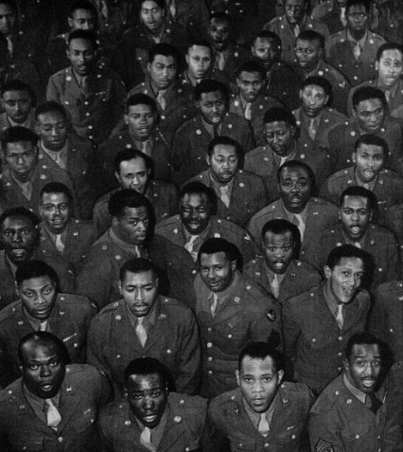

The two hundred strong ‘negro chorus’ at the Royal Albert Hall.

Roland Hayes, a son of two former slaves, was well known to British audiences of the time, although unlike his contemporary Paul Robeson, almost completely forgotten in Britain now. He had first come to London twenty three years before. Hayes, born in Georgia, had been finding it next to impossible to find prestigious engagements in his homeland and decided to travel to Britain to further his career.

Incredibly with a year of arriving in London he was asked to give a private performance to George V and Queen Mary at Buckingham palace on St Georges Day 1921. When Hayes arrived at the Palace, it was said that King George told his attendants: “There will be no formalities today. I shall meet Mr. Hayes man to man.” The royal recital immediately gave Hayes international prestige and he toured Britain and Europe to great success.