Bob Kopp

Firth of Forth

1945

# Practice flight

After Germany surrendered in WWII, the U.S. Army Air Force Headquarters began preparing to return to the U.S. In their infinite wisdom, they decided the air crews needed practice for flying across the Atlantic.

This was of some puzzlement to me since we had flown across that sea to reach Great Britain initially.

We were very inexperienced for that first trip but, with a few mishaps, we had made it. So after having

flown hundreds and hundreds of hours all over Europe, why did we need *practice* to return? The only

reason I could construct was…they feared "idle time would breed mischief". It turned out they might have been right.

A five hour *practice* flight was about the most boring thing thinkable for we war weary types. As it

happened, a few days before this scheduled event we all saw a Base Theater movie showing American

Fighter pilots flying UNDER the Eiffel Tower in France. So, as we approached Edinburgh, Scotland, on our practice mission, my pilot, Red Swett, called me on the intercom and asked "do your charts show the height over water of that big bridge down there?" I instantly knew what he was considering so I replied "no they don't and it's NOT high enough, forget it". His response was "well, we'll go down and take a look at it". Knowing Swett well, I felt quite confident that we'd be doing more than just "take a look" so I scrambled for the camera that the co-pilot and I had earlier purchased together. I thought no one would ever believe us if we bragged about this stunt when we got back to Eye so I thought I'd better have proof.

As I stood up in the Navigator's astro dome, to insure a clear shot of the bridge underside, I noted a large British warship anchored near shore, close to the bridge and there were many British sailors scrambling across the decks to get a good view of this obviously impending disaster. Our four big propellers were whipping up huge clouds of spray behind us. But to the sailors' dismay, we zoomed under the bridge with no problems whatsoever and then climbed up from Edinburgh to finish our mission.

After our boring five hour *"practice"* flight was completed, we landed at Eye. When we reached our

hardstand, the propellers had scarcely stopped spinning and I popped open the hatch to swing out… and, to my amazement, there stood the Base Adjutant. He harshly shouted "gimme your log". (It was

customary for the Navigator to record all events that occurred during a mission). I thought oh, oh we are in BIG trouble.

Apparently the British Navy took offense at these brash young Americans risking damage to their beautiful bridge. (The Forth Bridge) So they must have complained to the American officials. Luckily for us, the Navy was only smart enough to identify the offending the bomber as having the top half of the tail painted red. This was sufficient to identify us as belonging to the 490th Group but did NOT

define which specific aircraft was involved. When we returned to our barracks, we staunchly denied any such reckless behavior. However, there was no need to brag because other planes from our Group had been witnesses and quickly spread the word to all but the commanding officers. I believe a couple of our other bombers even followed us under.

However I was still worried about the incriminating photos I had taken, so I asked our co-pilot where the camera was (it was his job to carry it back because I had so much Navigator gear to lug). He had heard, of course, about the ruckus with the Adjutant so his reply to me was "I somehow lost it on the way back to ourhut".

Does that sound believable? Since the top brass had no way of identifying the culprits, no punishment ever

resulted.

Bob Kopp, Navigator

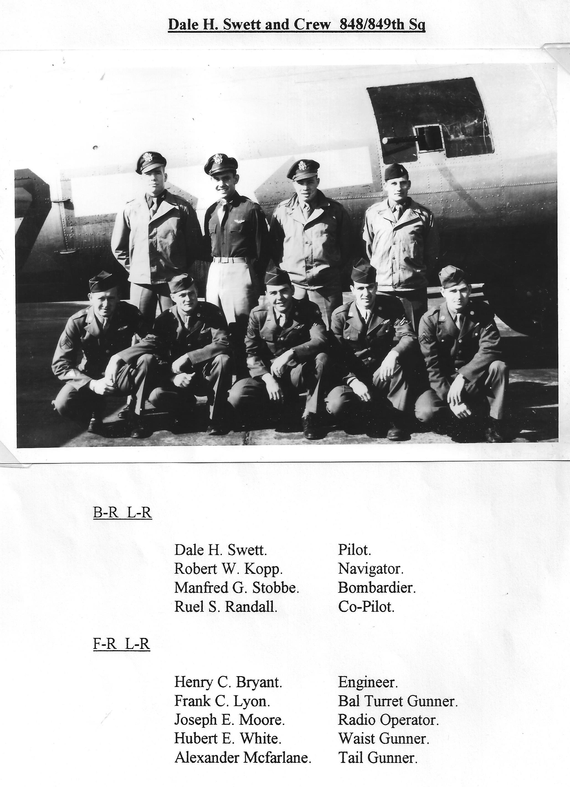

2nd story

