First Trip Abroad – Bob Kopp

Call to Action – 1944

My first flight overseas from the U.S. in WWII scheduled us to land in Goose Bay, Labrador and then fuel up and proceed to Iceland passing over Greenland.  Upon arriving in Labrador, our pilot was gung-ho to take off immediately after gassing up.  I demurred suggesting we check the weather first.  After viewing the forecast, I thought it didn't look that great and recommended we get a good nights' sleep and leave the next day.  To my surprise, the pilot thought a moment and then agreed.  One smart decision we made.

Before taking off from Goose Bay, they prepped us on what to expect.  It was 776 air miles to Greenland and a further 774 miles to Iceland.  They assured us we would have enough fuel to reach Iceland nonstop.  However, if events occurred requiring us to land at Greenland, observe the following facts: due to surrounding mountain ranges, you MUST put down on the single N/S strip there on your FIRST approach.  If you don't, you'll surely crash into the mountains because your plane wouldn't be able to gain sufficient altitude in the remaining space to climb over.  Not the most welcome news to green pilots and navigator.  I was only about 2 months out of navigation school, and barely 20 years old.  The eldest of us was 23.  Four were married but not I.

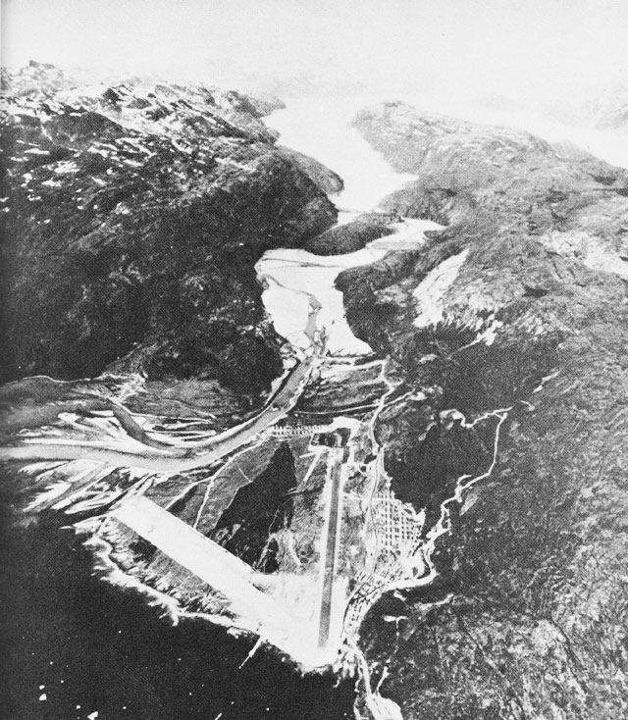

After taking off from Labrador, we had clouds below and above us all the way to Greenland so gaining any accurate navigation fixes were not possible.  As it turned out, being real green kids, we all were about to make mistakes.   I had much earlier asked our radio operator to get me a bearing from any radio compass station in Greenland he could contact.  He did so, but unintentionally, gave me the wrong station name.  Plotting that put us way south of course.  Also, I had asked the pilot to tell me the moment he received the null on his pilot's radio beam signal indicating that we were right above the Greenland radio station.  He forgot.  After waiting too long, I asked if he had heard it.  He said "oh, I forgot to tell you".  This signal was our backup to my navigation because my radio compass was spinning aimlessly. (Later, at Iceland, we found someone had stepped on the aerial wire disconnecting it.)  What a bunch of incompetents, all of us.  When I asked the pilot how long ago that he heard the null he said, "oh, about 10 or 15 minutes ago".   After perhaps 15 minutes flying back and forth seeking the null station in Greenland, I told the pilot we'd better continue on toward Iceland lest we run out of gas but TELL me if an  overhead cloud break appears ahead so I can take a celestial shot.  After sometime, the pilot called and said there's a clearing coming ahead.  So I grabbed my sextant and took a moon shot.  I was overjoyed at that point because fortunately, we were flying a brand new B-17 that had a new radar altimeter which showed the true altitude above ground.   So I had earlier realized that all I need do was watch those bouncing numbers on that radar altimeter and, when they leveled off, we must have crossed the Greenland coastline SOMEWHERE.  I stared at it for several minutes and, sure enough, it finally developed a steady reading.  Combining that time with the subsequent moon shot bearing taken later, and adjusting for time difference (navigation training had drilled into our heads that recording the exact time of any event was crucial), gave me a reasonable fix of our position.  I heaved a great sigh of relief for the first time on this flight…'til then I had been most anxious.

The bombardier and I then discussed the fact that this new airplane (which they later took away from us in Scotland because it was meant for higher brass to lead bomber squadrons) also had a ground viewing radar instead of a ball turret.  That meant we had a priceless navigation instrument aboard.  So the Bombardier and I crawled back to the radio room where the controls were housed. Then, despite the fact that all the controls on the unit were safety-wired unmovable and were covered with "do not tamper instructions", we cut the wires loose and fired it up.  We wondered, a bit, what our punishment would be for this forbidden act?  And then we decided, who cares, we think we need it for insuring our way, and after all, they were sending us to war.  What could they do?  Send us home?  I believe it displayed typical American independent thinking.

There was a repeater 'scope for this device on the navigator's desk.  So I crawled forward to my station and the bombardier worked on tuning up the radar.  I was suddenly relieved of all worry concerning our flight.  Soon the Bomber, as we called him, spoke up and said "I'm seeing islands down there".  I replied "nonsense, there are no islands between Iceland and Greenland".  Slowly we began to realize those were icebergs.  It was January.

Sometime long later, the 'scope revealed Iceland's characteristic western land hook, but it was too small yet to distinguish Reykjavik, our destination.

Suddenly, the pilot's external contact radio exploded with the warning "unidentified eastern bound aircraft identify yourself or we'll scramble fighters to intercept you".   The pilot then realized we hadn't turned on our IFF radio which was located in the planes' tail section.  He sent the waist gunner scrambling back to turn it on.  IFF was short for Identification Friend or Foe.  Another rookie mistake by us.  After we were identified and a bit later, as we neared our goal, the airport turned on a set of search lights whose beams formed an identifying cone at the precise field location.

After landing, I bent down and kissed the ground in relief.  We had actually made it.  A couple of the other planes that had hurried to take off from Labrador, the same day we arrived there, were forced to put down in Greenland by bad weather.  So we reached Iceland a day before they did.  Finally, mark us up with one smart move.

We then had a day of rest and found that, in Iceland during January, the sun doesn't rise until about  and sets .  A whole 4 hours.  The sun stays so low it always looks like early morning or almost sunset.

The ensuing 846 miles to Prestwick, Scotland were a comparatively calm trip.  I felt that we were finally beginning to catch on to this flying and navigating business … little realizing the terrors awaiting us when we began flying combat missions and found that the German anti-aircraft gunners and fighter pilots were most unfriendly, even lethal, during our visits.