Newton B Parker

Newt Parker, who was shot down and evaded capture in Czechoslavakia when a man and his wife took him in and hid him from the Germans, later dressing him in civilian clothes and passing him off as a deaf-mute. He went to the local police station on May 7th with the family that saved him. While there they toasted the end of the war and the locals went out and rounded up all the German’s in town and put them in jail. The following day the Police Chief drove Newt to Rozmital. He was delivered to General Patton’s army who was in the area of Rozmital. From there he was shipped to Le Havre to await transport back to the states

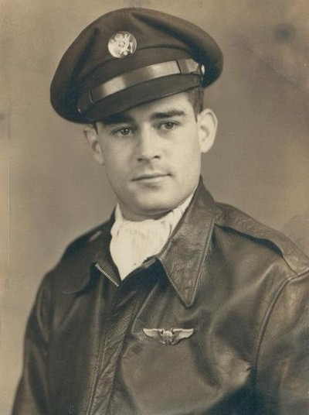

Transcription of a note made by Newton B. Parker from paper in his escape kit.

On April 19, 1945 we were briefed at 5am for our 28th mission. Take off at 9 am to Rouenice and brb. Mission. We entered enemy territory at 1:32pm At 2 pm we were starting a bomb run. Bombardier called B-17 going down at 2 O’clock. Flak at 2 )’Clock. Flak stopped. Me-262’s at 12 O’clock. I saw them first at 3 o’clock going away. Then at 5 o’clock low, coming in our flight position was airborne spare, therefore only the ship to our right and our own could fire. The radio operator was at his gun. I fired and the ammunition chutes did not feed right. I had to hand charge each round. The top turret man called me and asked what was wrong. I answered and at the same time the fighter was 50 yards out. This was the last interphone conversation. I felt an explosion and looked toward the left wing. It was in flames. I had my chute on, so I backed to the escape hatch, knocking the flak suit, I had hung there, out of the way as I went. I pulled the emergency release and the door fell out. I saw Johnson at the waist door and Malires heading for it. I did not see Carl Johnson. From the tail and the ball the alarm cannot be heard. I could see the fire. Whether Shorty knew of the trouble, I don’t know. R Johnson bailed out first, then me, then Malires. I fell several thousand feet, before pulling the ripcord and was below the other two. On the way down, I noted the positions of villages and woods. At 500 feet, I saw people running from a small village. The wind carried me about 1,000 yards from it. I hit in a flower field and landed incorrectly. I was thinking of the civilians and not the ground. Upon contact, my ankle was sprained and I was temporarily stunned. While in this condition the wind dragged me over the field, pulling off my flying boots. I then decided to evade capture and unfastened the harness, took off my Mae West and ran into nearby woods. A farmer and wife were standing by their home about 25 yards away, watching me, all this time. The others did not come in sight. The woods were pine therefore little cover. I ran until I found a clump of small pine and briar bushes and crawled into them and waited. My flying clothes blended perfectly with the cover. Then I heard the searchers coming. I was lying about 25 feet from the edge of a field. Men passed through the field and I could see them clearly. One man entered the woods about 15 feet from where I was hiding. I hid my face and hands to avoid reflection and he did not see me. Sometime after I had hidden, (I had no water) a German soldier walked to a grassy spot in the field, 75 yards away, sat down and lit a cigarette. Soon, he blew a whistle and other soldiers came out of the woods around me. Apparently, all did not hear the whistle because several shots were fired as a signal. There were about 12 soldiers and probably many more civilians searching for me. While waiting, I tore up and burned all papers on my person. I stayed here til it was dark, 9 hours. I had opened my escape kit and removed the compass. I decided to travel NW as I knew the army was near our target in that direction. My heater shoes were the only shoes I had. At dark, I started walking. I took one Benzedrine tablet. Soon I left the woods and crossed a field. I ran across, in a stooper position, stopping occasionally to listen. After this, I decided to walk at a moderate rate, at all times, so as to reserve my strength. I decided to eat one piece of candy a night, while walking and ½ piece a day while hiding. The first night I walked several miles and crossed 3 creeks. Removing my shoes and wading, then drying my feet with my handkerchief. I decided not to smoke for fear the glare of a match would give me away.at pre dawn I found a hiding place in the woods, for that day. I soon found my hiding place was above a small village as I could hear the town clock striking the hours. I tried to sleep but was soon awakened by the sound of chopping and a dog barking. Dogs worried me constantly. There was a large cock pheasant flying around me and I was in fear a hunter would hear it crowing and come upon me. My feet were cold so I cut the legs off of my heated suit and wrapped my feet in it. I hung my socks and shoes in the brush to dry. No one came near enough that I could see them through the brush, but I could hear people talking as they passed on a nearby path. At dusk I started walking. I had to cross a highway, so I unconcernedly crossed the adjacent fields and walked along the edge of the woods in the shadows.

The note finishes at this point………pare, therefore only the ship to his gun. I fired & the ammunition chutes did not feed

whistle, because several shots were fired as a si