Norvells’ last mission

Czeckoslovakia

1945

# Friends

# related by Bob Kopp – Navigator 490th BG (Heavy) USAAF

Following Germany's surrender, Norvell somehow made it back to Eye for a brief visit and he described to us the tragic details of that last mission. This is my recollection of his tale.

After his bomber was disabled by the ME 262's cannon fire, He called our pilot on the radio saying "Watch our stuff will you Red. We're going down". Those words will remain seared in my memory forever. He then instructed one of the enlisted men to help the others bail out. Several miles later, they too were able to escape. The result was that they landed a good distance from the first seven. Unfortunately for Norvell, the sudden jerk of the 'chute opening pulled his boots half off. Hitting the ground then broke one ankle. Early training told us that, if we had the option, always surrender to the German regular army or navy NOT the SS or civilians. They will kill you. As he lay helpless, unable to move, an SS trooper appeared and raised his burp gun. Norvell was sure

his life was over. Fortunately, at that moment, a German army officer drove up in his Jeep. He shouted orders to the SS trooper, which Norvell learned later, meant "Don't shoot. I want to interrogate him". That saved Norvell's life. Rather than interrogation, the army guy brought him straight to a hospital. Later Norvell was told that the SS had executed the seven guys who had bailed out first. A total of four bombers were downed on this, the next to the last mission, flown by the 490th.

Some weeks prior to this flight, Norvell's co-pilot, Lorenzo Smith, proudly announced that he had received a letter from his wife telling him he was a new father.

The fact that our two crews had lived together for our entire time at Eye, gave us the opportunity to see the war's effect upon each other. Most did their utmost to conceal the stress. Who wants to be thought a sissy? That was possible when the effects remained internal. However, for some, the effects were external and impossible to conceal. One such was Gordon Lake, Norvell's navigator. He was a soft spoken, sensitive fellow for whom I felt a kinship. I too was a navigator. However his favorite means of relaxation was a small portable, windup phonograph that he had found somewhere. The trouble was, he had only one record and he played it over and over and over again. The title was "Where or When". For all the years since, whenever I hear that tune, I'm immediately flooded by nostalgia for Gordon and his tune.

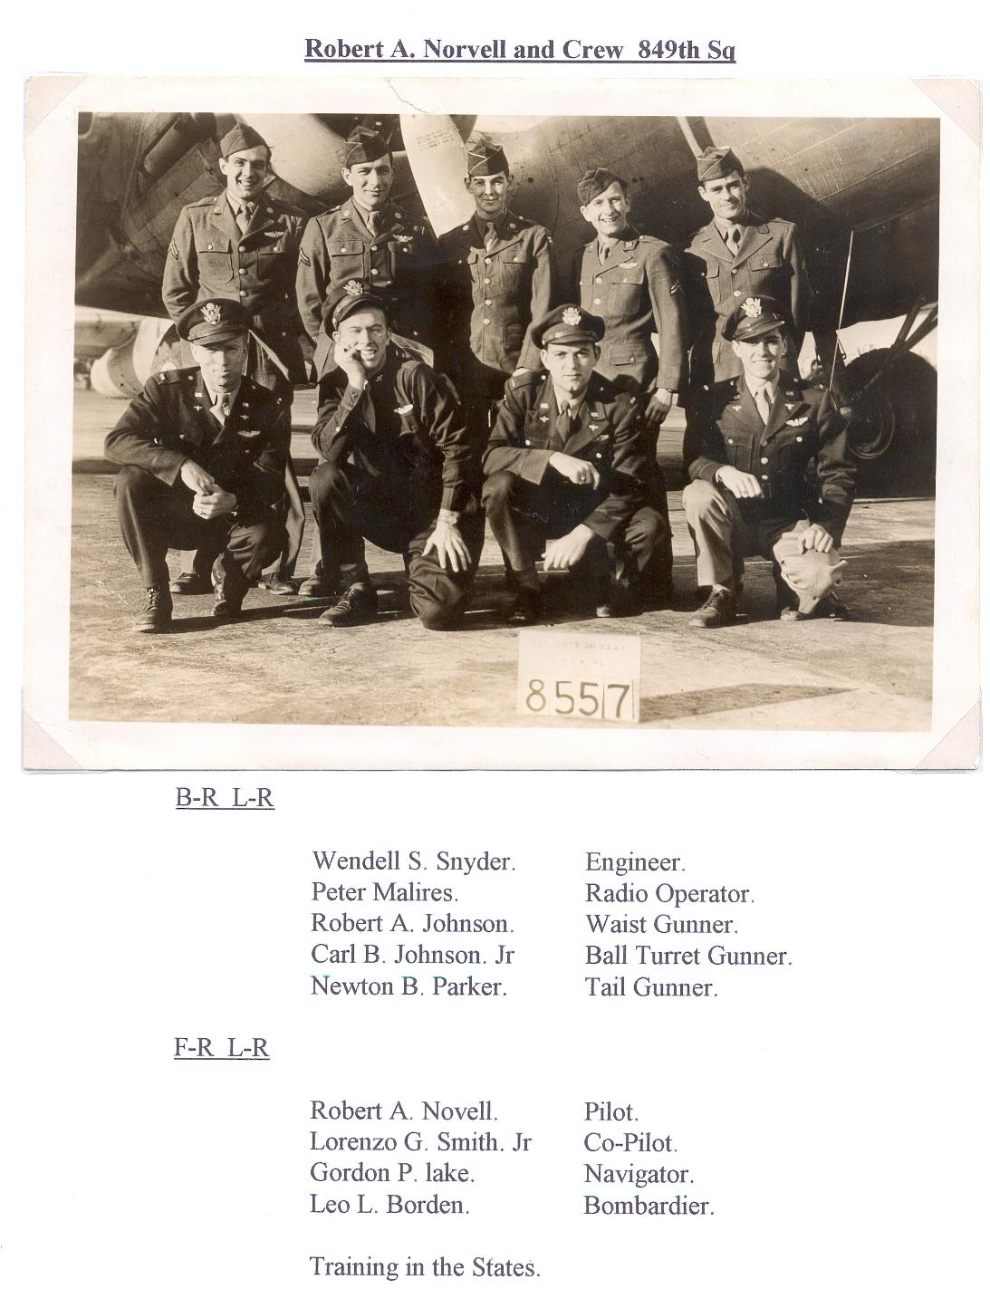As the number of missions mounted, Gordon's tremor increased… severe enough so that if we played a game of cards, we had to skip his turn at dealer. His tremors caused him to scatter the cards all about when he tried to shuffle. It finally reached the point that we, insensitively, tagged him as Shakey Lake. That was not out of derision. We all had problems. It was merely an accurate description of the effect combat stress forced on his system. One example of war's multiple, merciless effects on humans.

So ends my recollection..

Norvell Crew

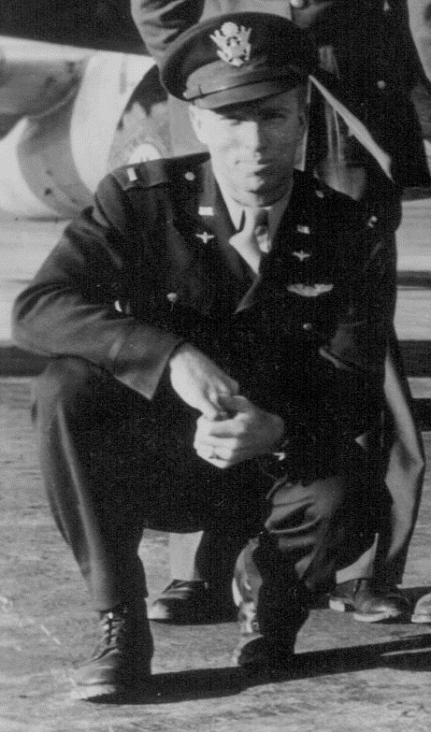

Figure . Robert Norvell

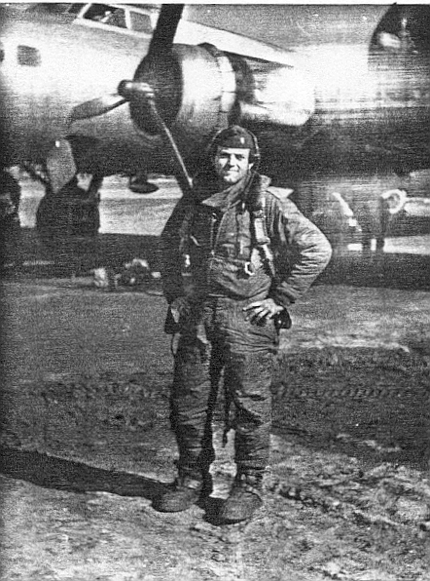

Figure 3 Gordon Lake