RUN UP TO EYE

ROBERT H. COLLINS, 2ND LieUTENANT

Honors:

Air Medal with 3 Oak Leaf clusters Distinguished Flying Cross

American Campaign Medal WWII Victory Medal

Occupation Medal (Germany) Euro-African-Middle Eastern Campaign Medal

United Nations Service Medal Korean Service Medal

Air Force Longevity Service Medal

With 4 Bronze Oak Leaf Clusters Air Force Outstanding Unit Award

Armed Forces Reserve Medal

Pearl Harbor! that’s what happened. Two days later and I was in Seattle applying to join the Navy Air Corps. I dreamt of being a pilot, that’s all I wanted. No chance on that, I failed the eye test and was sent home to drink carrot juice and do eye exercises! And go to college.

There I was able to take flying lessons through a programme offered by the U. S. Government programme to produce pilots for the Army Air Corps and the Navy. I completed the course and on my 21st birthday I hitchhiked to Geiger Field (Army Air Corps) at Spokane, Washington and joined the army for pilot training with the Air Corps.

In February, 1943 I was called up to active duty at Santa Ana Army Air Base (California) but still my eyes let me down. This time the Army decided and I was sent for Navigator Training at Mather Field, California, then after to Gunnery School.

By Christmas Eve 1943 my training was complete, I was commissioned as a 2nd Lieutenant and assigned to the 490th BG (H), 851st Squadron at Mountain Home, Idaho. Specific training in formation flying, navigation, gunnery and bombing commenced and by April 1944 when the new, straight from the factory B24’s arrived we were good to go.

We set out for England flying from Idaho to Lincoln, Nebraska for equipment, medical clearances then on to Morrison Field, Florida for a final briefing before heading overseas.

At that time we had no idea where we were flying to. We took off from Morrison Field in the pre dawn with no knowledge of our destination. We were instructed to open sealed orders once we reached a certain time or longitude. Only then did we learn our destination was to be England via Trinidad (where I had a surprise meet with Charles Lindbergh in the mess line), Belem, Natal, Dakar and Marrakesh.

En route we managed to obtain a stalk of Brazilian Bananas. We arrived at Station 134, Eye Airfield, with these hanging in the nose of the plane.

WE WERE AT WAR……….

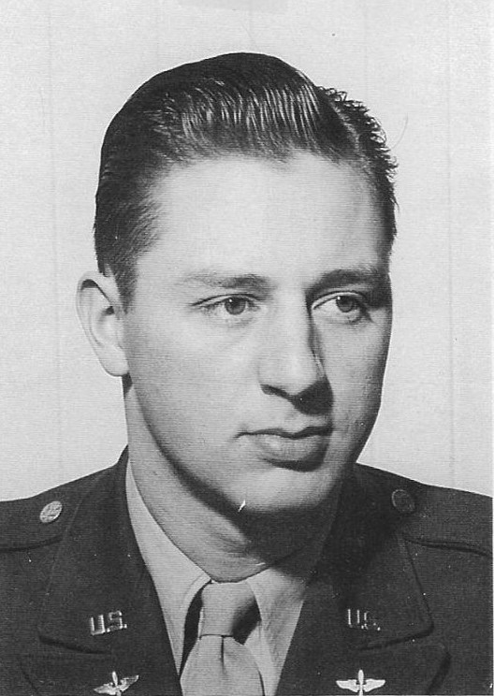

Robert H. Collins, B/R 2nd from the right.

