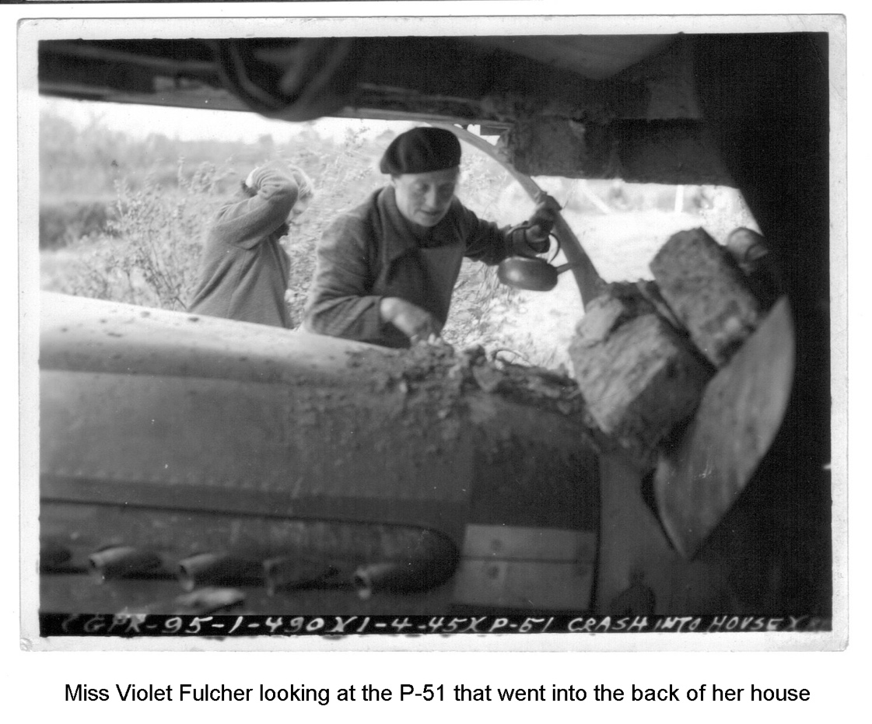

“Would you like a cup of tea?”
The United States Army Air Force
and the people of Eye and Brome
during the Second World War

16 March 2019

Compiled by Susan Brown, Richard Dinnin, Edward Hudson and Geoffrey Randall.
Contents

Acknowledgements

The authors would like to thank the following contributors: Janet and Alf Chambers, Harry Borrett, Charles Flatman, Norman Lock, Molly Ruth, Tony Seeley and Peter West all of whom gave us their recollections of the war years.
We are especially grateful to Eric Swain, historian of the 490th Bomb Group, for generously providing a good deal of the material on the air crews based in Eye from his archives.
We also thank Clive Stevens for his enthusiastic support and advice on so many occasions.
We also received welcome support from Jonathan Falconer of J.H. Haynes Publishing Group, Sparkford, Somerset and Ian MacLachlan to quote from the book Eighth Air Force Bomber Stories by Ian Maclachlan and Russel J.Zorn.

Foreword
This book brings back many memories of my time as a US airman on Eye airfield in World War 2.
We arrived at Eye on November 14, 1944 and each man (boy) had completed the required Army Air Force training programs to prepare him as a B-17 aircrew member flying bombing missions. We were the rookies sent to replace 490th Bomb Group crews who had completed their tour of duty, been wounded or shot down.
The air crews of Lt. William Templeton, Lt. Robert Tennenberg and Lt. Darrell Roufs had crossed the North Atlantic on the Queen Mary and travelled across the United Kingdom by train. We were beginning to wonder if would ever see a B-17 again. Winter was setting in when our crews got off the train at the little town of Diss in East Anglia late that cold murky November day. The drivers of the canvas covered trucks waiting for the replacement air crews told us to toss our duffle bags in the back and crawl in behind them for a short ride to the 490th Bomb Group (H) base, station 134, code name ‘Hangstrap’. I still have a copy of General Order #47 listing the enlisted men by rank, name, duty and serial numbers. The gist of the order said, “These men are assigned to the 490th Bomb group to participate in combat flights and operate planes or equipment until this order is cancelled.”
The three crews were assigned to the 848th squadron. As I think back, I recall thirty tired young airmen standing in the cold damp evening waiting to be assigned to our barracks. The overcast sky wasn’t fit for flying and the fog reminded me of a Sherlock Holmes movie. The squadron clerk, a feisty little Corporal, came out to guide gunners to their assigned huts. We picked up our duffle bags and followed him to our huts.
We knew we would soon be flying combat missions, but had no premonition that two of our thirty would be wounded and thirteen would die in the next six months.

James Lee Hutchinson

Introduction
In 1942 a quiet corner of rural Suffolk was being transformed, as was much of East Anglia, by the building of airfields and the arrival of thousands of American servicemen and women. They came to join the allied fight against Nazi tyranny and were to play a vital role in defeating it.
Acres of farmland were replaced by runways, hangars, Nissen huts, hospitals and an entire infrastructure needed to accommodate and support the heavy bombers, their air crews and ground staff. Most items were brought in from America. It was an astonishing feat of organisation, resources and technical expertise. The airfields were built at optimum speed and not designed to last, but the impact of this welcome transatlantic occupation was to change the horse-driven pattern of life among small rural communities across the region for ever.
This book tells the stories of two such neighbouring communities adjoining the airfield built between Eye and Brome in North Suffolk. It portrays ordinary people at an extraordinary time: young airmen, fresh out of high school called upon to test their courage and endurance to its limits; engineers, many from rural communities back home, signed up to learn new skills in a strange land and cold climate; and local residents, awe-struck by the scale of the technological and cultural innovations suddenly thrust into their midst. Drawing on letters, diaries, memoirs, published material and individual interviews, it uses their own words to describe the shared tragedies and triumphs, friendships and love, joys and sorrows of that short period of time.
It depicts the construction of the airfields, the arrival of the US servicemen and contrasts the everyday lives of local residents and those of the air crews. It describes the equipment they used and the legendary planes they flew and fought against.
At the core of the book, are first-hand accounts of missions flown from the airfield, the camaraderie and bravery of the crews; of the dangers inflicted not only by the enemy, but also by daytime formation flying and unpredictable weather; of the random fates of those forced to bail out over enemy territory.
Many died. From the airfield first known as Brome and later Eye, the 490th Bomb Group lost 234 men during the 12 months they were based there. At peak strength in 1944, USAAF employed 450,000 Americans in Britain, including ground support men and women. Nearly 30,000 never made it home.
This book is dedicated to all those courageous young Americans. We hope that the memory of those who made the ultimate sacrifice in the fight for freedom will never be lost.

EYE / BROME AIRFIELD

1 The USAAF arrives in Eye and Brome

When the American engineers began to arrive in September 1942 to build the airfield Eye was a small, quiet country town, Brome a tiny village. The way of life and economy was predominantly agricultural. Local people, most of them still children then, have vivid memories of their arrival and the changes they brought.

The war in late summer 1943
By late summer 1943 the war had developed into a near global conflict. It involved the United States, the United Kingdom and the British Empire, Russia, Germany and German occupied Europe, Italy, Japan and China. During the course of that year a string of initial Axis successes had begun to falter, but there was much still to do to open a western front against the Nazis.
In the Pacific, American forces had driven the Japanese from Guadacanal, the Aleutians, New Guinea and the Solomon Islands, though with heavy casualties.
In Burma, the Japanese advance was weakening as its supply lines were becoming ever more extended. The decisive battle for Kohima which marked the high water mark of the Japanese assault on Burma was fought by the British Army in late 1943.
In the Atlantic, the E boat menace which had created such damage to the British merchant fleet had been largely suppressed.
In North Africa, the German Afrika Corps had been defeated. This had been achieved by a joint American and British assault into Tunisia where in May 1943 the German army had finally surrendered. Two months later, allied forces had mounted the successful invasion of Sicily from North Africa.
Italy had given up the struggle and surrendered in July of the same year. In September Allied forces landed in Southern Italy. There then began the hard and bitterly fought campaign against the German army in Italy which continued until the end of the war.
In Russia, the Germans had lost nearly one million men in the terrible battle for Stalingrad. This defeat in the winter of 1943 had involved the loss of the whole of Germany’s Sixth Army. Four months later the Germans suffered another defeat at the battle of Kursk which remains the largest tank battle ever fought. It cost the Germans one million men. The German army never fully recovered from the combined losses at Stalingrad and Kursk. While the two battles cost the Russians equally as much, if not more, they had the manpower and industrial resources to rebuild their fighting strength. The German reserves were very largely spent.
While terrible sacrifice and much hard fighting lay ahead, the closing months of 1943 undoubtedly witnessed a change of fortune.
In the early stage of the war the RAF had tried daylight raids over the continent but their losses were so high that they soon reverted to night bombing. The United States Army Air Forces (USAAF) endeavoured to prove that day time bombing was achievable. Such missions were both daring and dangerous. The losses amongst the ten man crews were appallingly high. The ever changing and always unpredictable weather was a constant problem. Navigational instruments gave the greatest assistance in an empty sky and with clear visibility. However, in dense cloud or fog and in a sky which was crowded with slow moving columns of heavy bombers the situation was hazardous in the extreme.

The market town of Eye

Eye in 1943 presented a very different way of life from that to which the GIs were accustomed. Apart from the railway and a very few cars, the horse was used for most local transport and farm work. Modern amenities such as electricity, gas and running water were still rarities.
The small town of 2000 people has a long history. Eye derives its name from the Anglo Saxon word for “island”, being in the midst of an area of low lying marsh which over the centuries has been progressively drained.
Three thousand years ago there was a bronze age settlement on the northern outskirts of the town where the Hartismere school is now situated. Many artefacts have been found and a small museum is now on the site.
Eye castle was built very shortly after the Norman conquest, using the local impressed Saxon labour. The town is built in a roughly circular shape around the castle’s outer walls which over time were allowed to disintegrate. After the conquest, the population of Eye was around 700 and had become a large agricultural settlement. At that time there was a thriving market which on a much smaller scale continues to be held to the present day.
Eye received a royal charter from King John in 1205, giving the town borough status.

During the course of the Barons’ war of 1275 the castle was sacked and all but destroyed. It was never fully rebuilt and a few small sections of wall together with the central mound are all that remain of what had once been known as the King’s prison or the “Aye Dongeon”. Much later, in 1561, Lord Cornwallis ordered the construction of a windmill on the castle hill. The windmill was eventually demolished and Sir Edward Kerrison built a dwelling for his soldier servant who had saved his life at the battle of Waterloo in 1815. The building was largely destroyed in 1965 when it was struck by a violent storm.
In 1579 Queen Elizabeth 1 awarded the borough a Grant of Arms.
There is evidence of a church in Eye before the Norman conquest of 1066, probably built of wood. The building of the current church was started in the 12th century and an earlier doorway was included in its construction. The building of the tower was finally finished in 1479 and became “one of the wonders of Suffolk, 101 feet tall and panelled in flushwork from foot to parapet”.
In 1974 the town lost its borough status as a result of local government reorganisation. It then became a parish within Mid-Suffolk District Council. However links with its historic past persist. The town is still administered by Eye Town Council with a Mayor who, on formal occasions, still wears a bicorn hat, robes and mayoral chain. The Town Clerk and Mace Bearer also wear traditional attire.
Since the second world war, the horse has given way to the car and the lorry; the kerosene lamp and cooking with coke or wood have given way to gas, oil or electricity. Manual effort has largely given way to the tractor, the dishwasher, the washing machine, piped hot water, the motor mower, central heating and the internet. Farms used to employ 20 or 30 men, nowadays they employ two or three.
As the population has expanded there has inevitably been more building and more traffic. But Eye remains a quiet and largely unspoilt Suffolk country town, set amid green and lovely countryside.

The village of Brome
Brome lies two miles north of Eye. Its name stems from the Anglo Saxon word for broom a flowering shrub with yellow blooms. Fifteen hundred years ago, in Saxon times, it was probably there in some profusion and can still be seen today flanking the A134 as the road bypasses the village.
Brome has existed for at least a thousand years and is recorded in the Doomsday Book when it supported 87 people. Now, the village has a population of around 300, which seems to have remained fairly constant over the last two centuries.
The Cornwallis family played a prominent part both in the village and in the country as a whole for some 300 years. In Brome itself they were the principal land owner and employer. Over the years the family contributed to the nation’s soldiers, Privy Councillors, High Sheriffs, a comptroller of the royal household, ambassadors, a Lord of the Admiralty, Lord Lieutenants of the county, Lord Chief Justice of England, Constable of the Tower of London, a Governor general in India, a Governor of Gibraltar, and an Archbishop of Canterbury.
One of the family coats of arms has been adopted as the village crest. When Lord James Cornwallis died in 1852 without a male heir, the title lapsed. The family home, Brome Hall, which had been built in 1550 was demolished in 1953. However in the village, the Cornwallis name is still evident in the family dower house, which has been converted to a hotel and renamed The Oaksmere. It is also evident in the 10th century church which bears many effigies and monuments to past members of the family.
General Charles Cornwallis had commanded the British during the American War of Independence and had conceded the British defeat to George Washington. Members of the engineer battalions of the American army were probably unaware of this historic connection when they arrived to construct the airfield on farmland which was part of the Cornwallis family estate.
The impact of the USAAF on this small rural community must have been very great. The numbers of GIs on the airfield were more than the population of the village by a factor of roughly ten.
The grinding labour of working the land over the past centuries has now given way to machinery and a consequent huge reduction in the number employed on the farms. As a result Brome can today boast a host of different occupations and activities.

The building of the airfield
Eye / Brome was one of the last of the American airfields to be built in East Anglia. Work began in September 1942 by engineers from the 827th, 829th and 859th aviation battalions of the US 923rd Engineer Regiment and included the only black African American unit in the US 9th Engineer Command. The bulk of the work was carried out during the summer of 1943.The regiment proudly records that the building of Eye and Debach airfields were its outstanding achievements at that time:
“The men of this organisation worked long hours, learned new trades and skills and gave up much treasured off-duty time to meet the exacting completion dates which were imposed upon us”.
The runways and hardstands were built on a triangle of farmland bounded by the main Norwich to Ipswich road (A140) to the west, the B1077 from Eye to Brome to the east and Castleton Way to the south. Eight of the hardstands were sited west of the A140 and road traffic had to be halted by military police to allow the heavy bombers access to and from the runways. Administrative and accommodation buildings were to the north east of the field and extended into Brome village.

Photograph: Aerial view of the airfield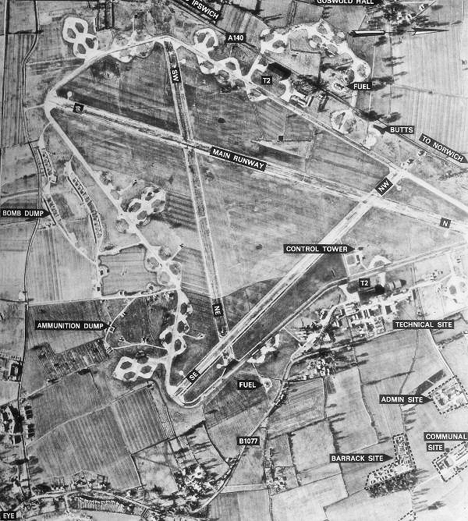

Photograph: The 829th battalion puts down first concrete on Potash Lane, Eye
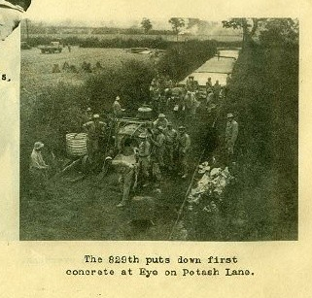
In contrast to many homes in Eye and Brome, buildings on the airfield had a water supply, sewage, telephone and electrical systems. The engineers slept in tents while they constructed the Nissen huts for the aircrews.
Photograph: “We slept in pup tents while building Nissen Huts and in Nissen Huts while building runways”
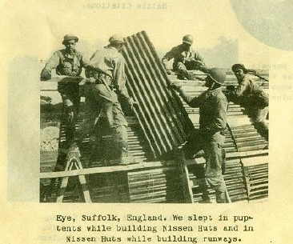

The engineer regiment records their role in the fight against Nazi Germany:
“Our task did not require us to engage in actual combat with the enemy, but as we watched the heavy bombers roar off in the early morning from the fields which we had constructed for them … and as we watched the fighters return from their strafing missions over the front lines to the haven we had provided for them, we felt a oneness with the combat men of the Air Corps and had a realization that we were playing a part in paving the way to victory”.
Following completion of Eye and Debach airfields by spring 1944, the men went on to support 61 heavy bomber stations, building new facilities, roads, resurfacing runways and taxiways with asphalt and concrete and performing other essential tasks so that the 8th Air force could keep up its assault on Germany. Subsequently they carried out construction and rehabilitation projects in France and Germany.
The regiment became famous for its 200 voice ‘US Army Negro Chorus’ which performed in the Royal Albert Hall in September 1943 with the black African American tenor Roland Hayes and the London Symphony Orchestra. They received such acclaim that further performances were arranged in Manchester, Liverpool, Edinburgh and Glasgow. The Chorus later made regular appearances in hospitals for wounded soldiers, Red Cross Clubs, churches and other venues.
Photograph: the chorus in rehearsal
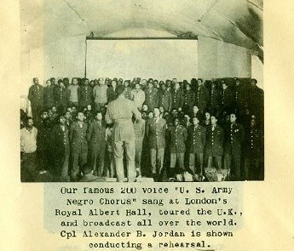

Local residents have vivid memories of the dramatic arrival of the Americans.
Peter West recalls the requisition of his father’s farm to build the airfield.
“The war brought great changes to our rural community: the men who were working on farms were being called up into the forces.
“The area became the centre of a drive to build airfields. Much of the labour force for the construction came from Ireland. Huge gravel pits, along the Waveney Valley were being excavated to provide the materials for their construction. In three years 16 airfields would be constructed within a 15 mile radius of Diss and Eye, each taking 300 acres of farmland.
Photograph: Peter West
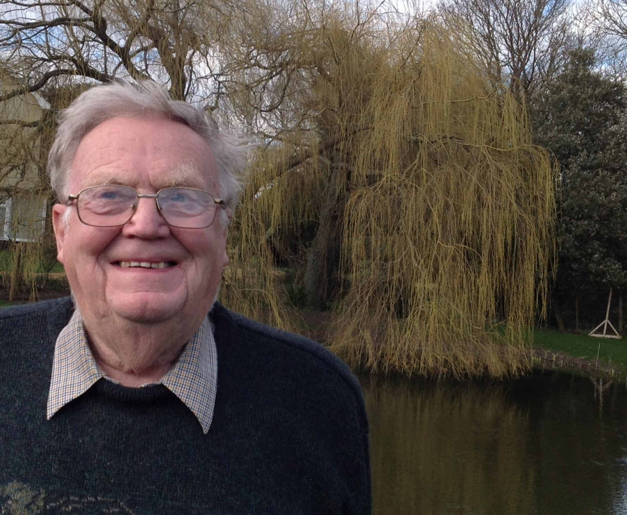
Photograph: Eye airfield under construction
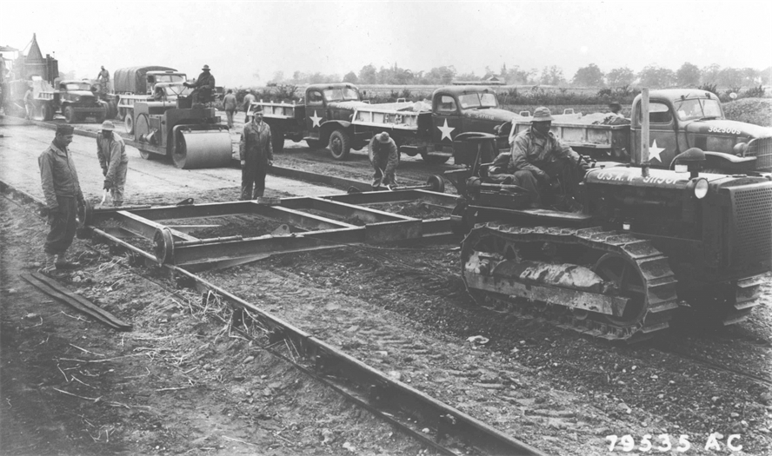

“In the summer of 1942 my father was informed that our farm in Brome was to become an American airbase, and American troops would be doing the construction with equipment being imported from the United States.
“It was during harvest when they arrived. Some American servicemen came from Horham airfield to erect tents. We were still cutting barley with a binder when they arrived. I was operating the binder which was an easy job for a boy. As the sheaves of barley were ejected from the binder, the Americans moved them aside to make space for the tents to be erected to accommodate 800 servicemen.
“The following day the threshing machine was placed in the field and the barley was threshed. The field was then clear for the servicemen who had previously arrived in Southampton and travelled to Diss railway station. My father had already been informed that the troops were from the southern state of Louisiana, and that they were all black. The officers - who were white - were the technicians and were to be housed in commandeered farm cottages in Eye. These were later demolished to make way for the runway.
“At this time segregation was the norm in the southern states of America. The local police and my father, who had already stated there would be no segregation on his farm, had informed the American officers there was no such thing in England. Jamaican and English airmen were already working side by side at Pulham.
“The Americans got a warm welcome from a German aircraft on the night of their arrival. No-one told them that black-outs were a necessity at night, and not being used to the cold nights, they set fire to the straw for warmth. The German aircraft flying overhead at the time dropped a canister of incendiary bombs, which exploded over the area. Luckily there were no casualties, but a great deal of excitement.
“The Americans had to wait for their equipment to arrive and in their spare time they soon became well integrated with the local community. Most of them were from rural communities in the southern states of America and were rural workers, so the working conditions were similar.
“With the Americans in our midst the whole area was extremely active. Fields in the three villages of Brome, Eye and Yaxley became an aerodrome with three runways, hangars and accommodation for 2,500 airmen.
“After harvest, it was back to school for me, which involved biking through the area of construction of the airfield every day, dodging bulldozers, jeeps and heavy lorries. It was chaos at first, but as the Americans completed their own road network, cycling became less hazardous.”

Aircrews arrive in Eye
Peter West recalls the aircrews’ arrival.
“It was early in 1943 when many of the airfields in the area became operational and there was a huge influx of American aircrews and ground staff. Trouble erupted in the evenings when the black troops from Brome intermingled with the servicemen on the other airfields. The local police and military authorities decided to ban the other bases’ personnel from the Eye area, and the black troops could not go to the Diss area. This only took place in the evenings and every bridge on the rivers Dove and Waveney had American military police stationed there to enforce the order.
“The ground crews for our airfield started arriving in late 1943. The aircraft, four- engine B-24 Liberators, started arriving early in 1944. Not able to fly the Atlantic direct, they flew via the Caribbean, Brazil and Africa. The Diss to Eye road was closed except for school children with passes. Some of the aircraft were parked on the other side of the Norwich / Ipswich road, and every time an aircraft crossed the road to reach the runway, the road was closed as well.”
It was just as much of a culture shock for the American arrivals as for the Suffolk people.
Crew members of the 490th Bombardment Group and their B-24 Liberators began arriving from late April 1944 from their training base in Mountain Home in Idaho. The Group comprised four squadrons: 848th, 849th 850th and 851^{st.}
The ground echelon of 850th Bomb Squadron arrived in Eye having travelled on the converted luxury liner New Amsterdam from New York to Greenock in Scotland and from there by train to Diss.
The following day they were given orientation lectures, which included English customs, courtesy, morals, what in those days they called “the coloured question” and money. The remaining few days were spent preparing the base for operation. An officers’ club was set up, with an initial fee of £5 “levied rather painfully” and free movies were available every evening in the enlisted men’s mess. An Aero Club was also established with a snack bar offering Coca Cola and there was a wide selection of reading material.
The squadron historian, Richard Knott, gives a contemporary account of the impact on the men of their new environment. The weather was “the most disagreeable feature of all. Regardless of the number of blankets used, the early morning hours in bed were painfully cold.”
At first the men found English money baffling, but there were very few items available for purchase in the ‘villages’ of Diss and Eye. “The warm English beer, cider and stout were a novelty, but there too, village stocks were found to be rather low to provide for the great influx of Americans”. Pubs were overcrowded and the game of darts became popular.
The new arrivals were taken aback to find that the black engineers who had been building the airfield had become so well integrated with the local communities.
Knott recorded: “The coloured situation was taken as rather a shock to most of the men. They found little racial distinction exercised in the local villages. Coloured troops of the Engineering Corps had long established themselves in local circles. The white Americans from the South found it difficult to reconcile their views and were never able to quite understand white girls dating black soldiers. It was a delicate situation.”
From the beginning of May the air crews began arriving via Valley in Wales and getting their first taste of navigation in England. To them the countryside all looked alike, ground haze was frequent and the airfields were so close together that some traffic patterns overlapped.
Within a week of arrival, however, 850th crews were told to prepare for movement the following day. They were sent to Cheddington in Northamptonshire to undergo special training for carrying out carpet-bagging missions (dropping supplies) to underground operators in occupied Europe, from the air base at Harrington. In August, the squadron changed designations with the 857th squadron of the 492nd Bomb Group and the 850th was reformed at the airfield in Eye with new crew members.
This occupation from across the Atlantic brought great changes to Eye and Brome, as local people recall in the next chapter.
2 Friendship and change: The impact of the airfields and crew on Eye people
As more aircrew arrived and the bombing missions started, the lives of many local people were transformed. Local residents have happy memories of the friendship, kindness and generosity of the US airmen and the changes they brought to wartime Suffolk.
Peter West remembers:
“It is difficult to explain the scale of the aerial activity at this period of the war. The RAF were overhead all night and the Americans on the airfield would be warming the engines of their aircraft well before dawn, ready for take-off.
“Who would have thought that I would have had the chance of flying with some of the airmen during the time they were stationed in Brome for the war campaign? At the age of sixteen we had to register for the services and were encouraged to join the Army or Navy cadets. I had already joined the Air Training Corps and had been issued with a uniform. Sometimes we were allowed to fly. I was able to persuade the American pilots to take me on their engine testing flights. On one occasion I was alone at the controls in the cockpit as the pilot and co-pilot went to the rear to play cards. The other airmen playing cards panicked when they saw their pilot and co-pilot sitting down with them. One airman looked forward to the cockpit but could see no-one at the controls. I was very small at the time, being only fifteen years old, and I was hidden from view by the seat.

Photograph: Local boys Peter West and Tony Seeley with Pilot Stadelhofer and crew
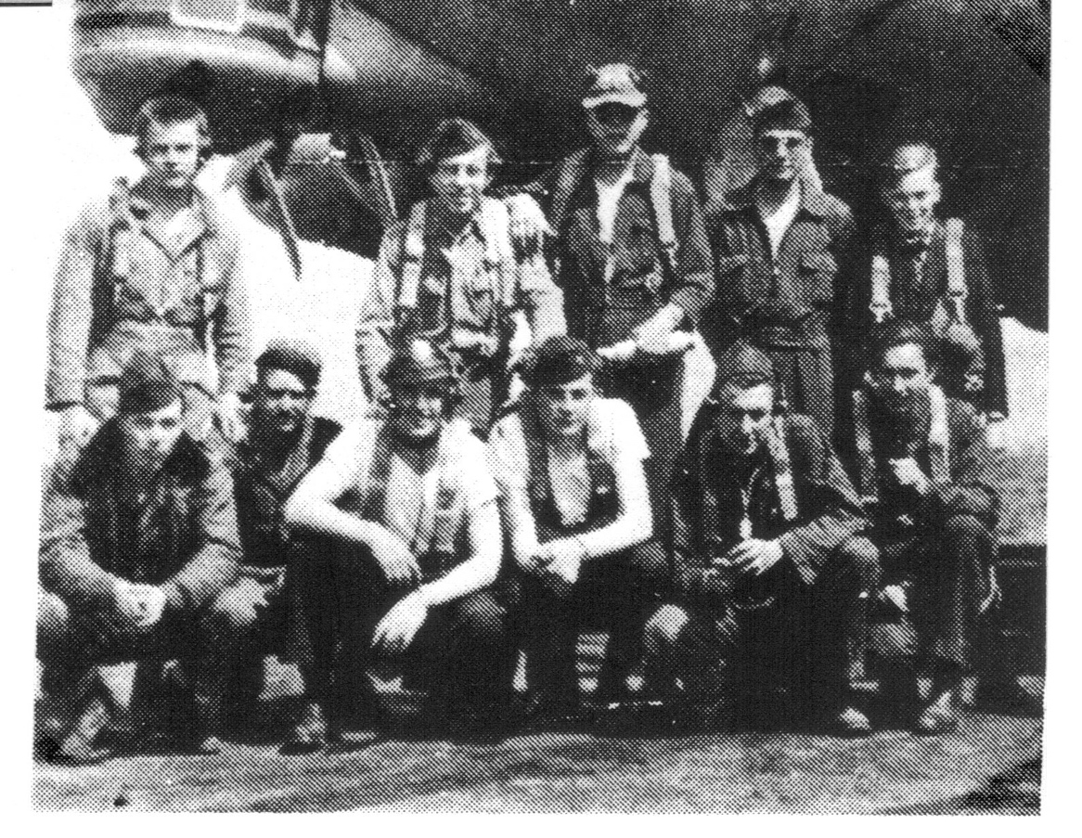
L-R standing: Glen L. Reed, Radio Operator; Peter L. Kobilsek, Navigator; Dix B. Miller, Engineer; Peter R. Calaty, Tail Gunner; Peter West, local boy. L-R kneeling: Harvey L. Root, Crew Chief; John P. Scoggin, Waist Gunner; John B. Jones, Co- Pilot; Fred C. Stadelhofer, Pilot; Clifford W. Dunham, Ball Gunner; Tony Seeley, local boy. Photographer: William W. Ritts, Togglier.

“Seeing the countryside from the air was a new experience for me. Airfields in Norfolk and Suffolk were thick on the ground. Our farm at Pulham could be seen miles away with its huge bomb-battered hangar. Next to the hangar was a huge scrap yard of crashed aircraft, which were piled three high and spread over 25 acres. Planes from all over East Anglia were brought here. Some were British, some German, but most were American”.

Other schoolboys were equally affected. Norman Lock recalls happy and tragic times:

Photograph: Norman Lock
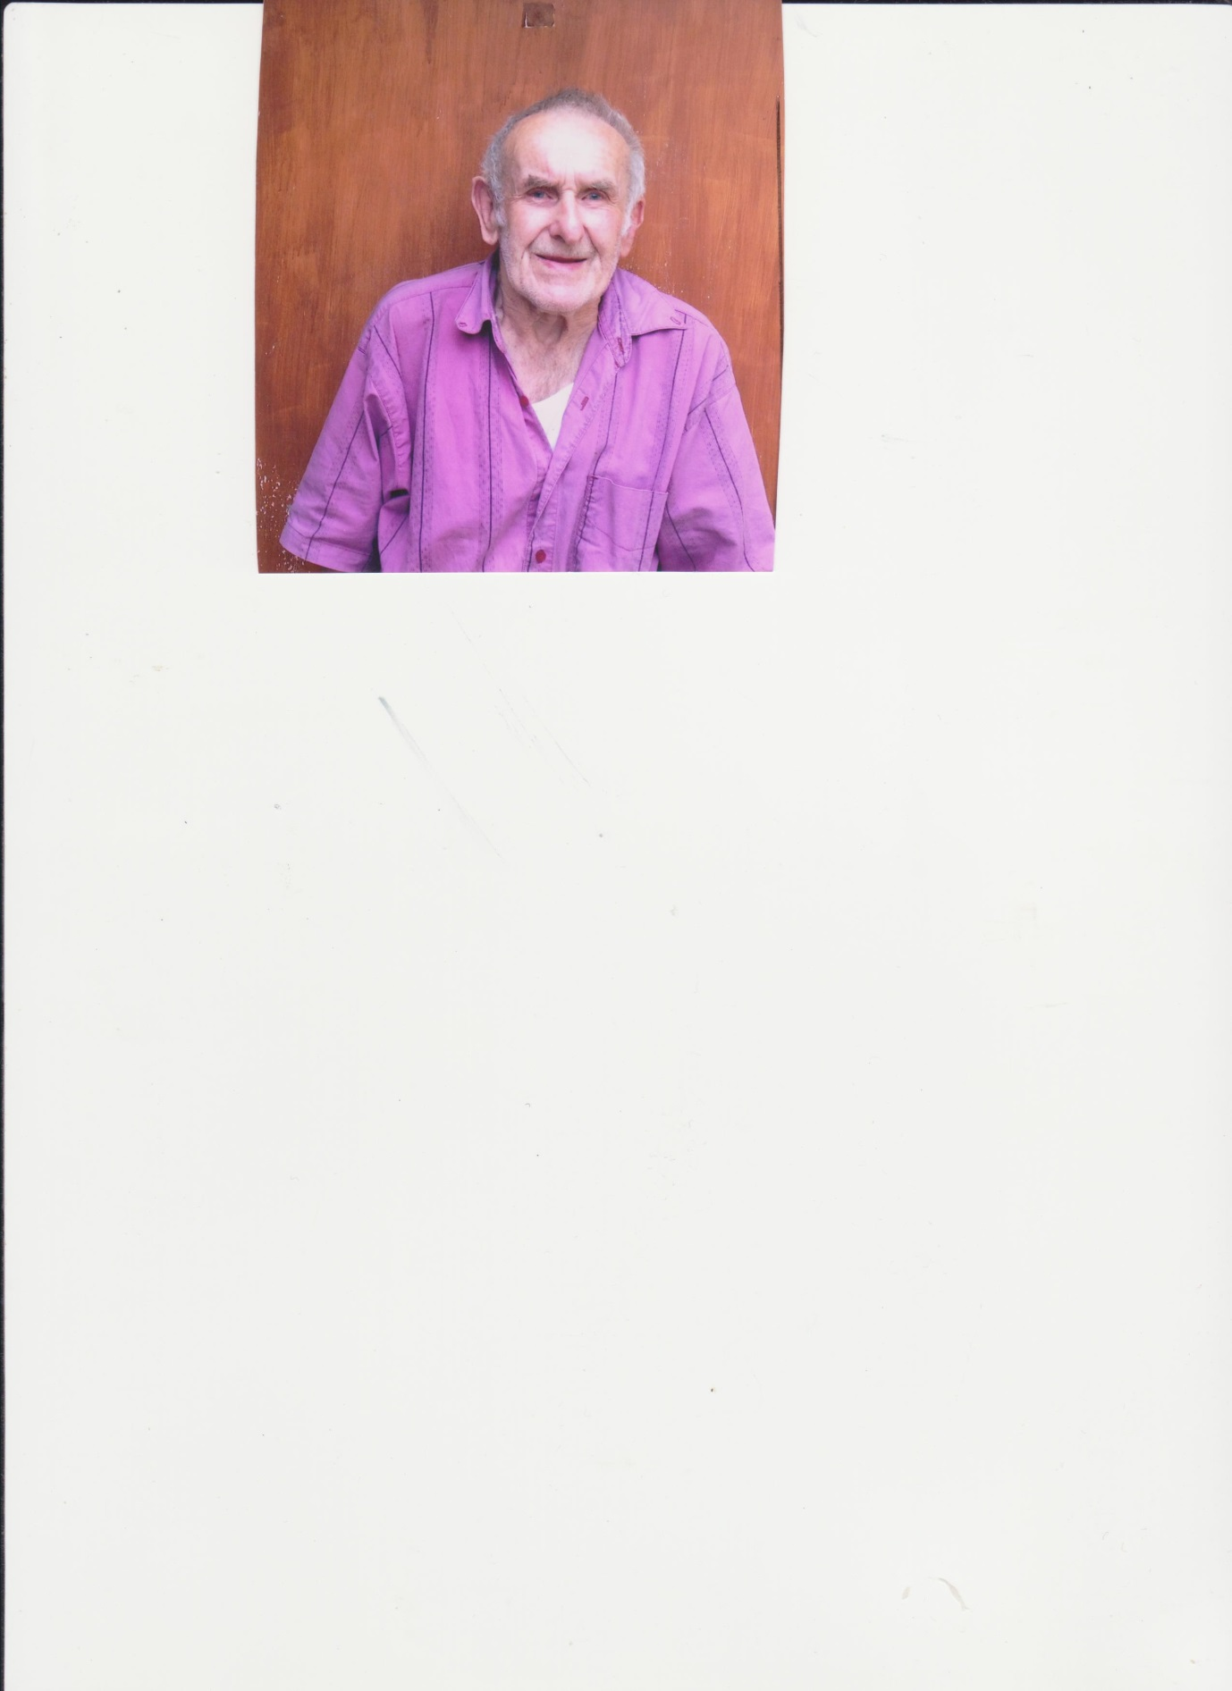
“I lived in Station Road in Eye and distinctly recall the building of Brome Airfield by the American Air Force personnel. As I had never seen a black person, the Americans were a bit of a strange sight. But they were very popular because they were always giving us schoolchildren chewing gum and 'candy'.
“It appeared to me that the black Americans were building Brome airfield, while the white Americans were building Horham airfield. The bridge at Ludgate Causeway was the barrier between the two, as fights used to break out between the two different sets of Americans. The Town Hall in Eye was given a new use by the Americans, that's where they used to play their basketball. Of course, it was also used for sing-songs, concerts and dances.
“I remember that we schoolboys used to search through the dustbins near the airfield looking for bits and pieces. I still have an American football that I found.
“On a sadder note, I remember looking into the barracks and seeing the empty beds of those who had not returned from the bombing raids.
“I saw a German Dornier fly over Station Road, firing its machine guns and dropping three bombs near the Eye Town Hall.
“Two other things I remember were the Italian prisoners of war who were labouring on the farms. We used to throw stones at them. There was also an American Red Cross Centre in the Rookery.”

Charles Flatman also remembers friendships with the Americans:

Photograph: Charles Flatman
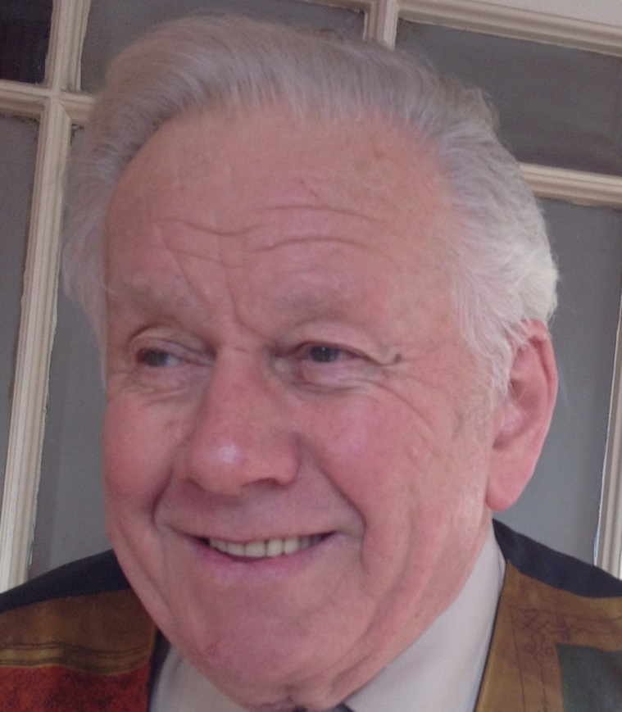
“I was a ten year old living in Eye when the first Americans arrived to build the Eye airfield. I have to say I had never seen a black person before the Americans arrived. However, there was an instant affinity with the local working men and the black Americans, even though they had a lot more money to spend than the locals. They behaved impeccably and my mother and grandmother took in their laundry. Church parades on a Sunday in Eye were a great sight, with the black Americans singing their beautiful hymns.
Photograph: Marching to church in Eye, Thanksgiving 1943
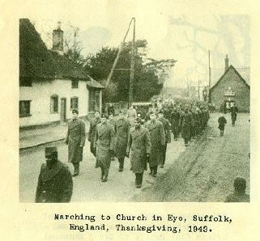
“Then came the day when the building of the airfield was finished and I remember watching the Liberator bombers landing at the Eye airfield.
“We schoolboys were not allowed onto the airfield, but we managed to sneak in, hiding behind the ovens and we formed an association with the cooks who were very kind to us, giving us things we had never seen before, such as pineapple chunks and cheese. We boys were also given PK rations, while the local girls were given silk stockings.

“The American airmen lived in Nissen huts on the aerodrome. If a bomber crew failed to return from a raid, their possessions were shared out amongst the rest of the Nissen hut.

“On many occasions I watched the USAAF bombers take off for their raids over Germany with a great feeling of exultation. Then there was a feeling of sadness as we saw some bombers limping home in a bad way. Added to that, I remember that my mother was in the process of doing the laundry for an airman who did not return.”

Some local boys became budding young airmen, as Tony Seeley relates:
“As a schoolboy member of the Air Training Corps, I greeted the arrival of 2,000 American construction engineers on the outskirts of Eye with enthusiasm, for they were a generous and warm hearted presence while building the airfield.
“Equipped with my pass which allowed me through the guard posts, I used to enter the base in order to collect money from the telephone kiosk. I was given access to restricted areas of the airfield during the bombing campaign. I remember frequent crashes in the vicinity of Eye, such as the fighter that ended up in the village shop at Brome; the awful crash at the Brome crossroads which killed the entire bomber crew and local workmen; and the crash at the end of the runway in Castleton Way (currently opposite the entrance to the Eye Airfield Industrial Estate), which again accounted for all the airmen on board.
“As time went by, I became accepted by the airmen on the base, particularly as I brought in fresh eggs for sale. I was allowed to sit in the mobile chequered caravan which contained the Air Traffic Controllers. Seated there, I can remember the excitement generated by the occasional red flare that was sent up, signalling an aborted take-off. I do recall counting out the bombers as they took off and got into formation to launch their attacks on Germany, and witnessing their return, some with battle damage and engines out of action. Wounded crew would be treated in the American hospital at Brome and more serious cases would be taken to a large hospital at Redgrave.

Photograph: Tony Seeley
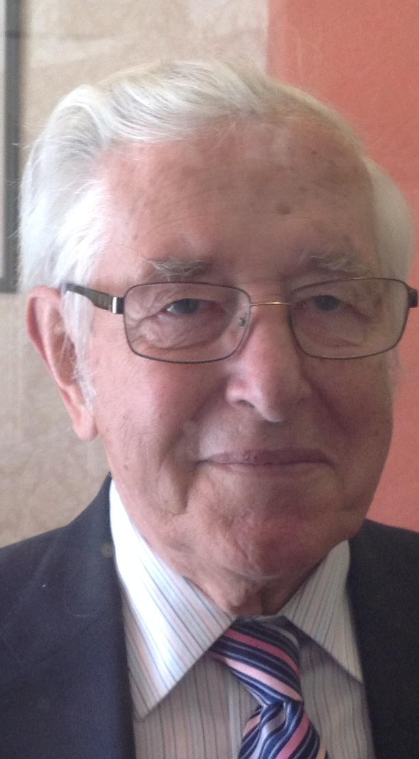

“I got to know the aircrews well, despite the fact that there must have been over 400 of them on the base (see the photograph on page 18 with an aircrew and Peter West). Of course, there was the inevitable sadness and emptiness when some failed to return from a mission, but the philosophy seemed to be one of not dwelling on the loss of friends or grieving, but getting on with the job.
“I am not particularly sure if my parents were fully aware of how many times I went on various flights. I was given a parachute which dangled unflatteringly between my legs. I must say that I always swore that I would never jump if the need arose. However, on one occasion when we were flying over the channel, the bomber went into a vertical dive. I was the first to the escape hatch, in readiness to make the jump. Fortunately, the pilot was able to rectify the dive.
“One of the most exciting flights that I accompanied was a “Chowhound Mission” to Holland. This was the delivery of food to the starving Dutch during a truce negotiated with the Germans in 1945. We flew in at 500 feet and I stood, precariously perched in the open bomb bay helping to throw out food parcels, watching the ground whizz past below my feet. This trip was not without its hazards as the German anti-aircraft gunners had their guns trained on us, but fortunately, they did not open fire.”
The Americans helped to liven up the social life of Eye, as Janet Chambers remembers:
“Being only seven when war was declared my memories are a little hazy, but some things stand out clearly: the solemn, cultured tone of the BBC news announcer, the mournful wailing of the air raid sirens, which sent us, armed with torches and blankets down to a cupboard below the stairs.

Photograph: Janet Chambers
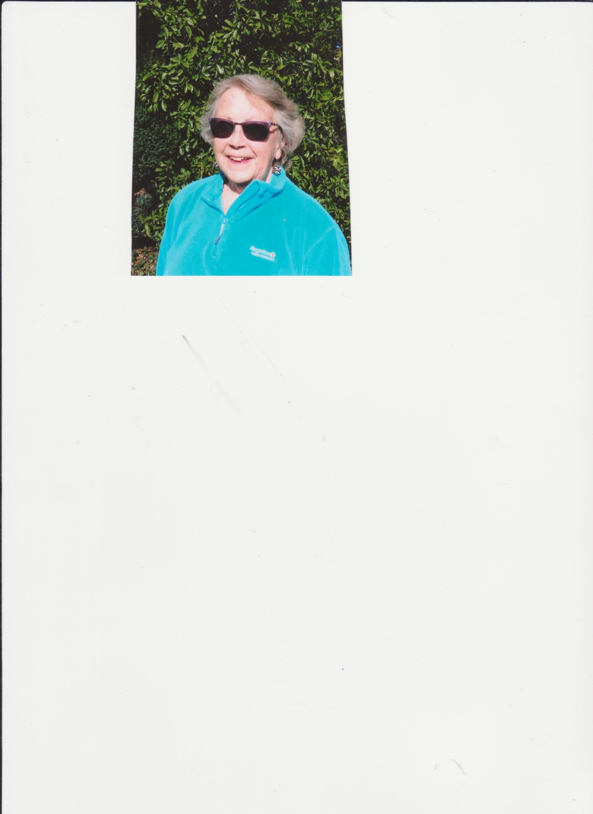

“Then the Americans came. ‘Got any gum, chum?’ became the eternal cry, and what were nylons that older girls were so crazy about?
“The social life of the town livened up considerably when the population was swelled by the Yanks and regular dances were arranged in the Town Hall. My uncle was a drummer in a dance band and his pianist, Harold Speed, refused to play the tinny out-of- tune instrument in the hall. My beloved piano on which I had just started to have proper music lessons, was transported to the hall, much against my will, returning with stains on the polished wood where beer mugs had been placed. Even more irritating was the fact that I was not considered old enough to attend the dances and felt sure I was missing all the fun. These dances were, of course, really popular with the local girls because here was a golden opportunity to meet the young USAAF boys from the local base. A truck would drive around the outlying district to ferry the girls to the dances.
“But on Sunday afternoons I was allowed to cycle to Horham airfield where we could visit the American cinema and watch the latest films - this was a tremendous treat, much better than the black and white films they put on at the Town Hall, with frequent breakdowns of the projector.
“My husband Alf haunted the airbase as a young boy and was regarded as a something of a mascot by the Americans one of whom, called Shorty, wanted to take him up on a flight. Luckily, he refused and ran back home across the fields. Later in the war, he heard that Shorty had crashed and been killed.”
Alf Chambers remembers his American friends and the treats which they took for granted but which to children in a rural community were luxuries:

Photograph: Alf Chambers
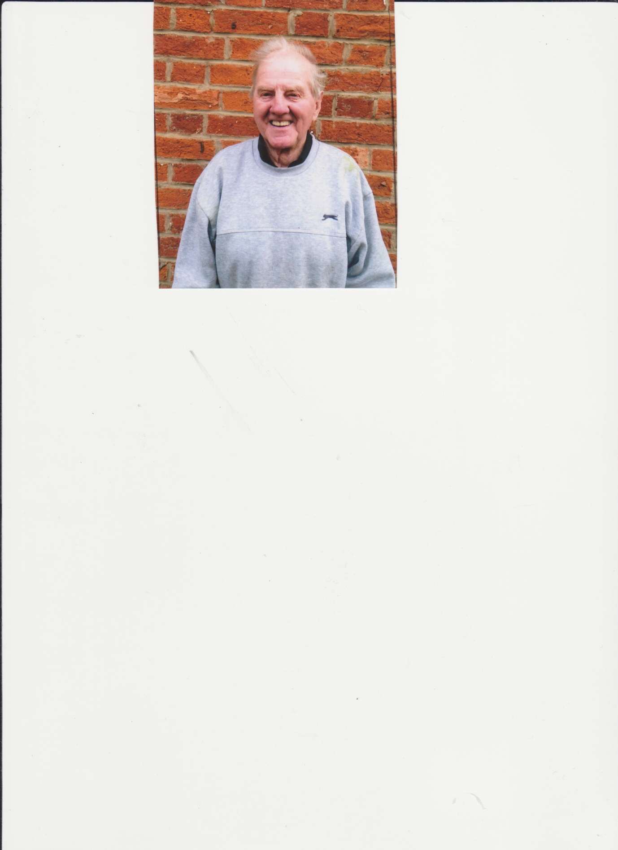

“When the Americans first arrived, their black labourers used to have their showers on the Pennings. They would march down from Horham to what were called the Steamers, water taken from the river and boiled for showering.
“Relations were very good between the American personnel and local residents. I was caught by an English policeman on the American base at Horham when I shouldn’t have been there. Four airmen appeared and rescued me saying “leave the Limey alone!” And he did.
“Those Yanks had everything that we didn’t have, driving around in their Buicks, and we seemed very poor in comparison. They were very generous giving away Coke, sweets which they called ‘candy’, chocolates and fruit. I got to know an American air gunner well. He was called ‘Shorty’ and had done 55 missions. The time came for ‘Shorty’ to be sent home, and I missed his farewell party. Sadly, I believe he crashed and was killed on his way back to the States.
“I remember biking up the hill to Horham airfield to their cinema on the camp. There we had ice cream! We children used to watch the stars such as Bing Crosby, while the Land Girls attended the dances on the base.

“The sky used to be full of bombers, hundreds of them. I remember looking out of my bedroom window and seeing a mid-air crash, when aircraft fell into Waterloo Woods. Parachutes were floating down. They say they found an arm there with a watch still ticking on its wrist.

“Once, when I was walking home, I got a lift back from an American colonel. When he dropped me off he said “See yer, you goddam Limey!”

“One of my great moments was to go to a dance at Horham where Glen Miller and his band were playing.

“In those days there was a form of segregation between the whites and blacks. The White Yanks used to go to The Cherry Tree pub in Ludgate Causeway, where they drank the place dry in one night”

Harry Borrett, a resident of Eye sadly died whilst this book was in preparation.
“I was born in Horham in 1928 and subsequently moved to Eye. Our village of Horham was then a very small rural community and only some four miles down the road from Eye. Life went on as it always had done. The work followed the seasons, one after the other. There was little money but we seldom went without. Not much ever changed. The land always looked the same and only the weather was different. Every body worked hard and the lazy had a bad time. We did not have that much but we were content.
My father was born in the next door village of Stradbroke where he became the head porter. Horham was then connected by rail to Stradbroke. In those days the railway wound its way through a number of our local villages but the line ceased to operate some years ago. It was anyway always on the edge of making a loss.
When I was twelve years of age, I used to cycle the five miles to school in Stradbroke. Our bicycles were painted white and were issued to us on a long loan by the school. I was once nearly late and cycled the five miles in just under twelve minutes. Whenever we were thought to be lazy or were guilty of bad behaviour we were not allowed to use our bicycles and had to walk the five miles back to home and then the same five miles back to school on the following morning. It did not matter if it was fine or raining or snowing. We had no sympathy from our parents who always backed the school's actions. I do not think it would be like that today. It would be on the front page of the East Anglian Times.

Photograph: Harry Borrett (note below)


I was 14 years old when the American construction crews started to build the airfield in the village. In the holidays and weekends I with the other Horham boys had to help unload the brick lorries which came from London. They brought the bricks from the bombed houses in the capital in order to put up the buildings on the base. We used to find some funny things at the bottom of the lorry and under the bricks. I remember coming across a set of false teeth, clothes, old shoes and all sorts of household items.
The airfield at Horham took some twelve months to build. Everything on it had been imported from the USA. The construction teams were almost all coloured Americans and their relations with the people of Horham were always very good. We all liked them. And they I think liked us. My mother used to take in the washing for the G.I’s . When they had an English girlfriend my mother used to provide her with a room for a day or so and for the duration of her stay at Horham. The G.I.’s on the base would often give us packets of Camel cigarettes, cans of ice cream and occasionally long forgotten fruits such as bananas or oranges. We had rather forgotten what they looked like.
When I had left school and at the age of sixteen I joined the Home Guard. This I much enjoyed. We were taught basic foot and arms drill, how to clean, strip and assemble our

(Harry Borrett, a long term resident of Eye died whilst this book was in preparation)
weapons, shooting on the range and field craft. Perhaps happily my newly acquired military skills were never put to the test.
On the completion of the construction of the base the Americans flew in their Liberator and Dakota bombers which were soon replaced by their even bigger Boeing B17’s. At that time a Mr.Baldry ran the Horham pub which was called the “Dragon.” During the day Mr. Baldry was also a wheelwright and made wooden wheels for the many farm carts in the area. Following the arrival of the ever thirsty air crews his pub was often drunk totally dry in one evening. His beer barrels were delivered to him on a Wednesday and I never remember there being any beer left by the Friday. One wonders how he was able to begin to cope with over 3000 men on the nearby airfield, let alone his regular village customers!
They, the Americans were always generous. I remember them laying on periodic film shows for the village. These we used to go to in large numbers. I also remember a Glen Miller band concert for which they held a big party. There was so much beer around that we could nearly swim in it.
I was one morning standing in the orchard and the sky was darkened by a huge mass of aircraft of many different types. Some of them were gliders which were under tow. They were heading roughly in the direction of Ipswich and beyond. It was the 6^{tth}.June1944, and they were part of the D Day force which was to play its part in the allied invasion of Europe. The planes were so close together that one could not have put a pin between them. The excitement in Horham and everywhere else ran high and our ears were glued to the BBC.
The terrible conflict being waged in the air and above Germany and occupied Europe was never very far away. I vividly remember one Sunday when I saw a shot up B17 which had returned from a raid and from it were being carried a number of dead and wounded members of the crew. They were taken to the hospital which had been built just outside the base and which had both a surgery and a mortuary. It is now a small museum to recall these and many similar tragic events. To see those poor young men was a sobering sight. They were very young and not that much older than myself. I think that these sights and others like them made us all think on how very fortunate we were to have been enabled to keep ourselves and our families safe. After D day we were all in the village becoming ever more aware of the then newly reported horrors which had been inflicted by Hitler and his regime upon the peoples just over the channel and beyond. After Dunkirk the same could have happened to us!
It was with a great sense of gratitude and sorrow that we in 1945 witnessed the 95th Bomb Group head for home from their Horham base and for ever leave us.”

Molly Ruth describes living conditions in her childhood which were very different from those of the servicemen, but she remembers with affection the impact the Americans had on their lives:

Photograph: Molly Ruth
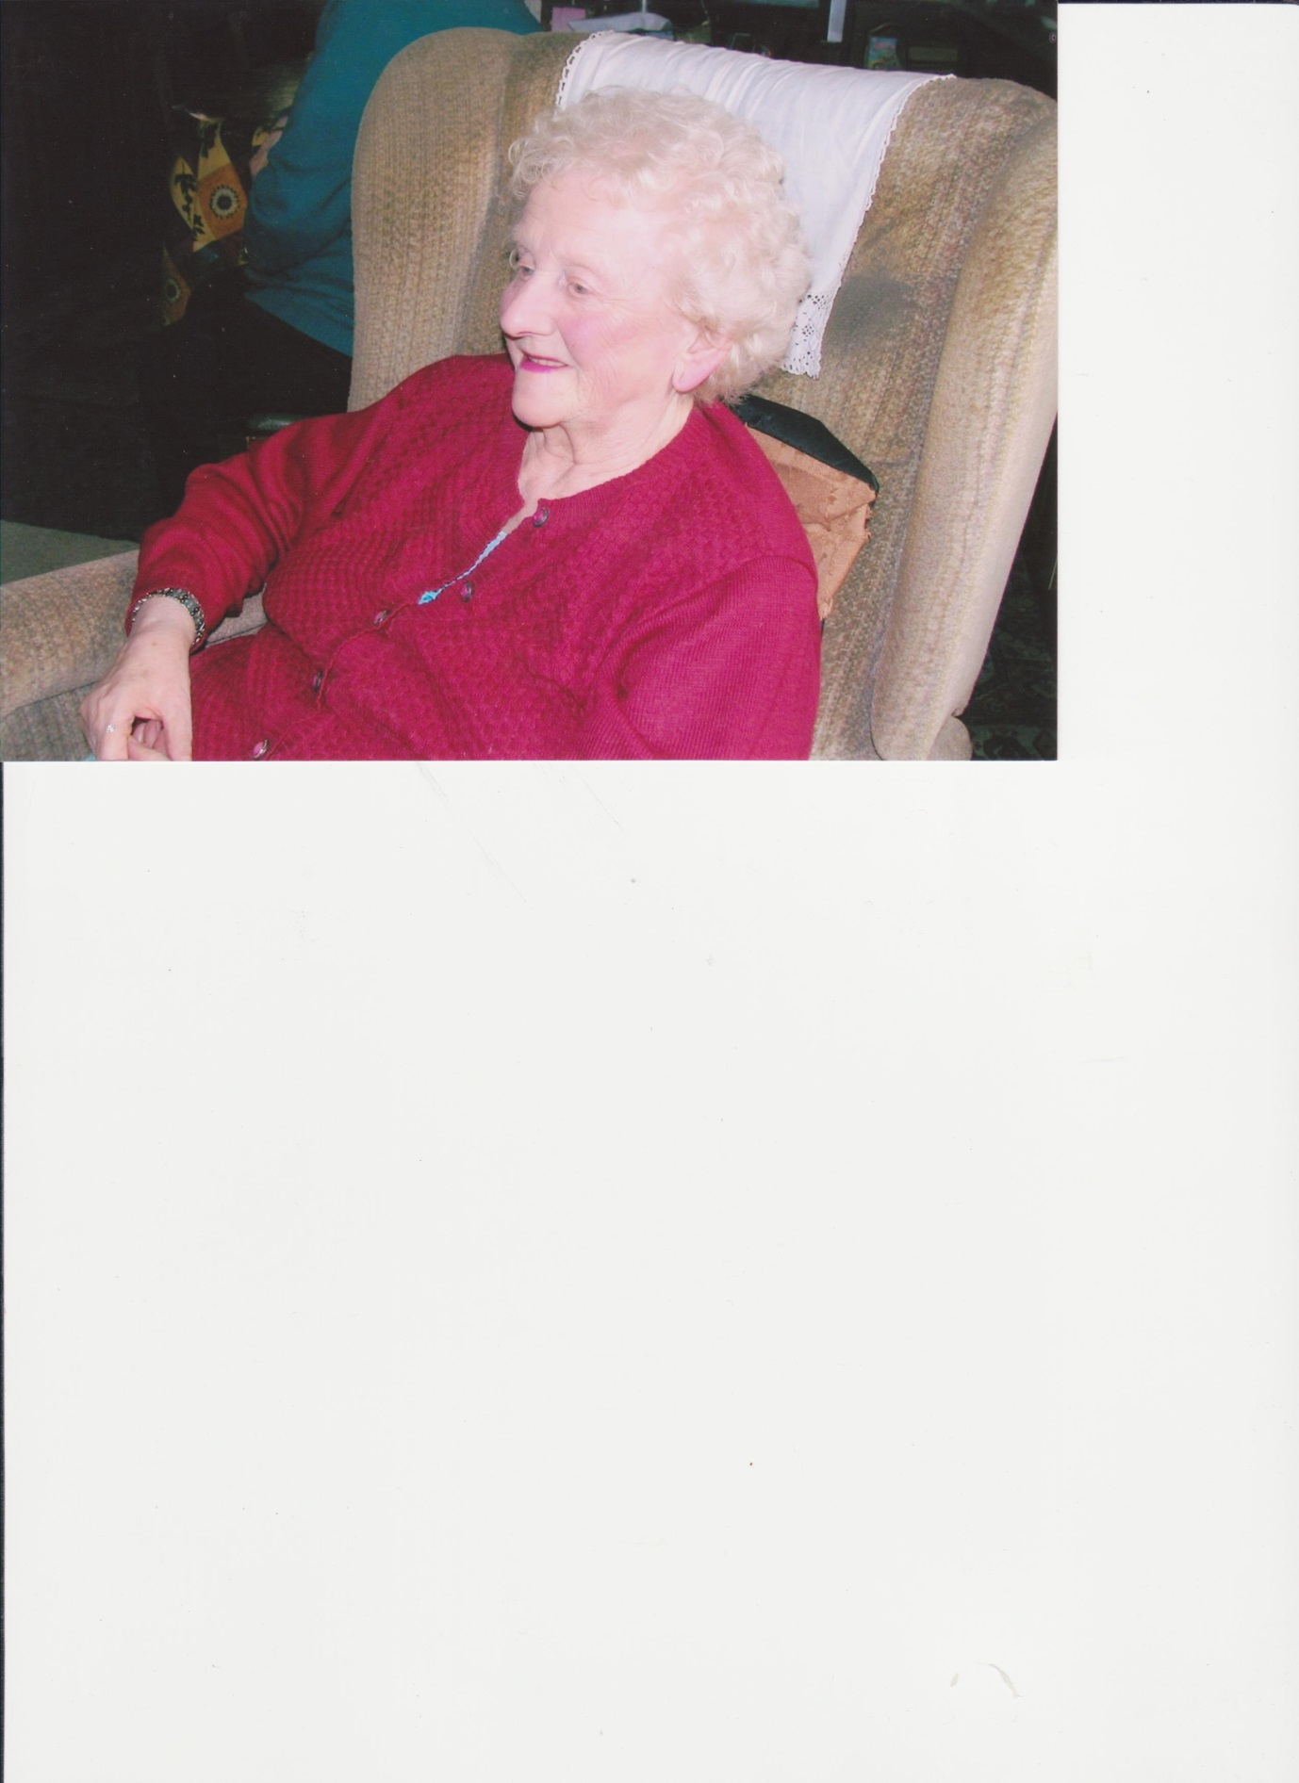

“My father was born in Eye. He was the head horseman on Mr. Cooper’s farm which is just beyond the Cranley Hill and on the road to the village of Redlingfield, three miles or so from Eye. To this day there are a fair number of my family that live in the town and in the villages nearby. Our home was in the Rettery where in the past flax was soaked in order to separate the fibres from the woody tissues.
“Our cottage was on a bend in the road. As was normal at that time, we had no electricity, no running water, no central heating or gas. Lighting was by paraffin lamp and candles. We went to bed by candle light. As children we were bathed by my mother in a tin tub in front of a coke fire. Cooking was done over a coke fire in a wall oven. Water had to be drawn from the well. The lavatory was in the garden and of the bucket variety. It was emptied daily by my father. In the winter we suffered terribly from chilblains on our fingers and toes.
“My sister and I walked the mile to our primary school which was near the castle keep. Whilst our very rural lives were always full, we followed a routine which had probably been much unchanged for some generations. There were sometimes two or three cars and a number of farm horses and carts which passed the Rettery every day. Otherwise we lived quietly and at peace.
“In 1942 I was ten years of age. It was at the end of that year that the American air force began to build their air bases at Horham and at Brome. The road past the house changed from being a very quiet minor road to the main thoroughfare between Eye and Horham. Heavily laden lorries and jeep loads of young GIs would hurtle up and down the road, nearly always at a great speed and with much unaccustomed noise. We lived on a fairly sharp bend. As a consequence it was not uncommon for the jeeps and their passengers to fail to round the corner. They would clear the ditch, make a big hole in my father’s carefully tended hedge and end up amongst mother’s much loved and now sorely damaged gooseberry bushes. The GIs never failing charm together with profuse apologies meant that they were always forgiven. They were seldom hurt apart from bumps, minor cuts and some massive bruising. For fear of our meeting our deaths under a jeep and amidst the gooseberry bushes, my sister and I were forbidden to go into that part of the garden which was near the road. My father’s hedge became a shadow of its former well-tended glory and the gooseberry bushes never really recovered. Our previously quiet walk to school had become so busy with traffic that our mother thenceforward escorted us both ways every day. This happened no matter if it was hailing, raining or snowing.
“Not only did our American allies have good manners and much charm, but they were also very generous. I have clear memories of lorries drawing up outside the school and 20 or 30 of us being driven to the Horham airfield for a huge tea party. On arrival all the foods which due to the war were then unobtainable in the shops were laid out in generous profusion. Biscuits, cakes, cream cakes, chocolates, ice cream, oranges, sweets and much other party food so dear to children were piled on our tables. We had similar lovely outings to the Brome Eye airfield where we were treated with the same cheerfulness, generosity and welcoming smiles.”

An evacuee in Eye
It was not only residents whose lives were changed. The town was also home to children evacuated from the bombing in London. One of them, Dorothy Presswell, wrote a book about her experiences as a schoolgirl when evacuated to Eye. This draws on her descriptions of that time.
Government concern that the bombing of London or other large cities would cause an uncontrolled flight to rural areas led to the evacuation of London children to the country without their parents. The administration of such a project was daunting: foster homes needed to be found for around half a million children.
The Ministry of Health required the Eye town council to produce a register of accommodation for up to 900 children. It specified that each child should take only a gas mask, a change of underclothes, night clothes, house shoes, spare stockings, socks, tooth brush, comb, towel, handkerchief, coat or mackintosh and a packet of food to last for one day. They had a label around their neck, stating name, address and school. Their clothing was packed into a pillow case. There were no toys included on the list.
Dorothy Presswell and her schoolmates arrived in Eye bewildered, tired and hungry. They were mustered in the Town Hall. Following a short welcoming speech from the mayor they were led off to their first billet. Dorothy’s hosts were elderly. The husband had polio. Dorothy stayed a few days but was then taken to another house just outside the town. The father of the household made it quite clear to her that that the presence of children was “a burden”. There followed two more changes of accommodation. Her brother was four years older but had been billeted elsewhere. Aged only nine she felt very alone.
It was a big shock for a Londoner to move to rural Eye. In London hot and cold running water, flush toilets and washing water were the norm, whereas in rural areas generally, drinking water was from a pump, washing water was from a butt in the yard, lighting was from a paraffin lamp, and the toilets were at the end of the garden. Soda crystals were used in the washing up water and old newspapers were used as lavatory paper. In the summer when it was too hot for coal fires indoors, cooking was done on oil stoves.
In London, noise was constant. Trams, trolley buses, dray horses and their lumbering loads rattled and clanked over the streets, many of which were still cobbled. The cries of news boys, rag and bone men and other street vendors were part of the capital’s bustling way of life.
The only thing a Londoner had in common with the life of the people of Eye was the English language and even then the Suffolk vernacular was not always easy to understand. For example “she is a twerp” become in Eye “she’s a duzzy fule”.
Even Dorothy’s religion was different. Her foster parents took her to chapel and she much missed the ritual of her church at home, particularly the church music and choral singing.
Letters from home were always looked forward to avidly, together with the hope of a postal order. Her billeting money covered only board and lodging and she swiftly learnt how to set money aside for shoe repairs, haircuts, darning wool, writing paper, stamps and other necessities.
While she gained a sense of freedom and independence in Eye, it was at the cost of homesickness and the comfort of her family’s love and security.
By February 1940, the government provided subsidised coach tickets for London parents to visit their children. It was a wonderful moment when Dorothy’s parents stood framed in the doorway of the bus which had pulled up at the White Lion hotel. Years later she could feel still the tremulous joy at the start of that day and the sickening sadness at its end.
Dorothy‘s entire London school had moved with most of their teachers in one group and were taught in the “area school” in Castleton Way in Eye. The buildings were then only two years old and surrounded by two acres of open gardens. They made a remarkable change from the drab and uninspiring Victorian buildings of her school in London.

Dorothy describes the wonders of the countryside. The growing hedgerows, Brussels sprouts on stalks, migrating swallows lining the telegraph wires, primroses in the woods, the Abbey fields inundated with flood water from the River Dove and the wooden V shaped snow plough which was pulled by a huge Suffolk shire horse.

She recalls the twice weekly gas powered bus which progressed through the villages to the county town of Ipswich 20 miles to the south. The gas was contained in a dustbin-like container which was towed along behind. When the bus was fully loaded with passengers it did not have the power to negotiate a hill. The passengers then had to get behind the vehicle and help push.
Eye directly entered the war when on the afternoon of 11th September 1940 a lone German Dornier 17 circled the town. Its military purpose remains unknown. The raider dropped five bombs all of which failed to explode. One landed outside the main entrance to the Town Hall. The bomb then bounced off the road and through an upstairs window of Nunn’s the outfitters. The pilot fired many bullets from the Dornier’s machine guns. None caused any damage but one passed through the arm chair of Mr Ruffles, the town’s much respected chief billeting officer. Mr Ruffles was at the time enjoying an after lunch nap and, much to his annoyance, the bullet passed through a loose fold in his trousers. Happily he was quite unhurt.
Two years later Dorothy saw two soldiers who had just arrived from across the Atlantic. They belonged to the engineer battalions engaged in building the airfield between Eye and Brome. One of the runways ran parallel to the school and Dorothy and her friends would watch the Liberator and Flying Fortress bombers take off and land. Dorothy and her friends were always much saddened when they saw aircraft involved in accidents.
The young American servicemen caused a stir in both Brome and Eye. Their transport careered at speed through both places. The mayor of Eye felt compelled to write to the commanding officer asking that his transport might slow down. Never had the burghers of Eye seen armed soldiers outside the Barclays bank when the pay day money was collected. This was much more exciting than a gangster movie at the picture house in Diss.

The Americans were made welcome by the vicar of Eye to his church. The base’s choir sang at a number of evensongs. At Christmas in 1944, the choir combined with the singers of Eye for a rousing performance of Handel’s Messiah. The extroverted young airmen from across the Atlantic were much liked by all.
These had been bleak and lonely years for Dorothy who sorely missed her family, but a fourth and final change of billet brought a change of fortune. She moved to a narrow fronted Tudor house in Church Street named Shingle House, still there today. It was the home of Francis and Hannah Hunt who were both elderly. There were no power points and only three rooms had electric lights. Irons were heated on the kitchen stove and washing was done in an outside wash house for which the water was heated by a hand fed boiler. It was a long walk to the privy which was at the bottom of the garden and which was of the bucket in the shed variety. In the winter months Mrs Hunt, clad in winter coat, hat, gloves and scarf would in the dark sally forth with her torch and umbrella to her destination. In order to keep upright and in icy weather she would for added support hook her umbrella handle over the clothes line.
Despite the physical hardships. Dorothy felt she had “walked into paradise”. When her rations were low her plate was always mysteriously filled until the next ration day. In the evenings after homework Mr Hunt and Dorothy would engage happily in games of dominoes or lexicon. She enjoyed a level of kindness and love from the Hunts which hugely helped her to overcome the separation from her family. She remained in frequent contact after the war until Mrs Hunt died in 1952.
When the peace was at last declared Dorothy returned home to see a large and welcoming Union Jack which had been hung from a top window in the celebration of her return.

Wartime rationing

Food rationing in wartime Britain began in January 1940. Many foods were strictly rationed: bacon, ham, butter, sugar, meat, tea, cheese (one ounce per person per week), all tinned foods, dried fruits, cereals and eggs. Soon, most people were becoming accustomed to such items as dried eggs, snoek (a long thin marine food fish) and tinned sausages, National Dried Milk for babies, rissoles and whale meat. Potatoes were used for pastry, scones and puddings. Gone for some years were delights such as bananas, white bread, coffee, Sunday joints and icing sugar on cakes.
Such strict rationing was a burden to all. Housewives on a daily basis faced lengthy queues for almost everything. It was a problem also for the shopkeepers who had to operate the system and attracted much unpopularity. Hotels, restaurants and cafes were faced with a myriad of instructions as to how much food was allowed for each customer.
The White Lion Hotel in Eye was told that it was illegal to serve more than one dish from foods that were in short supply, even if such items such as meat, poultry, game, fish, eggs and cheese were then available.
All were required to buy food using a personal ration book, which was buff coloured for adults, blue for children and green for infants. A tough stance was taken on those who tried to cheat the system. An Eye man was fined £20 for obtaining extra rations from two shops in the town. The shopkeepers concerned were each fined 5 pounds and 2 shillings for illegally supplying one half pound of margarine, one quarter pound of lard, one and a half pounds of sugar and one pound and nine ounces of cheese. Such fines were substantial sums of money in those days.
In 1941 clothing purchases were also rationed. This new system was put into action over the course of a weekend in order to prevent panic buying. As the war progressed the allocation of clothing coupons sharply decreased. "Make do and Mend" classes became popular. Patchwork skirts were introduced. Leg dye in lieu of stockings and handed down clothes became the norm. Pregnant women had no extra coupons.
Paper was also in very short supply; throwing of confetti at weddings was banned. Shops were forbidden to wrap foodstuffs in paper. Empty cigarette packets were returned to the counter and then re-used by the tobacco companies. School stationery was reduced by a half. School pupils were required to rule lines on the inside of their exercise books and to draw two lines at the top and bottom of each page. All margins were ignored. The Ministry of Education issued a leaflet to the effect that any teaching caused by lack of paper might be overcome with "lively and searching oral work".
Because food was in short supply, the endemic problem of rats in rural areas was taken very seriously. All hay ricks were to be fenced off to prevent the escape of the rat population inside. 108 rats were accounted for in two local ricks near Eye. They were killed by two terriers and one boy with a stick. In just one month the Hartismere Rural District Council reported 16,000 rats had been destroyed. One of the local sanitary inspector's less enviable tasks was to count the dead bodies. On one farm in Eye in the week prior to his visit, 450 dead rats had been kept in a closed barrel. To avoid the stench, the inspector decreed that he would be quite satisfied to count only the severed tails.

People living in Eye at the time have many happy memories of their American friends, but also full awareness of the dangers and tragedies of war. The next two chapters tell the airmen’s stories.

3 Life on Eye airfield

When the young aircrews arrived in Suffolk they found a bleak existence awaiting them in the freezing English winter and the prospect of desperately dangerous missions. The stresses were relieved by visits to local pubs, dances and occasional trips to London and elsewhere.
James Lee Hutchinson (‘Hutch’), who trained as a radio operator and gunner, arrived in Eye in late November 1944 with his fellow crew members and pilot Bill Templeton. He was nineteen. They were among other replacement crews for those who had either completed their tour of duty or been shot down. He has written extensively and vividly of his experiences flying with the 848th Squadron and of their day-to day lives. The following is drawn from his published work.

Living quarters
The accommodation provided for around 3000 crew members who were based at Eye was frugal:
“We referred to our hut as the ‘Brome Dome 29’. It was a sixteen by thirty foot steel Quonset hut with a concrete floor and a very small stove sitting in the centre surrounded by twelve steel bunks. It looked like a giant grey ash can half buried in the ground with a brick wall in each end containing a door and two windows with blackout curtains. There was a smoking chimney through the roof.

Photograph: ‘Hutch’ outside Hut 29, Eye airfield
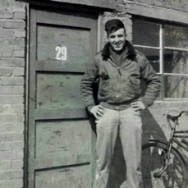
“The concrete floor and metal frame of the hut made it very cold on winter nights and coke for the stove was rationed to a bucket a day. A steel helmet became a vessel for heating shaving water on the stove”. They shared the hut with another crew, veterans of ten missions at the time Hutch and his fellow crew members first arrived. Later, when the experienced crew had completed their tour of duty they were replaced by a new crew:
“These guys were still in training and hadn’t experienced the stress of combat missions. They stayed up late at night and ignored our request to hit the sack and turn out the lights. The situation quickly came to a head one night. Our crew had just flown an eight-hour mission and were alerted for another raid the following day with a 3.00 wake-up call. We got no action on our request for lights out so at 9.00 pm Roddy pulled out his .45 automatic and shot out two ceiling lights before someone hit the light switch … a rule was established …. We all became good friends as the war progressed.”
In the evenings, fish and chips were a favourite treat, “especially if the mess hall chow hadn’t been too appetising”. A local farm boy, Russell Etheridge, would go out to get them from the White Swan pub. He was fourteen years old and would run errands for the crew, while his mother did their laundry every week, both for a small fee. He would return with the order still warm, wrapped in newspaper: “On a cold winter night eight Yank crewmen and Russell could make a large package disappear quickly.”
One night Russell announced his sister was getting married. One of the crew members managed to obtain a damaged parachute from supplies which was presented to her for making a wedding dress.

Leisure time
There were regular bicycle trips to Diss which had more pubs and shops than Eye, “first through a lane with huge trees overhanging the road … then it was out of the trees, into the open road past the deserted golf course.” Military vehicles were everywhere, but very little civilian traffic because of petrol conservation. Returning at night was hazardous with no headlights on vehicles and blackout curtains covering all windows, so everywhere was pitch black.
Three or four times a month, dances were held at the Aero Club when the GI Wolves, the base dance band, would play. Girls were brought in from surrounding villages as dancing partners. A Christmas Party was held for the children of local villages on 23rd December 1944. Santa Claus, a Christmas tree, movies, gifts and refreshments were all provided.
There were trips to London when crews were able to obtain a three–day pass. A ‘pass truck’ would take them into Diss to catch the train for Liverpool Street. The Rainbow Corner Canteen on Shaftesbury Avenue, run by the American Red Cross for US servicemen was a popular haunt. From there they could send cablegrams home. At the Corner House in Piccadilly Circus they found American beer: “Oh happy day! After a month or so of mild and bitters at Diss pubs we finally got cold beer.” They would go sight-seeing and watch American films showing in the theatres.

We can only imagine how welcome these diversions were from the terrible dangers they faced. The next chapter takes us on some of the missions they flew.

4 Aircrews tell their stories

Memoirs, diaries and letters from the young crewmen paint a vivid picture of the reality of flying bomber missions.

The dangers
The airmen, whose average age was around 20, faced extreme danger day by day.
“Hutch” quotes the ‘Stars and Stripes’ newspaper of 22 February 1945. In late 1943 aircrews had only 36 per cent chance of completing all 25 of the missions assigned to them. By January 1944 this had increased to 66 per cent, taking account of those who parachuted to safety, or were captured as prisoners of war, or otherwise returned to their units. The improvement in survival rate was attributed to growing air supremacy over the Luftwaffe fighters and intensified fighter plane escorts to protect the heavy bombers. Accordingly Bomber Command increased the number of required missions to 35.

The crew members
Al Shaw was ball turret gunner with 490th in Eye. He describes his experience of the ball turret, which was usually manned by the smallest crew member. The space was so narrow the gunner had to crouch virtually in a foetal position and rotate the entire turret and guns in the direction he wanted to shoot. He had an aerial view few others in the aircraft had. “You got in from inside the fuselage and looked down through the window to fire the guns. I wasn’t very big so I fit in well… It was an eerie feeling … looking between your boots at 25,000 feet and seeing the distant ground below through a thin pane of glass, with blasts of anti-aircraft fire crackling all around you and maybe a sputtering engine.”
Radio operator Hutch describes the work of the bombardier and navigator in the Plexiglas nose, nicknamed the ‘greenhouse’. In it, the Norden bombsight, a gyroscope and computer connected to the plane’s automatic pilot, controlled the flight direction. From the bombardier’s input, this equipment was able to establish the optimum point at which his bombs should be released. Once over the target, the bombardier took control of the plane and would feed into the computer the necessary adjustments for wind speed and altitude before releasing the bomb load. Hutch portrays the experience of flying in the nose as “similar to sitting on an extremely high ledge in a stone quarry back home and watching the landscape slip underneath”. He did not envy them their jobs.
His radio room was in the middle of the plane just behind the bomb bay door. On a small desk fastened to the bulkhead were the radio receiver and Morse code sending key. Next to the desk was a small window and another across the aisle, from these the engines and wings were visible. Overhead was a Plexiglas sunroof, which in earlier models of the B-17 housed a machine gun. Other crew members had to pass through the room back and forth from tail to nose, although such traffic was minimal above six thousand feet because of the need to put on a portable oxygen mask.

The Flying Fortress, USAAF B-17 Strategic Bomber
The Flying Fortress was an awesome weapon of war which could inflict massive damage on its target area. By 1944 more than four and a half thousand of these four- engine aircraft were operational. The B-17 was designed by Boeing as a high flying and long range strategic bomber. Its operations over Europe were intended to “deprive Germany of its ability to wage war”. By 1945 the B-17‘s had dropped some 640,000 metric tons of bombs over German industrial and military targets.
The B-17 was a large and robust machine which even when much damaged from enemy action was often still able to make the flight back to its UK base. Such return flights could be made with only one engine, and/or large portions of the tail or wing having been shot away and the structure being peppered with machine gun bullets, shrapnel and flak.
Depending on its bomb load, it had a range of between 1300 and 1600 miles with a cruising speed of 150 miles an hour. It could operate up to a height of 30,000 feet and fielded a crew of ten men. The crew was composed of two pilots, a bombardier and seven gunners, two of whom had a dual role as navigator and radio operator. The aircraft was equipped with a Norden electro mechanical bomb sight with a gyro stabilised analogue computer. This gave the bombardier the optimum point at which his bombs should be released.
Throughout the war there were a number of modifications and variants to the original design to combat the increasing effectiveness of the `German anti-aircraft defence systems. The 88mm anti-aircraft gun (see page 49) and Messerschmitt 109 fighter (see page 57) provided a robust response to allied attacks and together were able to claim large numbers of British and USAAF bombers and their crews.
In August 1943, a major raid on the Schweinfurt ball bearings factories bore a terrible cost. Out of 230 B-17’s which took part in the attack, 36 aircraft were shot down and five crashed on the way back. In a mission on the same day over Regensburg, a further 24 B-17’s went down. A second attempt to complete the destruction of the Schweinfurt factories later that year resulted in 60 out of the 291 B-17’s which set out being destroyed in the air, five crashed on their way back home and twelve more were so badly damaged that they were beyond repair. 650 aircrew members were lost. Such losses in men and materials were not sustainable and measures had to be found to reduce the risks.
Until 1943 the B-17’s had flown in a wedge formation. A survey that year found that 50% of losses were caused by aircraft becoming separated from their formation and being picked off when flying alone. The wedge formation was abandoned and in groups of 36, aircraft were stacked in close vertical columns and in box formations. This greatly enhanced their joint defensive fire power against German fighters. However, by flying in such a tight formation, mid-air collisions were sometimes inevitable, particularly in bad weather conditions.
Additional firepower was added to the newly introduced Model G of the B-17. It was now equipped with 13 x.5 mm. calibre machine guns, which carried between them 11,000 rounds of ammunition, enormously adding to its defensive field of fire. The final version of the B-17 could carry a bomb load of 20,000 lbs.
Earlier versions of the B-17 had proved vulnerable to enemy fighter attack from the front; the nose gunner’s firing position was much strengthened with a wider angle of target vision and fire.
Despite their armament, unless the B17’s had an effective fighter escort able to carry sufficient fuel to fly to and from the target areas they were vulnerable to attack. The newly designed USAAF Mustang fighter had this ability and became operational early in 1944 (see page 00).
With the new modifications, tighter flying formations, together with long range fighter escorts, the operational losses of the B-17’s were steadily reduced.
Of the 158 missions flown from Eye / Brome 40 B-17’s were destroyed

Clothing and equipment
Temperatures were below zero at high altitude and all crew members wore electrically-heated boots, shirts, trousers, gloves and caps under their heavy flight suits. Each was plugged in at their crew position. Frostbite could result if there was any failure of the suit or gloves were removed. Over the heated clothing were fur-lined leather flying boots, trousers and jacket. From 1944 onwards, crew members would also wear a flak jacket on top of their leather jacket and a steel flak helmet. These jackets would weigh around twenty pounds but would give crews some sense of reassurance. Then there was the parachute harness and parachute chest pack to put on, when bail-out seemed likely. Crews also took their GI boots on every flight, as they would need these on the ground in the event of having to parachute down.
There was an emergency duffle bag containing extra clothing, first aid kits and oxygen masks. Each crew member was supplied with a Mae West life jacket and a small escape kit tied to their parachute harness, containing a compass, morphine syringe, a K ration box. They also carried a .45 automatic pistol and an ID card in Russian saying ‘I am an American’.
Photograph: “Ya Amerikánets”
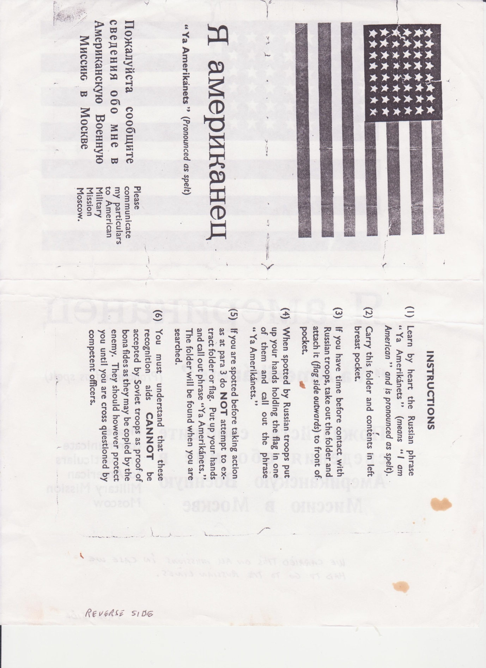

Provisions
Missions would often last six or seven hours. Lunch, if they had time, would consist of army ‘K rations’ – typically, a small tin of Spam, cheese spread, crackers and a chocolate bar. Sometimes there would be high-energy candy, which crews might save up to give to local children living near the airfield.
Aircrews have given us vivid descriptions of flying their dangerous missions over Nazi occupied Europe.

A mission in a Flying Fortress
The USAAF bombers flew daytime missions, which meant a wake-up call anytime between 1.00 and 4.00 am, depending on the target; the earlier the call, the longer the mission. Crews were given a hearty breakfast to sustain them through the day ahead. They then went to the briefing hut, where flight routes and details of the mission were explained; officers were briefed separately from enlisted men. The equipment hut was next, to collect oxygen masks, chute harnesses, life jackets, heated suits and other essentials. At the parachute hut on the Eye airfield there was a sign, according to Hutch, “If it doesn’t work, bring it back”.
A jeep would take the crew and their equipment to the hardstand where the plane had been fuelled, loaded with bombs, flak protection gear, guns and ammunition.
Taking off
It was no mean feat to get this full load of around 56,000 pounds, into the air. Hutch describes the experience:
“There was a terrific roar over the countryside as pilots of thirty or more bombers gunned their four motors and carried out pre-flight checks to make sure they were prepared to get into line and lift their loaded B-17s into the air … the pilot had to reach a speed of over 110 mph before he dared to lift off the runway and climb into the crowded skies over England. Planes took off every thirty seconds, often climbing through zero visibility to assemble in squadron formation and on into their groups at their assigned altitudes. Lead planes used various coloured flares to identify their bomb group assembly location.”

Photograph: B17 taxies on runway at Eye
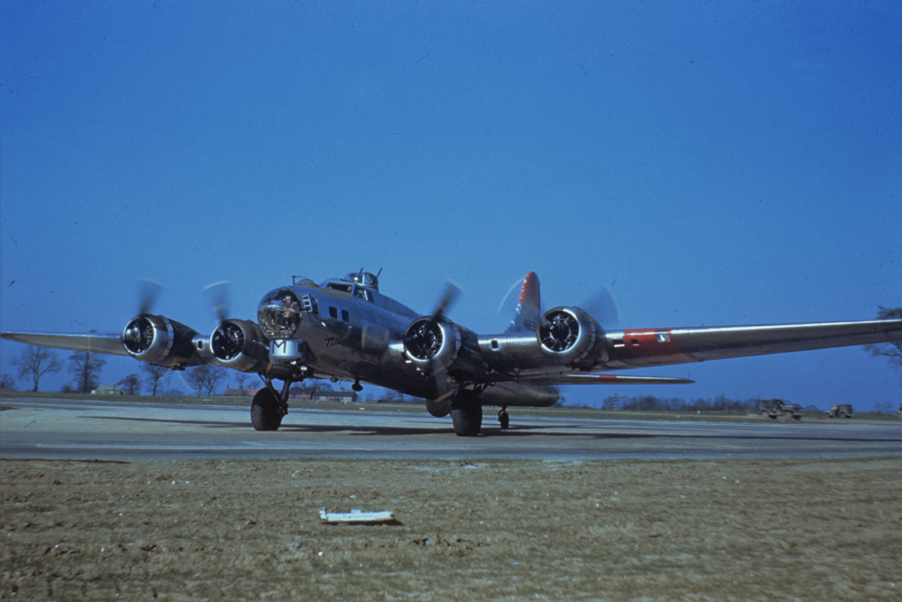

Sometimes there were accidents during take-off: planes might fail to lift off before the end of the runway, or collide mid-air as they strived to reach their assembly position, particularly when visibility was poor. This could mean “flaming wreckage of planes and live bombs falling back into the East Anglia countryside and twenty lost men”.
Once airborne, the planes would assemble in a tight box formation to deter enemy fighters flying between them. In each formation, three squadrons of bombers were layered horizontally and vertically, in high, middle and low positions to allow their bomb loads to be released simultaneously over the target. The middle squadron took the lead. Each squadron consisted of twelve to fifteen planes and an average formation occupied around a cubic mile of sky.
Photograph: B-17s of 490th Bomb Group flying in formation
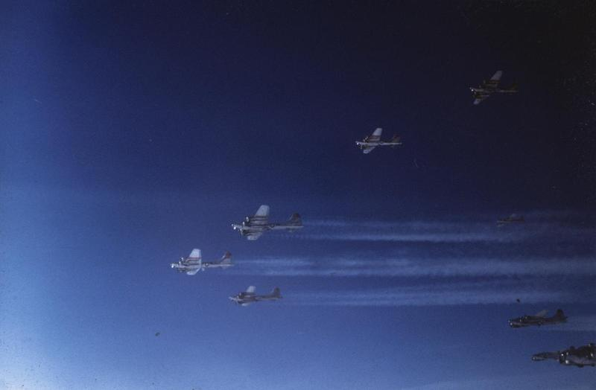
On the mission
Pilot Ray Hann of 849th Squadron describes a typical mission:
“Going over the channel was a breathing spell until we got over enemy territory. We could always see our fighter cover. Unless our group was first over, the target was usually black with flak. To be able to see the stuff for fifty miles or so, and know we were going straight into it, was something only we know …. The bomb bays open and we’re in the flak and a bunch of prayers are being said. Pieces of flak rattle when they hit the plane but all is forgotten except having a tight formation so that the trip won’t be in vain. At last, ‘bombs away’ it won’t be long now. A quick turn, an increase in speed, change in altitude and it’s all over.
The men check in any casualties and battle damage on the interphone. We then check out formation and change positions if any ships have gone down. Nothing to worry about except the lead navigator making good the flak alleys or fighters on route back. Everyone relaxes when we get back to allied territory.”
The return flights however, were also hazardous. Damaged planes had to be nursed home, some not making it back over the channel before having to attempt a landing, or ditch in the sea, or abandon ship and bail out. If weather conditions were bad, the risk of mid-air collision was still high with so many planes in the sky even if no longer in tight formation.

Mission accomplished
Photograph: B17 landing at Eye, guided by mobile control tower
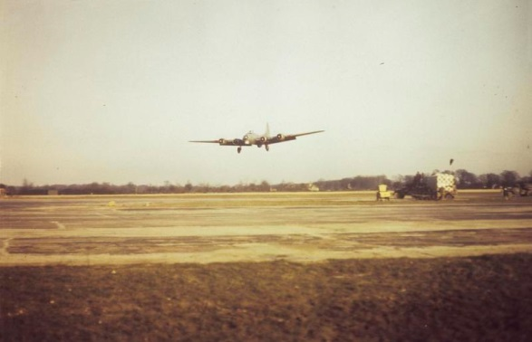
After returning from a six or seven hour mission, the day’s work was not yet over. Crews had to clean their machine guns and return them with parachutes and other equipment to the stores and then go into a de-briefing session. Intelligence personnel would interrogate them in detail on everything they had observed during the mission, particularly on enemy fighters and flak locations. Such information was passed on to the Eighth Air Force central intelligence to enable them to improve briefing material for future missions. During these interrogations the Red Cross would fortify them with coffee, cookies and a shot of scotch:
“for those who needed a boost after many hours of stress. That alcohol really gave us a lift. Some guys gave their drink to their buddies and there were some who were ‘lifted’ pretty high by the time they got to the Mess Hall”.
Aircrew members have left searing accounts of the dangers of flying these missions.

Surviving 35 missions
1st Lt. Charles Matthew Baffo was a pilot with the 490th, based in Eye from May to November 1944. He completed his combat training in Idaho in April 1944 and flew a B-24 to England via Florida, Trinidad, Brazil and then on to Dakar in Africa and Marrakesh. Over the Sahara there were no altitude restrictions:
“so I got down, I wanted to see the desert and what the camels looked like so I got down to 14,000 feet”.
The whole trip took almost two weeks. He landed at Land’s End and recalls having to pay “a quid” to the Red Cross volunteers for the coffee and donuts offered on arrival.
He then flew on to Eye, finding his first experience of navigating in England bewildering:
“There are no main distinguishing features, just patches of green all around you. A P47 escorted us and showed us how the get to the base. The first couple of days we were just flying around getting enough information so we could recognize it. If you came out of a cloud, you didn’t know where you were”.
Around mid-May he began ‘milk run’ missions with more experienced crews who had been brought in to help newcomers adjust. These early targets were not heavily defended and were just across the channel in France or Belgium. A few weeks after his arrival the B-24 Liberators were replaced by B-17 Flying Fortresses.
Pilots had to take off and manoeuvre the aircraft into formation before dawn without navigation lights. They had never practised this before in the US, but Baffo remembers being able to make out other aircraft by their turbochargers which would glow red hot in the night sky.
On D-Day, the mission was to drop bombs behind a line of bonfires lit by paratroopers who had landed the previous night. Visibility was poor and there was some confusion about “whether we had dropped the first load of bombs in the right place so we had to go back and load up again with more bombs, so we had to fly the same mission twice”. Turning back across the channel:
“I saw for the first time all the aircraft coming in and in the channel there were all these ships - hundreds of them - and the skies were full of airplanes, like mosquitoes. We must have been some of the early ones in, there were hundreds of aircraft behind us, all at the same altitude”.

Photograph: Charles Baffo
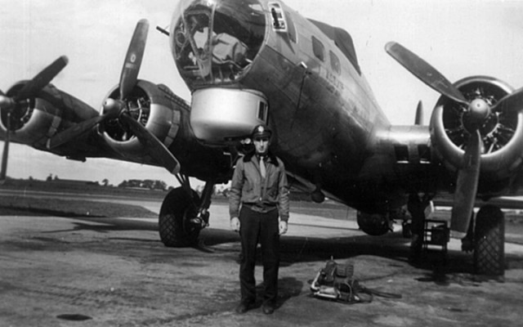

Charles Baffo remembers being forced to abandon one mission to Berlin on take-off:
“There were these damn chickens at the end of the runway and we flew through them. The guy ahead of me must have riled them up and one of them hit me in the engine and the engine caught fire. So that was the end of my flight to Berlin that day. I was known as the chicken chef.”
He got to know the farmer, Peter West’s father, whose house was across the road. “We would go for a walk and visit him and he would come over onto the base. He was a very proper Englishman … We would take him to the Astro Club and give him a pork chop sandwich so he could take it home to his wife”.
Off-duty, Charles remembers there was little to do: “You lay in your bunk, you learned to sleep, you learned to read, you’d ride a bicycle. On occasion you were allowed off base and you went into Eye to a pub. But there was nothing there … But you were just happy not to go on a mission. After a while you began to sweat it out. The flak would finally be getting to you”.
On one mission over Cologne, flak had pierced over a hundred holes in his fuselage, but none of any consequence and the plane was patched up. On a subsequent mission however, flak forced him down: “I lost an engine, I was spilling gas and could not get back to the base and with three engines I couldn’t stay with the group”. Escorted by two P51s he managed to get to Brussels, overshot the runway but landed safely with no-one hurt. While waiting four or five days for the aircraft to be repaired, the crew went into Brussels, which had just been liberated. They stayed in a hotel where US soldiers had been put up. He remembers there being very little food, apart from stewed rabbit which tasted “like shoe leather”. They had money in their escape kit “but there was nothing to buy but champagne. So we bought champagne with our escape money”.
Lt. Baffo completed his 35 missions in November 1944 and had a week or so off before flying home from Scotland. “You could travel anywhere you wanted at no cost so I just rode the train and travelled all over England. On one occasion I met a very lovely English girl – I still think of her – who invited me to stay at her house. Her dad was a general who she said would welcome an opportunity to talk with an American. But I said ‘I gotta go home to my mommy’”.
Charles Baffo died on 17th October 2014, at the age of 92. Two months later, the French Government posthumously awarded him the Légion d’Honneur, which is bestowed on “eligible U.S. veterans of WWII who contributed significantly to the liberation of France from 1944 to 1945.”

Baptism of fire
Pilot Ray Hann recorded his first mission in his diary:
“October 2, 1944 Kassel, Germany
This was a day to remember. It was the first combat mission for the crew and my first as first pilot. The flak was heavy over the target. We were bombing the marshalling yards. There was a big black puff of smoke in front of our nose and number three engine was on fire. We opened the cowlings, cut the engine and dove about 1500’ until the fire was out. Fortunately there were not any fighters in the area and we were able to climb back to our group. We had taken some hits, but aside from the engine being out, everything seemed to be okay. We were about half way across the channel when we spotted a hole in the left wing and a blue flame coming out of it. We got away from the formation and called in Mayday to the Group tower. We were almost to the English coast by then and letting down. The lower we got the heavier the flames until it seemed the whole wing was on fire. When we were at altitude there was much less oxygen to feed the flame. As we neared the field the blaze had spread over the entire wing and I knew there was very little time to get out of that plane. I came in on the first runway that I saw that just happened to be a 1500’ runway and downwind. All the fire trucks and equipment of course were waiting for us on the upwind runway. The crew scrambled out before the plane stopped, but I still had all the electrical wires and parachute on. It seemed an eternity before I got out.
Photograph: B17s of 490th Bomb Group in formation, one aircraft smoking
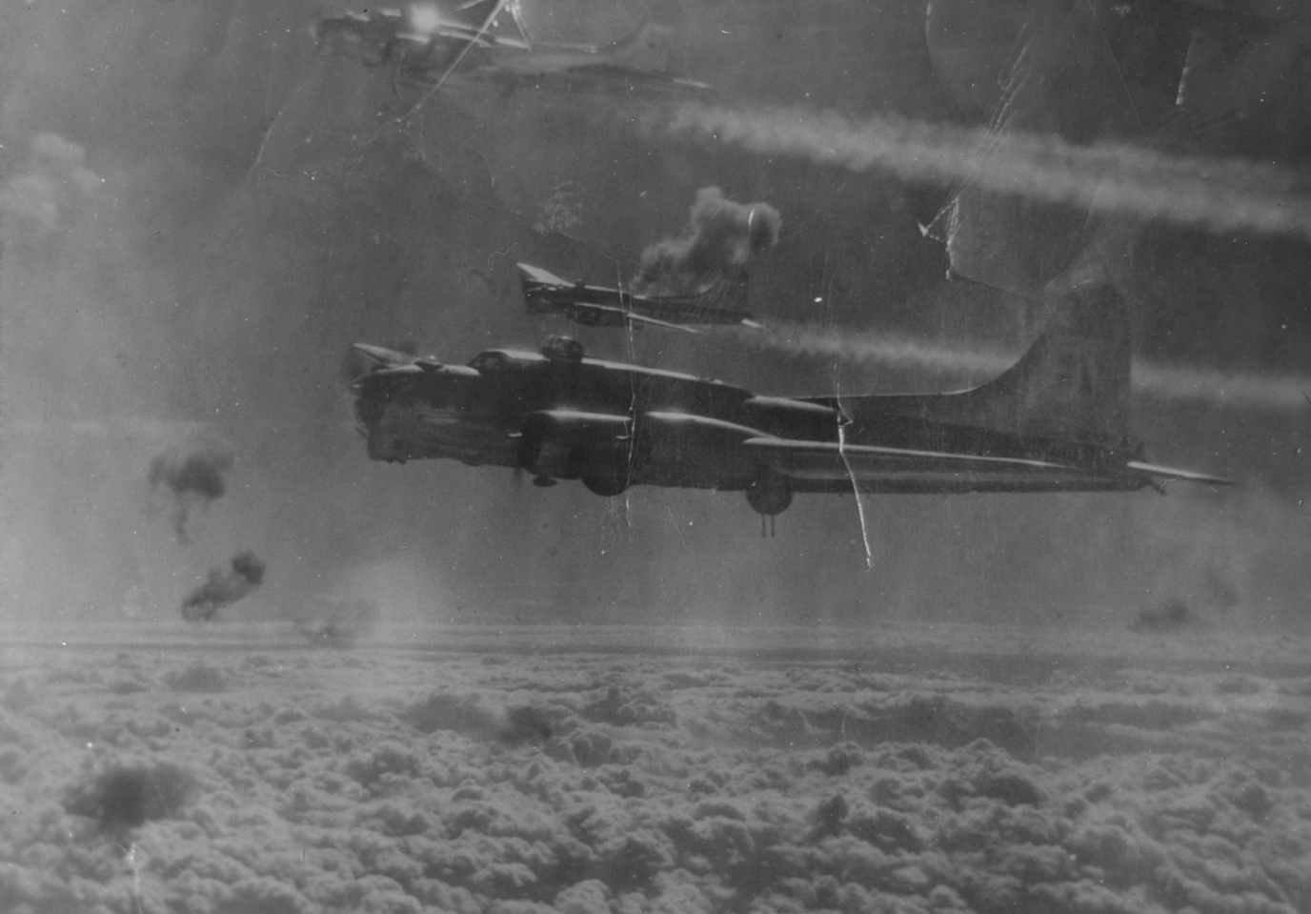
“I didn’t even go to the briefing. When they passed out our ration of scotch both [Mike] Quagliano [radio operator] and [Milo] Simicek [tail gunner] gave me theirs. What a way to start our tour. I understand that the air force photographers were taking pictures.”

Photograph: Ray Hann and crew
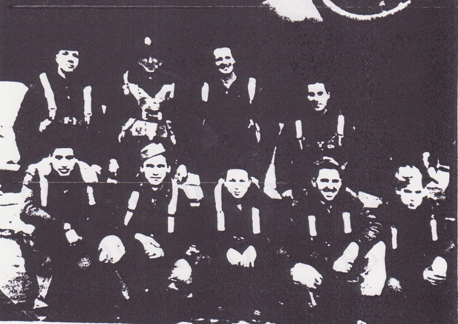
L-R Standing: Emanuel J. Johnson, Navigator; Pat McEwan, Co-Pilot; Ray E. Hann, Pilot; Douglas M. Cooper, Bombardier. L-R Kneeling: Michael C. Quagliano, Radio Operator; Milas Simecek, Tail Gunner; Francis N. Christmas, Top Turret; James J. Morrison, Waist Gunner; Arthur C. Dersham, Ball Turret.

The German 88 mm Anti-aircraft Gun
The British term “flak” for anti-aircraft fire emanates from the German word “FliegerAbwehrKanone”
The Krupp 88 mm gun with a crew of up to eight soldiers was an effective and much feared weapon. It was first developed as early as 1928 in collaboration with the Swedish Bofors company. It was produced in 1934 and was deployed during the course of the Spanish civil war in 1936. In that conflict it demonstrated its ability to destroy aircraft in flight and was shown to be equally effective against armoured vehicles and tanks. Between 1939 and 1945 it underwent a number of variations.
The gun had many strengths. It was highly mobile. From its cruciform pivotal mount it could fire as needed in any direction. From the firing mode it could be converted to its travelling mode by raising the two cruciform sides and attaching a single two wheeled trailer at the front and rear of the gun. This could be done in less than three and a half minutes. It could be returned to the firing mode in less than two and a half minutes. It could fire seven or eight shells a minute. As the bombing over Germany intensified, the radar-directed AA batteries of 88’s were increased to eight guns. The Wurzburg radar system gave each battery the ability to transmit the necessary aiming data on to the indicator on the mount of each of its guns. When a moving enemy aircraft was sighted each gun in the battery was able to lock on to its flight path. With a fair degree of accuracy and without difficulty it could project its shells up to and as necessary beyond the operating height of the attacking bomber aircraft. The batteries were supported by search lights which were also radar controlled.
The gun had a maximum elevation of 85 degrees.
The types of shell which were fired by the 88’s were developed throughout the war. The final variation was incendiary, contained shrapnel in a thin case and was time fused. It could inflict fearful damage. It was fortunate that it was developed almost at the war’s end when it was too late to issue them in large numbers.
The 88 mm weapon was equally effective as a tank destroyer. It could take out all types of allied tank including the formidable Russian built T34. It would pierce up to 152 mm of armour at 1500 metres.
The Germans produced some 18,000 of these guns during the course of the war. The intensity of the bombing over Germany necessitated the concentration of a large number of 88s to defend the heartland of the Reich. This reduced the numbers available for use on the Russian front.
Although effective the gun did have its problems. It was a complicated weapon to maintain. Its empty shell cases could on occasions jam in the breech after a round had been fired. The gun had a high profile and could not be concealed quickly. It was heavy to pull. Despite these disadvantages it was a dangerous and highly effective weapon of war.
During the course of the conflict some 12,000 allied heavy bombers were destroyed by enemy action over Europe. 100,000 aircrew lost their lives. In no small part this heavy price was due to the 88 mm gun.

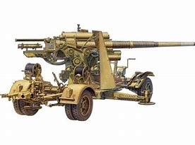

The winter of 1944/5 was particularly harsh and aircrews struggled in the adverse weather to complete their missions. Ray Hann records an abandoned mission on Christmas Day:
“December 25, 1944 Ahrweiler, Germany
A Christmas we will never forget. It was so foggy that I couldn’t see the wing tips. The ground was slippery from ice and hoarfrost. I had [Francis] Christmas [top turret] go out and line the plane up straight on the runway. All I had to do was take off using the direction indicator and a prayer. When I hit about 75 mph I knew we were off the runway. I couldn’t lift off at that speed so I throttled back and yelled to Pat [McEwen, co-pilot] to pull the wheels out from under us. Christmas fired a flare and about that time it felt like we had gone over a stump or something. Number 2 engine was smoking and we came to a sudden stop. I tried to climb out, but between the wires, chutes etc., I seemed to be stuck. I unbuckled the chute and pulled loose from the wires and I jumped through the door. It was a short distance because the wheels had been pulled up. I jumped into a pond covered with ice. When I tried to scramble out the ice would give way and I knew the plane would blow up. Somebody helped me out and we all ran and hid behind a large mound of dirt. It seemed like an eternity before a couple of jeeps picked us up. They scrubbed the mission at that point. None of the crew was hurt, at least physically. Merry Christmas. I met with Col. Bostrom and he sent us on a 48hr pass. I got a bottle of Johnny Walker red label and headed for London.”

Photograph: Snow on Eye airfield

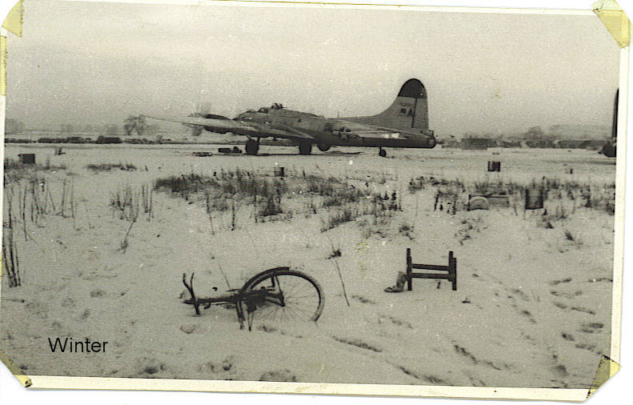

A week later he and the crew were given a welcome break:
“January 3, 1945
I guess they figured we had enough or we were all flak happy so they sent us to a rest home at Land’s End, England. I was to meet with Ben Lyon and Bebe Daniels to broadcast back to the States. They were movie stars and Ben was the public relations official for the 8th Air Force. I spoke about what it was like to go through a mission. They are going to notify the parents of the crew when it would be broadcast. We had a week of horseback riding, shot skeet, movies, dances, girls, girls and more girls. It was the only time I ever saw [Emanuel] Johnson [navigator] drunk. After a week of that I was anxious to get back and get this tour over with.”
Returning to base, they found they had lost some friends while they had been away relaxing:
“We had a new crew in our hut. Hodges had gone down along with McGee, Woods, Ward and McGrath while we were gone. Hodges was flying my position.”

Other diaries reveal the crews’ relentless drive to survive their quota of missions.

Countdown to survival
Norman C. Borgman kept a meticulous log of every mission he flew, each ending with a tally of the number completed and the number still to achieve and to survive. He was the tail gunner of pilot Gerald Leland’s crew in the 851st bomb squadron. The following extracts are from his diary.
“January 5 1945: First experience with war at first hand. 2 planes in low formation collided in mid-air after bomb-run. One plane cut squarely in half – blown to bits practically covering the sky with parts – second plane went down in flat spin – one burst of flame followed by another burst which enveloped entire plane. 3 chutes seen – all others believed gone down (15 men). One man to get out was Major Blum – was blown completely out of ship. No other news – rumoured that 4th chute burned.
“January 16: [After bombing the target] … We start back with everyone relaxing. As we cross the Rhine we are hit with an accurate flak barrage. Holes thru bomb bay door, left wing, tail rudder (again) one hit on the ball turret and the right oxygen supply is hit, cutting it off. We all switch over to the right hand supply and Showalter comes out of ball. Everybody is okay although everyone but the Navigator had their flak suit off. No fighter opposition and our fighter support was excellent. As we got to the channel we are notified that the weather has “socked in” at our field and we cannot land there. We have to fly to RAF [base] and land and stay there for the night. We are the first ship to land and before the squadron is in we have driven the Limeys almost crazy because of our formation landings. We sleep good though, as we are dog tired after 25 hours of flying in 3 days. 3 down and 32 to go.
“January 28: Take off at 8.45 at which time we are in the midst of a terrific snowstorm but nevertheless we taxi out of our hardstand. Between snow flurries we take off. After 18 ships are off, the rest are ordered scrubbed. We try to find our squadron but cannot so we take off over the channel alone trying to overtake them. When we reach the Netherlands we still have not caught them so shortly before the I.P. [Initial Point] we tack on with an 8 ship element which later proves to be the 432nd Group. At the target area there is very accurate flak ranging from moderate to intense. We are lucky though and get no hits, in fact very little of the flak. On the way back we go with the group part-way as a protective measure against enemy fighters. At the channel we start off on our own. We land in practically another snowstorm – some narrow misses with other aircraft but we get down okay. 5 down and 30 to go.
“February 15: It is another deep penetration going within 40 miles of the Russian front line … an extremely uncomfortable mission because of the long time on oxygen…
“P.S. A great deal of excitement in the morning as a plane caught fire in a nearby hardstand loaded with bombs. Everyone took off for cover as we were afraid bombs would cook off.
“Flak and 50s were going off like 4th of July celebrations but it did not blow up completely. The entire nose was destroyed though. 9 down and 26 to go.
“February 23: Returning from target … As we hit the channel we get into thick overcast again and almost lose our formation. At one time we are within 50 feet of the water to get below the ceiling … At the field it is very bad with planes all over the sky and we really have some close ones. On landing, when we are 25 feet from the ground our wing goes down in a 40° bank and it takes both pilot and co-pilot to straighten it out. A bumpy landing but we are back. Another one gone. 15 down and 20 to go.

Photograph: Extract from Norman C. Borgman’s diary
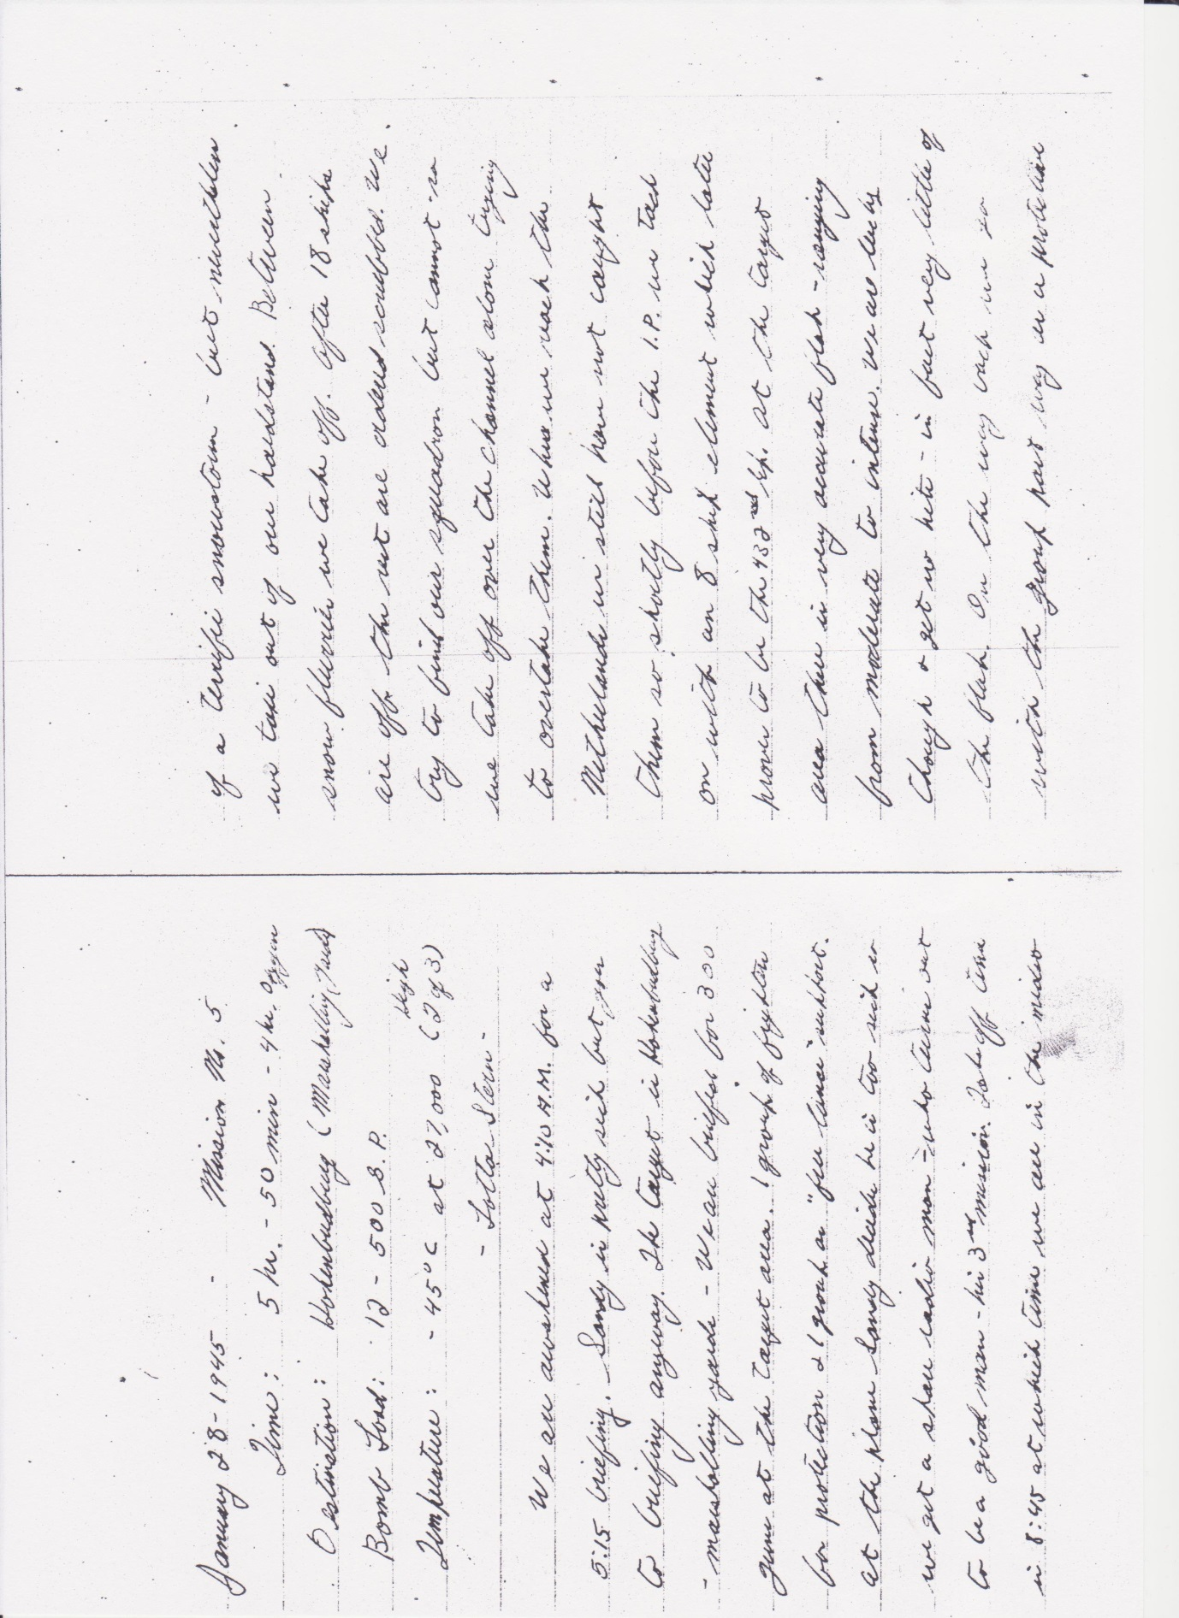

Photograph: Norman Borgman and the crew of ‘Lotta Stern’ of 851st Bomb Squadron, February 1945
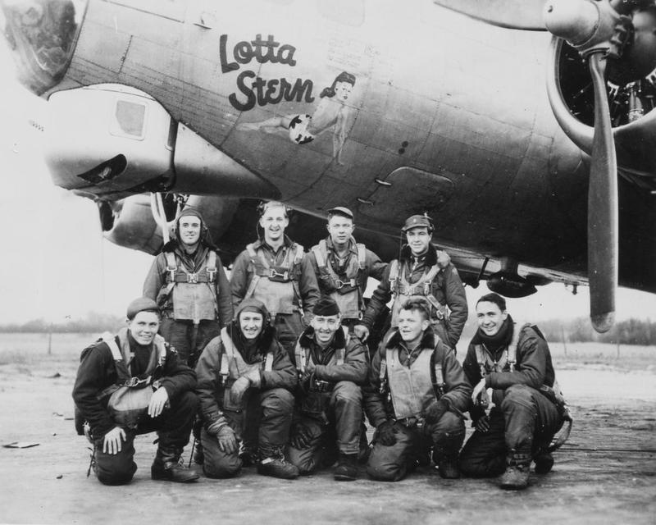
` L-R Standing: Chas Molloy, Navigator; John Smith, Co-pilot; Gerald Leland, Pilot; Donald Hale, Bombardier. L-R Kneeling: Robert Showalter, Ball Turret Gunner; Norman Borgman, Tail Gunner; Milton Sanford, Radio Operator; Gordon Handrell, Flight Engineer; Russell March, Waist Gunner.

“March 9: Just before bombs are away we start to get flak. It is quite heavy and in relation to our plane, is very accurate. One blast hit our left wing tip and many others were so close they lifted me off my seat. It seemed that each blast would come right up through the plane. We later found approximately 125 holes in the wings with one piece going thru the radio room narrowly missing Sandy. Another piece hit the cowling on number one engine but luckily did not seriously damage it.
“About 10 minutes from the target area a Fort in the group ahead of us blew up – evidently as a result of damage incurred by the flak. We saw 4 chutes but estimates seen all the way to 9. Could watch the plane all the way to the ground and it hit with a horrible burst of flames.
“One of our planes in the low squadron was hit very hard. 2 engines shot out and oxygen system gone and the radio operator and navigator seriously injured. They landed on the continent. 22 down and 13 to go.
“April 7: Our target is Parchim, a jet airfield quite a long haul into Germany with fighters expected … Shortly after reaching enemy territory Gerry [pilot] gets a report over VHF that a group in A division ahead of us have been hit by fighters so we are all put on the alert. Shortly after that we get our visitors.
“The first pass in by a FW-190 who came out of the sun and passed under our formation so fast no-one in the group has a chance to fire and neither does he. There are quite a few fighters around us but they stay away. Two ships in the group ahead are seen to blow up. Probably hit by fighters. 3 chutes are seen.
“All of a sudden [Mandy] opens up from the upper turret on an ME109 making a pass at our lead ship from 3.00. He slides over the top of our plane and continues on to hit the high squadron above and to our right. He hits one plane on the No 2 engine breaks out in flames. The ME 109 is hit – a wing comes off and bursts into flames. At the same time a FW 190 is shot down by the high squadron.
“The B-17 which is hit leaves formation and chutes start to appear. The plane slides to our rear with two engines feathered the tail practically shot off and the wing burning. Chutes are still coming out and the last man seen to leave comes out with the bombs. Evidently almost everyone got out but in enemy territory. Another ship in the high squadron is evidently hit too as it leaves formation and heads back – have not heard from it as yet.
“After that our bomb run is free of fighters and we drop the bombs at 15,000 completely wiping out the airfield. The way back is uneventful although we still keep an alert watch.
“Entire crew are interrogated and we put in a claim for Mandy – hope it goes thru…Our most exciting mission to date … So it’s another one under our belt. 29 down and 6 to go.”
Norman’s last combat mission (no 31) was on April 20: “a milk run as no fighters are encountered and no flak … ended up with a beautiful landing. A swell mission – one of our easiest.”
His last three missions were at low altitude, dropping rations over the Netherlands and the final diary entry, dated May 2 ends:
“All the Dutch people can be plainly seen waving flags etc. A very rough mission because of the low altitude and some stormy weather. But at least a mission on which we did some good”.

Messerschmitt Bf 109
The most effective German fighter aircraft was the Messerschmitt Bf 109. Although during the course of the war it went through a number of modifications, it retained its basic design. In the 1930s and 40s it was one of the first modern fighter aircraft. It had a closed canopy for the pilot, retractable landing gear and a liquid cooled and inverted V12 aero engine. It was active in the Spanish civil war and was used by the German Luftwaffe until the war’s end in 1945.
Its original purpose was to intercept enemy aircraft. As later models were developed the ME 109 was allotted other tasks. It was used to escort bombers, to operate as a fighter bomber, an all-weather fighter, a ground attack aircraft and for reconnaissance missions. It was supplied to a number of Germany’s war time allies and operated with several other countries after the war and until the early 1960’s. From 1936 until 1945 33,984 ME 109’s were produced. 14,152 such aircraft were built in 1944 alone.
By continuing development and modification, the ME 109 remained a threat to allied aircraft until the end of the war. It became the backbone of the Luftwaffe’s day fighter force.
The first prototype was ready by May 1935. However the German engines were not yet ready. It is now hard to believe that with a gathering prospect of war four Rolls Royce Kestrel V1 engines were obtained from the UK. With a British engine, the prototype ME 109 made its maiden flight at the end of May. In the summer of 1935 the German Jumo engines were produced. A year later the first ME109 with its newly installed German engine was enabled to fly. By 1939, immediately prior to the German blitzkrieg on Poland, the Luftwaffe had built some1000 ME 109’s.
At the test stage most pilots were critical. They preferred the open cockpit, low wing loading and easy handling of the aircraft to which they had been accustomed. When on a flat surface the ME 109 had its nose at a fairly steep angle to the ground. This gave the pilot a problem in that from his cockpit he had some difficulty in gaining a frontal view of his take off route ahead. To be able to gain a view he had to zig zag down the run way. They were also concerned that the cockpit opened at the side of the aircraft and would not open in flight. A further worry was that the automatic leading edge wing slats might make an unintended opening during combat or aerobatics and thus lead to a possible crash. The landing gear wheels were attached to the fuselage at an angle of 85 degrees. It therefore followed that the pilot needed to land evenly on both wheels. If he landed unevenly and too much stress was placed on the angled single wheel it was likely to crumple under the weight of the whole plane. However following the test pilot’s demonstration of the 109’s capabilities in flight, the German authorities ruled in its favour. The news that the British Spitfire had been put into production catalysed the decision to adopt and produce the 109 on an urgent basis.
During the battle of Britain in 1940, the Spitfire and the ME109 were almost evenly matched. The 109s were limited by their flight range which was 373 miles. This did not allow them much of a margin by the time they had arrived over the UK. During the whole period of the blitz over this country, Spitfires and Hurricanes were able to land and refuel on airfields which were relatively very close. The 109s did not have this facility. They did however have a much faster rate of climb together with the ability to carry out a sustained and fast dive from a much greater height. In this respect they had a signal advantage which was due to the fuel injection system having a constant flow when negative gravity applied in a steep dive. For its time it was undoubtedly a first class fighter aircraft.
In the Battle of Britain from July to October 1940 a total of 591 ME109’s were brought down. This was against a total loss of 342 Spitfires.
It may well be that because the performance of the two fighters was so close, their success or otherwise may have depended upon pilot experience, numbers of their aircraft in the sky, tactics and position prior to an engagement.

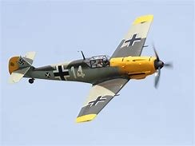

“Lucky or miraculous”
Another pilot who successfully completed 35 missions from Eye was Clyde W Thompson, serving with the 848th Bomb Squadron. He remembers:
“Drama in the cockpit: we had a target that was kinda nasty. My co-pilot and I had a rule. I would take off and land and fly the bomb run and he would spell me off every 20 minutes when we were flying in formation. Always he hated to look at the flak. When we were on a bomb run he would hunker down in his seat and pull his helmet down over his eyes and just watch the instruments in front of him, pretending he was the engineer.
“We took a heavy hit in the nose and the first thing I saw was a foot shard of steel hanging off the astrodome swinging back and forth. It made the navigator kinda nervous. At the same time there was a lot of glass flying around the cockpit and the next thing I knew, all four engines stopped. The propeller stopped turning. And you should’ve seen the reaction of my co-pilot. All those dials went flop back to zero. He came up like this and his hat flew back into the bomb bay and he was looking at me ‘what’s wrong?’ Just then they all started turning again. The engines came on full power … What happened was the flak had hit the switches, cut all the wires and they proceeded to re-wire themselves. I’d say that’s lucky or miraculous, I don’t know which.
“Then you have the tragedy. It was October 6 1944. I only had what I call one serious day flying in combat. (It was) about the 17th out of the 35 missions and we were scheduled for Berlin. We got out all the way to the IP without any problem. Just as we hit the IP the flak hit us, my left wing and right on the left side of the flank [aircraft]. There was a big explosion on his aircraft which threw him upside down and he was coming down flat right on top of me. Fortunately I was able to skip down to the left and get out of his way so he cleared. That plane went down in a spin and 8 chutes came out but I saw from the record only the pilot survived.
“So meantime we get back on the run and we got our own dose of flak and we lost No. 1 engine and No. 3 got hit … so we were running on 2 ¼ engines and the loneliest feeling I’ve ever had was when my squadron pulled away and I’m out there all by myself, the whole sky. So I punched the fighter button and called for the blue angels. I don’t think it was 39 seconds when I had four 51s on my wing and they took me all the way to the channel.
“Once we got across [the channel, heading] to the base at Eye I called for a straight in approach, but I made the mistake of saying ‘I’ve only got one wheel and a couple of engines, no flap, no tail wheel, no hydraulic’ and the colonel came on and he said ‘You get that pile of junk outta here. I don’t want it screwing up my runways.’ And again I’m out there all by myself, they didn’t care about me. By this time I was down to about 200 feet. We went down to Whitbridge [sic] which was 20 minutes and got there in time, before we hit the ground, that is. So we made it. We had everything in our favour – a light crosswind at the same side as the wheel was good. I had an engine out on the left side which let me hold the wing up and I could side-slip into the wind. The wind couldn’t have been better. We had the best landing we ever had on one wheel. Now that’s luck.”
The USAAF Fighter Mustang P51

The heavy losses incurred in the USAAF bombing missions to Schweinfurt and Regensburg in 1943 (see page 00), had shown the need for a long range fighter escort which could operate at the cruising altitude of the B-17.
The Thunderbolt fighter lacked the flying range to provide an escort to many of the target areas. The Luftwaffe only had to delay their attacks on the approaching bombers until lack of fuel compelled the escorts to return to base. At that time the USAAF Lockheed Lightning had the range but was only available in relatively small numbers as its engine was complicated and difficult to maintain and repair.
The answer to the problem lay in the single-seater Mustang P51 fighter plane which had first taken to the skies in 1940. With its additional wing mounted fuel tanks it had been designed as a long range fighter escort. It was a high performance aircraft which could fly and operate at up to almost 42,000 feet. It had the added advantage of being able to operate as a ground attack fighter bomber.
It became operational in Europe in December 1943 and by the spring of 1944 the modified P51D arrived in large numbers. The modified version included four primary improvements. The pilot was provided with a raised bubble shaped canopy which gave him the advantage of all round vision. His .50 calibre machine guns were increased from four to six and he was provided with the much improved K14 gun sight. His guns were fitted with a simplified ammunition feed system which resulted in fewer jams and misfires. Some 8,000 of these Mustang fighters were built before the end of the war.
Neither the Focke Wulf nor the Messerschmitt Bf 109 was a match for the new Mustang. The Focke Wolf was over burdened by its heavy weapons and could perform less well at the cruising altitude of the American bombers. While the ME109 could operate at a high altitude it also was affected by the weight of its armaments. Both were vulnerable to an attacking Mustang.
Early in their deployment over Europe it was thought better to advance the Mustangs in front of the B-17 bomber formations and to intercept the Luftwaffe fighters while they were taking off or establishing their positions in their respective attacking groups. This plan was immediately effective and the Germans lost nearly one fifth of their fighter pilots in the first week of this new tactic.
The Luftwaffe response was to deploy a screen of light fighters to attract and divert the Mustang escorts. As soon as the Mustangs were thus otherwise engaged a “sturmgruppe” of heavily armed Focke Wulfs would attack the incoming B-17’s by closing up to its rear and raking the length of the aircraft with fire. When it worked this strategy was very successful, but the USAAF replied with a series of raids which were designed to take out the Luftwaffe airfields and to destroy its aircraft on the ground. The increasing numbers of the Mustang P51’s were to become decisive in nullifying the German fighter plane resource. By July 1944, the allies had in effect won the war against the Luftwaffe. The allied invasion of Normandy was thus largely unimpeded by attack from the air. Similarly, the allied bombing of the German communication centres, factories and military targets could progress unopposed from enemy fighter opposition.
The Mustang played a large part in the successful suppression of the Luftwaffe’s fighter resource.

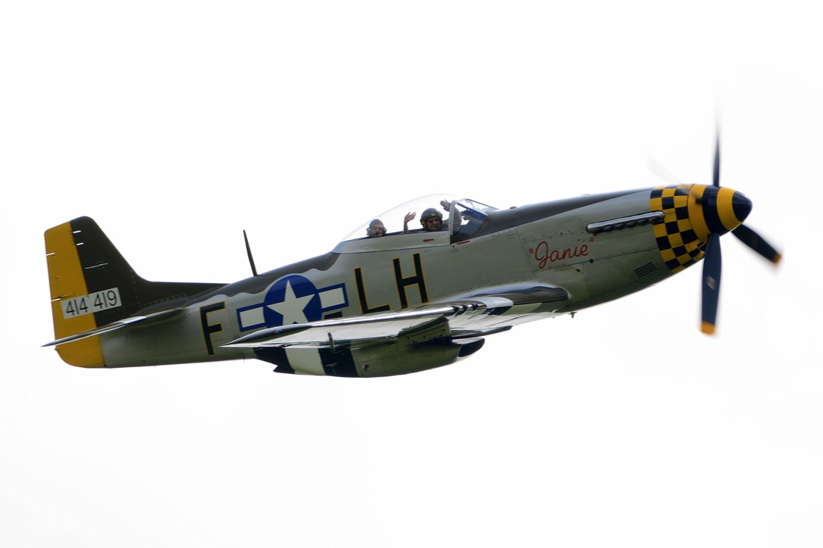

The tragic crashes around Eye
Several terrible crashes happened around Eye. Some occurred on take-off, others were badly damaged aircraft attempting to get back home. Local residents witnessed these crashes and tell chilling stories of what they experienced.
Peter West remembers:
“In 1943 a Flying Fortress from Thorpe Abbotts airfield crashed on the road killing three local workmen and a horse as well as the crew of 10.
“In 1944 two aircraft crashed at the end of the runway in Brome after failing to gain height. There were no casualties in the first crash, but a fortnight later a plane crashed and exploded killing the crew of 10. A few days later, a Mustang fighter crashed into the kitchen of the village shop while attempting to land. (See page 65 for the pilot’s account).
“A mid-air collision between two bombers with the loss of 17 crew members, (three parachuted to safety) is still too horrible to think about. The bombs they were carrying on the planes exploded when they hit the ground. One landed on our cattle shed which is no more. In the spring of 1945, another Mustang crashed into a tree behind the farmyard killing the pilot.
“On the 29th July 1944, I witnessed a Liberator Bomber returning to land with only two engines working. It failed to reach the runway and glided over a row of oak trees knocking the tops off before crashing on the road outside the Brome Swan. I was soon on my bike at the scene, but by the time I arrived, the plane was ablaze. I was amazed to see all the crew had escaped the inferno, although two of them died shortly afterwards.”

Norman Lock, a schoolboy at the time recounts:
“I remember on many occasions, about 100 USAAF bombers circling over Waterloo Woods, getting into formation for a bombing raid over Germany. Once, while I was watching from my bedroom window, I saw two Liberators collide and crash into the woods. They cordoned off the woods to stop schoolboys like me from snooping about. It is said that an arm was found with the watch still ticking on the wrist.
“On another occasion, a B-17 bomber crash landed near the Pennings. The crew managed to bail out, but two cows were killed in the crash. There were unexploded bombs lying about all over the place, and some of them ended up in the river.”
Eighth Air Force Bomber Stories, by Ian McLachlan and Russell J. Zorn tells the story of the crash at Brome crossroads:
“Wednesday, 10th November, 1943 started like any other day for Rose Wingfield. Despite work under way for a new bomber base at Eye, the war had impinged little on her life, although she welcomed the extra money earned by laundering for American airmen. Such tranquillity would shatter that day in circumstances Rose would never forget.
Rose tidied the house before deciding she needed some items from Brome village store. She cycled the short distance to the shop run by the sisters Ethel and Violet Fulcher. Chatting for a few minutes, Rose remarked on the mild weather- she still wore a summer dress and the mid-morning sun had made her journey from Number 20 Brome village very pleasant. It had gone 10.30 am when Rose left the shop and began pedalling homewards past the Old Rectory, now a country hotel named The Oaksmere. Here, the evidence of war was strangely signified by an avenue of stunted lime trees whose tops had been lopped off because they lay on the approach to the new airfield. Work on the big base, which was still under construction, had levelled woodland, demolished two cottages and obliterated Potash Lane. This spoiled surrounding drainage and Rose was not surprised to see four workmen ditching alongside the road. One of them stood at the roadside with a horse and tumbrel, while the others laboured in the ditch itself. Rose recognised old Charlie Burridge from Langton Green and called out a cheerful “Morning Charlie” as she went by, adding jokingly, “You are digging your own grave, are you Charlie?” Charlie paused. “I hope not, Ma’am”, he laughed.
Scarce had she left the scene when Rose was frightened by a tremendous roar overhead but behind and near the workmen. Leaping from her bicycle, Rose turned and stood transfixed, a terrified spectator powerless to prevent any of the rapidly –happening horror and barely safe herself. Less than fifty feet above and diving directly at the workmen was a huge bomber. Four anguished engines seemed to scream their last moments, and one was blazing fiercely. In those moments before the crashing crescendo of fire and death, Rose saw workmen fleeing for their lives, but their very existence was overwhelmed by 25 tons of doomed bomber. As the bomber smashed directly on to the road gang, its propellers knifed cleanly through the rearing, terror stricken horse, chopping the animal in half. Charlie Burridge, Walter Clarke and William Dixon died instantly. One of the workmen, possibly Ernie Barker, almost escaped. Rose saw a figure leaping for safety, only to be scythed down by the bomber’s wingtip. He died from his injuries two days later.
Stunned by the speed of events, Rose had hardly gained any composure before rescue vehicles hurtled onto the scene. A huge pall of acrid, black smoke billowed into a clear blue sky from the intense and angry phosphorous-fed flames. Within the inferno, ammunition cooked and exploded, sending stray bullets zinging across the landscape.... Rose realised she could help no one, and Military Police ushered shocked eyewitnesses and other spectators to safety.
The early hours of 10th November had found the pilot Lt. Arthur J. Reynolds and his crew flying the B-17 from Alconbury to Thorpe Abbotts. Cleared for departure, the B-17 began its final flight. Somewhere beyond the point of no return, the bomber’s number one engine caught fire. With the aircraft struggling to stay airborne but too low for parachutes, the best chance was the runway under construction at Eye. This lay almost directly ahead, and was closer than Thorpe Abbotts. Events overruled both skill and courage as flames seared through essential control cables and determined the fate of both aircrew and workers”.
Molly Ruth remembers another tragedy:
“I remember one night being in bed when as dawn was breaking there was a tremendous explosion. A part of the bedroom ceiling then caved in from the blast. My sister and I were very frightened. We were told later in the day the sad news that two B-17 bombers had crashed into one another some 800 yards away in Waterloo wood. Later in the day my father took my sister and myself to see the many pieces of wreckage which were both hanging in the blast shredded trees and on the ground. It all made a chilling sight and everybody was hugely saddened at the awful loss of the aircrew, all of whom had been killed”.
Not all crashes ended so tragically.

Dropping in for tea with Miss Ethel and Miss Violet Fulcher
John B. Guy was a fighter pilot based at Bury St Edmunds from January 1945. His role was to fly a P-51 which would accompany and protect B-17s on their bombing missions.
On 30th March 1945, he had been credited as the first pilot to shoot down a German jet. He said it helped to boost the morale of B-17 pilots: “to know we could shoot ‘em down if we could just catch them”.
Two days later, on Easter Sunday, his mission was called off and he was planning to go to church, when he was assigned a training flight instead. Afterwards he wrote to his wife:
“Well honey, you almost lost a husband today…. We went up and made passes on B-17s and rat-raced for about an hour. We started home then and were almost there when my engine started getting rough. Before I could even call my flight leader the engine quit cold. I was at 1000 feet then. There was a B-17 field [Eye] about 5 miles away on my left so I headed for it. I was lined up with a runway so I could put my wheels and flaps down to land. But – I was going down wind. I got down about 10 feet off the ground and the plane kept floating with the end of the runway getting closer. I saw I wasn’t going to make it so I pulled up my wheels and prayed. I hit the ground in a little pasture about 100 yards past the end of the runway, ploughed through a big hedgerow and finally ran into a house and stopped. I plowed [sic] a furrow about 100 yards long and almost tore my right wing off on some stumps. I was afraid the plane would catch fire and it seemed like it took me hours to get out. Two GIs came from somewhere and were helping me out almost before I stopped sliding. In a matter of seconds, ambulances, fire trucks and about 50 people were there. I’m alright though, it just shook me up a little bit. They couldn’t believe I wasn’t hurt and I couldn’t either for that matter. They took some pictures and a sargent [sic] promised he would send them to me.

Photograph: The P-51 crashed into Miss Fulcher’s shop
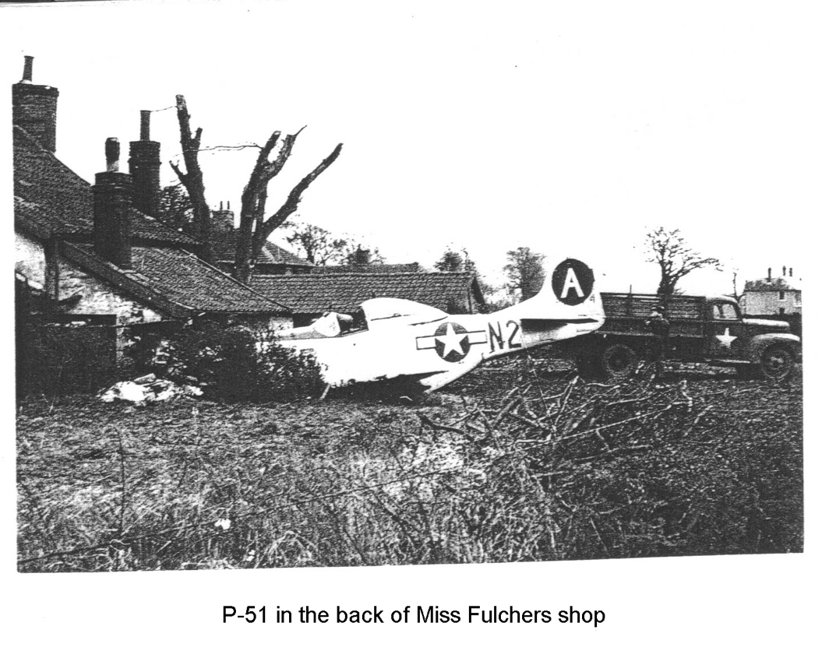

. I guess you’re wondering about the house. Two old ladies lived in the house and neither one of them was hurt. I only damaged one room. It was the kitchen and I knocked a hole about 6 feet across in the wall. It was right funny looking. There was the nose of the plane sticking into the room and a fire was still burning in the fireplace and on the same wall I went through was the china closet and (believe it or not) there wasn’t a dish or cup broken. The two old ladies were much more concerned about me than themselves or the house. Of course the Army will take care of the damage.
Photograph: Miss Fulcher with kettle in hand examining the damage
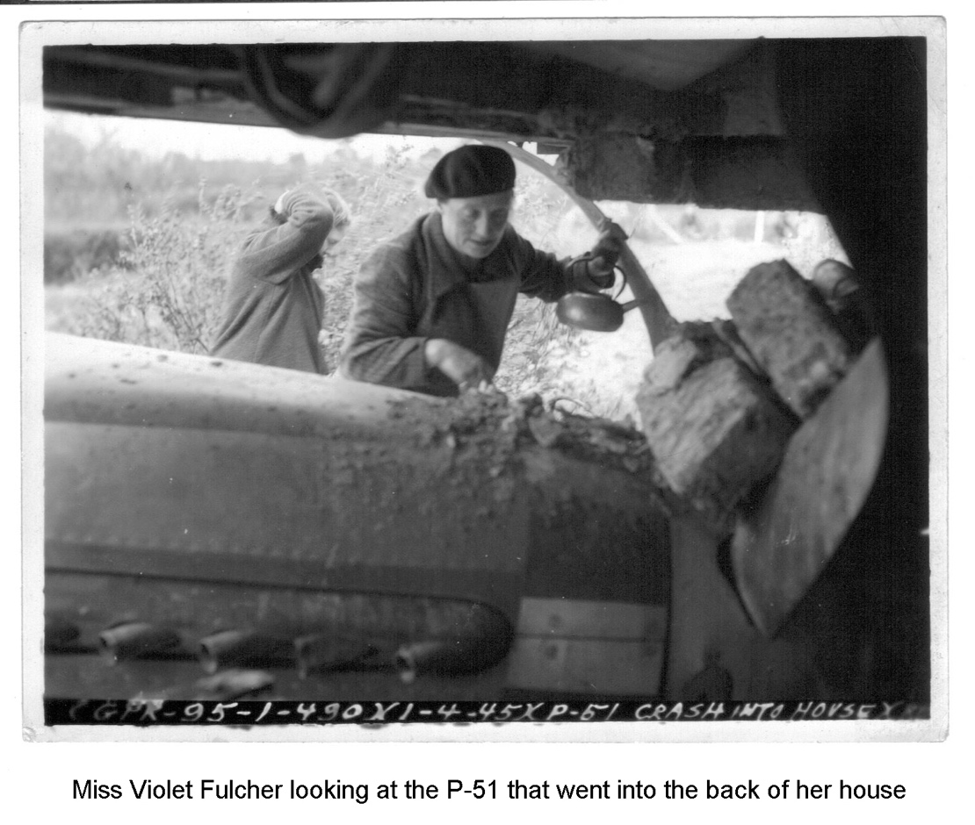
They were very nice to me at the field there and I ate dinner and hung around the Officers’ Club until they sent a jeep over from my field.”

Shot down over Germany
Many more planes went down over occupied Europe. Some aircrew who were shot down managed to survive by bailing out. The lucky ones were taken prisoner of war. The unlucky ones failed to land safely or were shot after capture by Nazi forces.

The fate of ‘Bombo’ and its crew
The B-17 nicknamed ‘Bombo’ of the 490th Group set off from Eye on 13th September 1944, heading for industrial targets near Ludwigshafen. The pilot was 1st Lt. Bob Funk. This was the crew’s third mission in a B-17, having previously carried out seven missions in B-24s. After releasing their bombs, the right side of the plane was hit by flak between the nose and the engines. The lead plane was also hit and fell some 5,000 feet. With his right fuel tanks on fire, Funk headed for France. After about 20 minutes, the aircraft became unstable and finally uncontrollable and the crew were ordered to bail out, while still over German territory.
Bombardier Rae Stokes left by the nose hatch, following the navigator Allen Quinn who had taken some persuasion to let go. They landed in a village where SS troops were billeted and received some unpleasant threats to their lives, but were spared and eventually taken as POWs to Stalag Luft 1 in Barth on the Baltic coast.
Steve Andrews was the aircraft’s radio operator and at 35, the oldest crew member. He had been hit in the face and knee by the blast although not seriously, but was in shock. The co-pilot Frank Heeden and flight engineer Tom Dobson helped him attach a chute to his harness and threw him out of the main escape hatch. They waited until they saw his chute open before bailing out themselves. He landed near the village of Fuerth, where a tank artillery regiment were billeting. After rudimentary questioning the commanding officer of the unit ordered Steve Andrews to be shot. He was buried in a shallow grave. Some of the villagers disinterred him and took him to their own cemetery.
Frank Heeden left the plane through the front escape hatch and he too landed safely near a village where an SS Division was stationed. After questioning by the commanding officer he was led out of the headquarters and driven away in a jeep. The villagers later found his body in a shallow hole and took him to their local cemetery where they buried him, contradicting the orders of the SS unit. At the end of the war in August 1945, his remains were disinterred and American experts concluded the cause of death had been multiple bullet wounds and fractures through the skull.
The tail gunner Charlie Fowlkes was the next to bail out and the remaining crew members watched his chute open, but never saw him again. Fifty years later his brother heard what had happened. An explosion in the plane’s fuel tanks dislodged part of the right wing tip which then flew across his parachute lines severing them and he fell to the ground. His empty chute and harness were found some distance from Charlie, whose body was taken by locals to the Fuerth cemetery and buried in the same grave as Steve Andrews.
Bob Lincoln the top turret gunner was in shock and failed to respond to the pilot’s repeated orders to bail out. He had removed his chute. Pilot Bob Funk tried to reattach him to the harness and pull him down into the nose section with him but without success. Bob Lincoln went down with the plane. His remains and identification were found when the site of the crash was excavated over fifty years later. They were sent to the US and buried with full military honours in the National Cemetery in St Louis, Missouri, his home town.
Ball turret gunner Bob Lawrence, flight engineer Tom Dobson and Bob Funk finally bailed out and all three landed near a village only a mile from Fuerth where Steve Andrews was shot. By contrast, they had a more sympathetic reception and were offered cigarettes by two officers of the local army unit, one of whom was 1st Lt. Dr Max Adenaeur, son of the post-war German Chancellor. They spent the remaining months of the war as POWs.

On the run in Germany
Co-pilot Lt. Gerald Lay and other crew members spent the evening of 24th November 1944 celebrating the 20th birthday of their pilot, Lt. Frank ‘Lefty’ Delmerico. They were not scheduled to fly the following day, a Saturday, so the party went on late. To their surprise and disgruntlement, an orderly shook them awake at four o’clock the next morning, insisting they would be flying. Only six crews out of 848th squadron had been selected for that day and they were one of the “lucky” ones. The 490th group was to lead the 8th Air Force on a raid to Merseberg to bomb an oil refinery and the six escorts were to throw out chaff over the target to baffle German radar. It was this crew’s second mission.
Over the target area, the sky was clear and the flak was heavy. Delmerico’s plane, ‘Pannsy Belle’ was hit first in number one engine, followed by a burst in front of the number two engine. This blasted a hole in the side of the plane next to the navigator John Fitzgerald, blowing off his oxygen mask. He was found unconscious by the crew chief, Corporal Omar Schiedt, who was able to replace the mask and quickly revive him. They were heading for home when Gerald noticed a stream of oil coming out of number three engine. With only one and a half engines functioning, the pilots decided they should lighten the plane as much as they could and instructed the crew to throw out anything loose that they could find. Then engine number four began leaking oil and the plane was rapidly losing altitude. They told the crew to bail out before it got too low for it to be safe. Gerald put on his chest pack parachute and was leaning forward to pick up his GI shoes, which he knew he would need on the ground instead of flying boots, when:
“a puff of white silk was all out in my face and I realised my parachute had been triggered and it was opening inside the cockpit. I forgot about the GI boots but grabbed up the parachute as best I could under the conditions and wrapped my arms around it to hold it from getting completely undone … I bailed out of the nose door and once I was clear of the plane I opened my arms up and released the parachute and it opened up safely.”
As he drifted to the ground he saw a road between two villages with a soldier on a motorcycle travelling along it. The soldier stopped, evidently having seen Gerald. Just when it seemed he would land in the motorcycle’s sidecar, a gust of wind carried him off the road up into a pine thicket where he came to rest, dangling from his parachute with toes barely touching the ground. He quickly released himself from the parachute and made off up into the woods escaping the soldier. In a dense briar patch amid the pines he found a sinkhole:
“While I was waiting for it to get dark I took stock of my situation … I was wearing a pair of long john underwear, a heated flying suit, my green army uniform pants, shirt and then over these was the fur lined flying pants and jacket. I was wearing heated boots inside the flying boots and I decided the heated suit would be of no benefit to me on the ground so I left it in the sinkhole, and I had some small hard candy that was vitamin enriched, a 45 automatic pistol, my pocket knife and that was about it”.
He ventured out into the darkness, walking westwards towards the front lines and could hear the boom of heavy artillery in the distance. He came to a stream eight to ten feet wide, too far to jump across; he decided to wade through it. By that time, everything was covered in a hard frost and it was cold:
“I pulled off those fleece-lined flying boots and the fleece-lined pants and rolled up my uniform pants as much as I could and bundled up my jacket, pants and shoes in my arms and started to wade into the stream. Well, the water was a little more swift and probably a little deeper than I had judged it to be … while I was trying to pull my pants up a bit higher I dropped one of my boots into the water. I knew I was in big trouble if I did not recover that boot.”
He waded on and tossed everything he was carrying onto the bank opposite and returned to retrieve the boot which he managed to do, but his clothes were completely drenched. He “stripped off bare” and put on the fur-lined trousers and jacket, and his boots, one wet, one dry. Gerald set off walking briskly to keep his blood circulating, carrying his wet clothes. By morning there were flurries of snow. He decided his wet clothing would not dry out while bundled up:
“one of the hardest things I have ever done was to strip back down in the cold air and put that ice cold, wet clothing back on … eventually my body heat did dry the clothing and I was able to be somewhat comfortable. I travelled through the wooded areas dodging villages until Tuesday night when another snow fell… .
“I decided I might need to find some place inside to get in out of the snow and cold. Just before I came to a small village, I did find some turnips in a field, they were frozen but they tasted pretty good when you hadn’t eaten anything in several days. Then I found an old apple tree that had some old knotty apples still hanging on it. So I got some of those.”
He walked on into the village looking for a church, but found a basement entrance at the back of a building down some steps. The door at the bottom opened into an area three foot square and about eight feet high. An inner door was nailed closed:
“I decided this was the place that I could stay…. All I could do was to stand or sit kind of curled up or lie down curled up in a ball because there was not enough room to stretch out. But it was inside and out of the weather. So I spent the rest of Tuesday night there and the next day all day.”
At nightfall on Wednesday he stepped out with the intention of travelling on, but the snow was melting and the ground had become muddy and slippery. After falling over several times he returned to his basement. The next morning two young boys discovered him, presumably having seen his muddy tracks. He handed over his revolver to the villagers who had followed the boys and was led to the local mayor’s house. They gave him a cup of coffee and a piece of toast, “the first real food I had had in over five days. So it tasted awfully good”.
After a ‘phone call and deliberations, Gerald was escorted out of the village by a uniformed person and they were met by a young German soldier on a bicycle. Although communication between them was difficult, he seemed to be friendly and took him to the town of Westerberg, a distance of about 7 km, and the office of a more senior officer. By this time, Gerald’s feet were so sore he could hardly walk and he pulled off his boots. When the German officer came in he was furious and hurled a stream of abuse at the weary and uncomprehending Gerald: “He finally made me understand that he wanted my boots back on and then he wanted me out of his office”.
Outside, Gerald was beginning to feel seriously unwell; the effects of cold, sleeplessness, lack of food and days of walking in unsuitable footwear were taking their toll and he slumped down. The German officer was insisting that he stand up when:
“suddenly I heard a lady in perfect English ask me what my trouble was. I told her I was feeling sick …. So she marched into his office and I could tell… she really let him have it. She was a friend who helped me and I really appreciated her help. I sat there and tried to recuperate”.
Later he was approached by two young boys who spoke English. The elder boy was asking questions:
“He wanted to know how much I got paid for bombing a school or hospital. They had been told the American flyers were all Chicago gangsters and that they got a bonus for bombing a school or hospital. Of course I tried to tell him differently but I don’t know if I made much headway there or not.”
The German officer arranged for Gerald to be taken by armed escort on a train to what he believed was either a French prisoner of war camp or a forced labour camp imported from France:
“Anyway, they were French and they treated me royally…. They gave me a bowl of hot soup or stew and did it ever taste so good. Then they fixed up some bread with cheese in it and wrapped it up to take with me the next day when I travelled.”
The next morning he was taken by train to Frankfort and the interrogation centre at Oberrusel, where he was put in solitary confinement. Fortunately his interrogation was brief: “ it didn’t take me long to convince him I was a greenhorn and didn’t know anything and was fresh from the States and there was no useful information he could get from me.”
From there he was put on another train to Wetzlar which was a POW distribution centre. Astonishingly, on that same train he found two other members of the crew: “There was Lefty and Fitz, the pilot and navigator. So, we were together then and this was a real joy to get to see someone I knew and someone I could talk to because these were the first people who could converse with me since I bailed out of that plane.”
At Wetzlar, the townspeople were far from friendly. It had been bombed the night before and was still smoking. The target had been a nearby gun barrel factory but the bombers missed it and hit the town instead. But at the camp they found friends, a crew that they had trained with. They stayed there for a few days and were given “real food and the chance to be together”. Then they were loaded onto a troop train heading for Berlin. By now it was 6th December. That evening they saw flares on either side of the train as they were pulling out of the rail yards of a small town. Some British pilots who were with them on the train confirmed they were from RAF bombers:
“Sure enough there were bombs going off and anti-aircraft fire started firing from flat cars located in the railroad yard. There was all kinds of noise, the flashing of guns, bombs going off on the left side of the train. Then I looked out the right side of the train and there were bombs going off on that side too, so we were right in the middle of an RAF raid. The train crept along just barely moving. The guards locked the doors of the car we were in and they got off our train and under flat cars of other trains all along the tracks next to us, some were jumping and taking cover in the ditches running parallel to the rails. The train did keep creeping along slowly and eventually we got through without a scratch.”
At daylight the next morning they pulled into the marshalling rail yard in Berlin. It was foggy and rainy, for which they were thankful. It was 7th December and they had speculated whether the boys back in England would be planning a bombing raid on Berlin to celebrate Pearl Harbour Day. They subsequently found out that one had indeed been planned, but was abandoned because of bad weather.
Later that day they pulled into Barth, a small city on the Baltic Sea. On a peninsular overlooking the sea on either side, was the prison camp Stalag 1.
Lt. Gerald Lay, his friends and some nine thousand other POWs spent the rest of the war there.
Six other members of the ‘Pannsy Belle’ crew parachuted safely and were taken prisoners of war. The tail gunner, Sgt Bob Newsome was killed in action.

Life as a POW
Lt John D Beach’s crew
A B-17 of 851 Bomb Squadron 490th Group was hit by flak on the 9th September 1944. The pilot Lt John Beach and co-pilot 2nd Lt John O. Terlecky were both killed by the flak before the plane crashed. The ball turret gunner S/Sgt James S Vogt died when struck by the tail section of the aircraft as he attempted to bail out. The parachute apparently never opened. He was later identified by other crew members for the Germans who captured them, where he was found lying near a farmhouse.
Lt. S.E. Beigler was flying as the navigator. He and Kenneth Wolfe bailed out and spent the war as German prisoners. Two other survivors of this shoot-down, Joseph L Milliken and Michael T Walsh Jr wrote after the war that the enlisted men were sent to Stalag Luft IV in the north of Germany, with the officer cadre sent elsewhere.
The POWs survived the cold winter of 1944-45 warmed only by “hot bricks made of a peat compound, watery green soup, hard bread and ersatz tea”. The international Red Cross supervised the prison camps closely and “around once a week the boys got Red Cross parcels that were divided among the men in each room, where about 20-21 men slept on straw mattresses on the floor.” These parcels usually contained items not available otherwise such as ‘chocolate bars, cigarettes, powdered coffee and powdered milk.’
There were roll calls held twice a day and if a POW did not answer to their name the whole group had to stand outside “in the cold and snow until they were found”. They were guarded by older German soldiers, too old to be on the front lines and ‘large shepherd dogs that were allowed to run loose in the camp at nights’. Before being liberated by the Wolverine Division they were force-marched in January 1945 away from the camps to avoid the advancing Russian army. Their columns were strafed and bombed by Allied airplanes while being moved but luckily there were no casualties.
Another crew member in the 851st squadron recorded in his diary for that day that Lt Beach’s crew had taken their place in the mission. Bombardier Bill Gaylor (‘Gabe’) wrote “didn’t fly today. Beach took our place and was shot down over Dusseldorf”. According to the diary, Beach’s plane had also received a severe battering during the previous day’s mission on 8th September: “Lots of flak. We didn’t get hit but Beach was shot up pretty bad”.

Those who never came home

“Home by Christmas”
In November 1944 co-pilot Lt Martin Meadows had nearly completed his quota of missions with the 850th Bomb Squadron. His letters home to his mother are filled with anticipation of his return:
“There is a very good possibility that I may be finishing up in few weeks. If I’m lucky I may even be home around the first of the year”.
He was especially looking forward to escaping the English weather:
“England is no place to be in the winter, I thought it was cold in Idaho last year but it was nothing compared to this. How they can get people to spend their whole lives on this island I don’t know. I’ll sure be glad to leave it when the time comes. We haven’t been able to get this hut we live in warm yet. It’s about the size of our living room and we have one stove about the size of a five gallon bucket to heat it. I’ve never worn long wool underwear before, but I just take mine off about once a week now to take a shower (cold water)”.
In his next letter of 25th November he writes of his recent promotion to 1st Lieutenant which gave him a “little raise in pay, that’s about all”. Warmer weather had meant he had been able to take off three layers of his long underwear, but it was not good enough to rely on flying back home when the time came:
“I had hopes of finishing up and getting home by Christmas, but I’m afraid I’ll be good to get home by the middle of Jan. I’ll probably have to go back by boat because of the bad flying weather over the ocean.”
This was his last letter home. With only three more missions to complete, he was in an aircraft which went down on 5th December. Although normally based at Eye, he was flying that day as lead crew in a B-17 with the 34th Bomb Group from Mendelsham. The Command pilot was on board so Martin Meadows took the tail gunner’s position. All crew members except the pilot died.

Photograph : Lt Martin Meadows’ last letter home
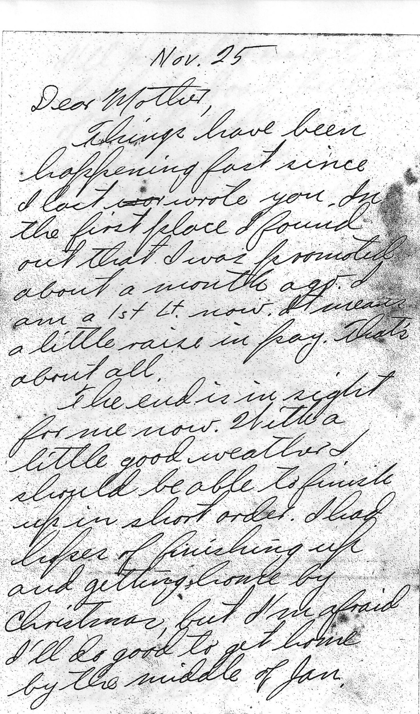

Photograph: the local newspaper report
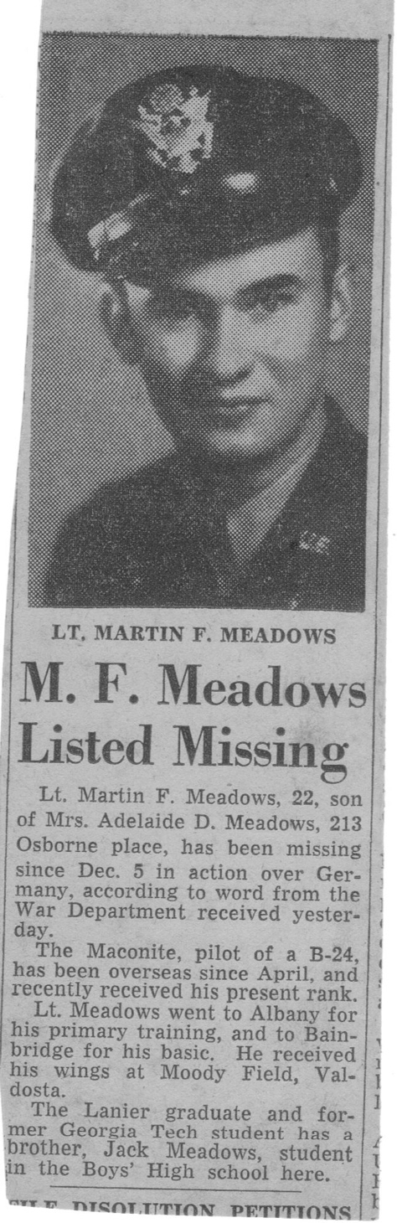

Photograph: the telegram
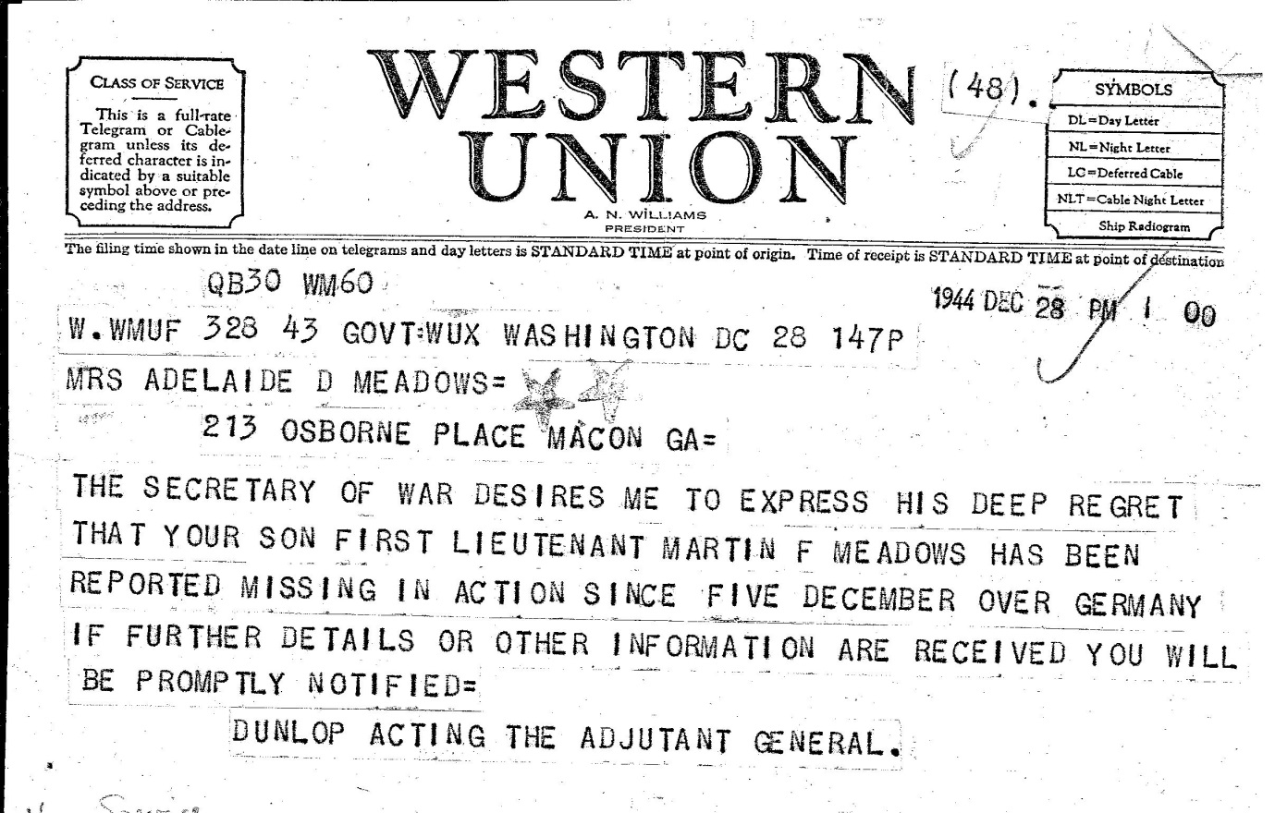

Rufus Brome keeps guard
Second Lieutenant Richard L. Ransom realised his boyhood ambition while stationed in Eye as a pilot. Since the age of nine he had yearned for a Great Dane, but his parents told him that living in a city was no place for such a big dog. When they later moved to the country he was unable to find one and made do with an Irish setter instead.
Shortly after arriving in England he heard of a kennel near Portsmouth which bred Great Danes and obtained a 48 hour leave permit to go and have a look. He returned with a seven-week-old golden fawn puppy named Rufus and $300 dollars poorer. Dick added the name ‘Brome’ in honour of the airbase.
Rufus quickly became a favourite among the aircrews, amusing them with his gangling puppy antics when they returned tired from their missions. He appointed himself custodian of his master’s bunk, guarding his clothing, shoes and other belongings.
On 13th August 1944, Lt Ransom left on a training mission from which he never returned. There was a mid-air collision over Scole and eleven crewmen lost their lives. Rufus remained on guard for a full week, refusing both food and water and only leaving the bunk for long enough when hearing footsteps outside, to see whether it was his master returning.
Eventually Rufus befriended another airman who looked after him during the ensuing year while trying to obtain a passage for him to America. Funds were raised by Dick’s friends on the airbase and Wally Higgins, the Supply Officer, eventually arranged for Rufus to be sent to Ransom’s parents’ home in Lockport, New York state, where he was lovingly welcomed.
Photograph: Squadron Mascot Brome with Lowell B. Vander Hamm
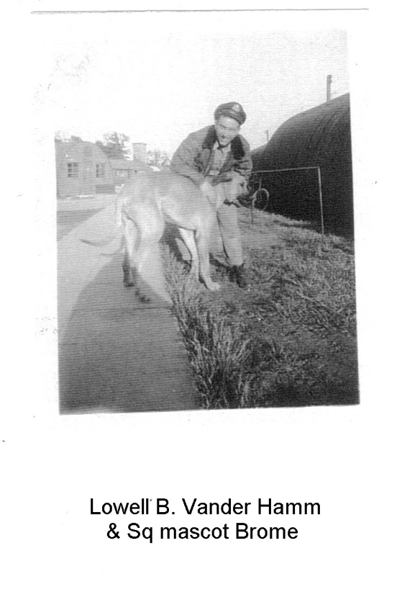

Happily Ever After: Vicky and Santo DiNaro
Out of the tragedy of war, there was also born love and happiness. This story is reprinted from Women’s World.
Santo DiNaro was a turret gunner with the 490th Bomb Group. Vicky was a Women’s Land Army girl, stationed at Oak Lawn, Eye and worked on Haver’s Farm.
Vicky planted her feet firmly on the ground and gave the cow a threatening glance. But Daisy just stared back impassively through huge bovine eyes, obviously not impressed.
The frustrated English girl rubbed her ankle trying to soothe the spot where the massive Jersey’s hoof had registered her unwillingness to be milked. Vicky brushed a tear from her eye. She just had to milk that bloody cow. There was a war on and milking cows was her job.
Looking across the field she spotted a handsome dark haired airman from the nearby base. “Would you mind holding this cow so I can try to milk her?” Vicky pleaded. Santo DiNaro did not mind at all. The American was bewitched by the English girl’s pretty face and her peaches-and-cream complexion. And when he looked into her eyes he was lost.
Photograph: Vicky and Santo on Havers Farm in Eye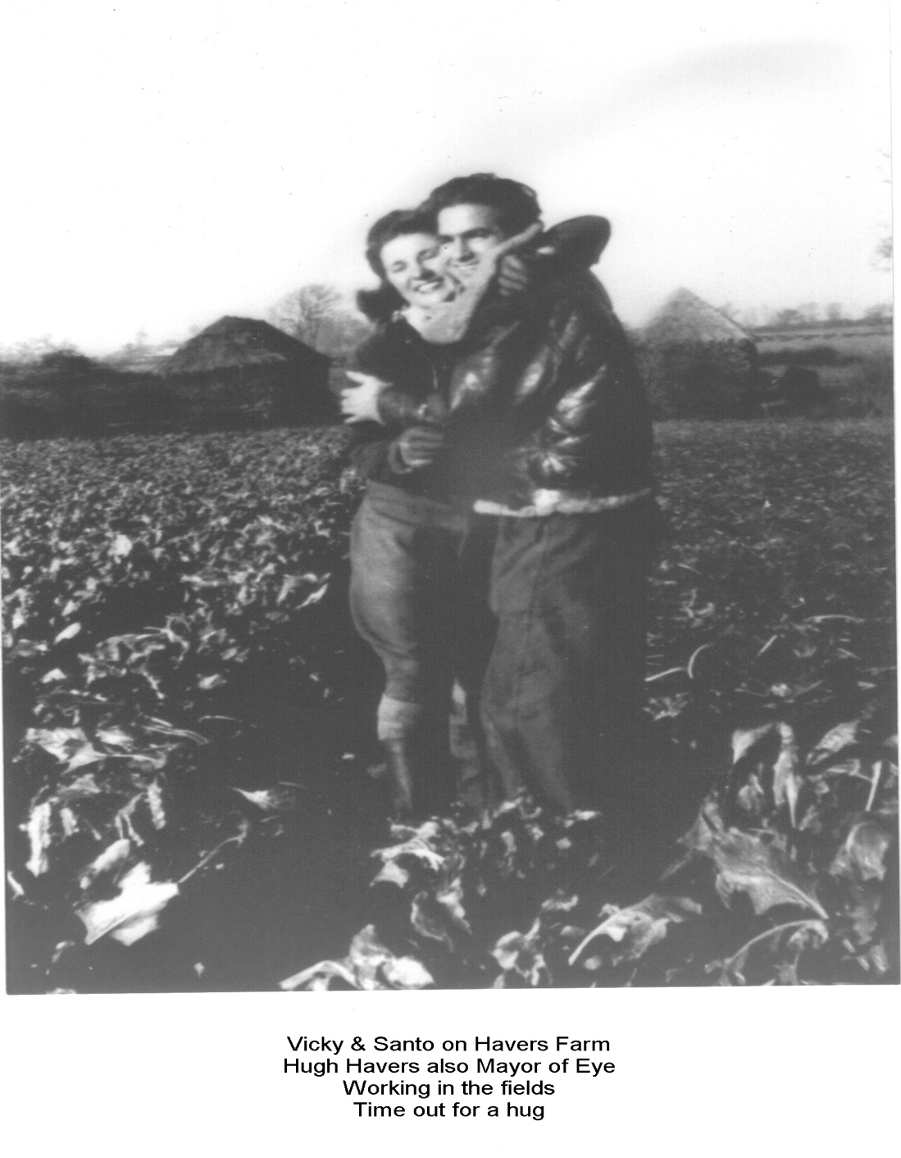
For Vicky, Cupid’s arrow took a little longer to hit the mark. “I liked him” she recalls. “He told me straight away he worked in a factory back in the States. The others lied and told us they were doctors or lawyers. But I told him I would never leave my country. We could only be friends.”
However, with time she fell prey to the sorcery that already held Santo in its sway and as their friendship turned to love, America seemed not so far away. Convincing her parents was another matter. Vicky’s father, a blacksmith, thought that all Americans were out for a good time and didn’t want his daughter to have anything to do with them.
“Don’t you ever bring a Yank into this house” he warned. But when she brought Santo home, her father liked him immediately and gave the couple his blessing. He said “You know, I would have married your mother wherever she came from”. Then, “if you ever need to come home, just ask”.
On 4th November 1944 Santo and Vicky were married in London. He was 21, she, 20. The bride wore a borrowed wedding gown and her reception feast was tea and jam sandwiches that neighbours had generously donated from their meagre wartime rations.
The newlyweds rented a farmhouse near the airbase. Though they had vowed not to have children until the war was over, Vicky soon became pregnant. A few months later, the honeymoon was over as Santo had been ordered back to the States for reassignment to the Pacific. Vicky wished him a tearful goodbye in August 1945 and went back to live with her parents. Shortly after the war with Japan ended and Santo was discharged. He went to work for an aircraft company and waited for Vicky to join him.
A month later, Vicky became the mother of twins, John and Santo Jr. Vicky spent long hours standing in line for her visa, a baby on each hip. And Santo waited impatiently, the letters and pictures poor substitutes for his beautiful family.
Vicky and the twins were the last to leave the ship when it docked in New York. By the time they found Santo he was wild with anxiety. “When we saw each other again” says Vicky, “we both cried. He didn’t know whether to hug me or the twins first”.

Photograph: Vicky arriving in New York with the twins, the first time Santo had seen them
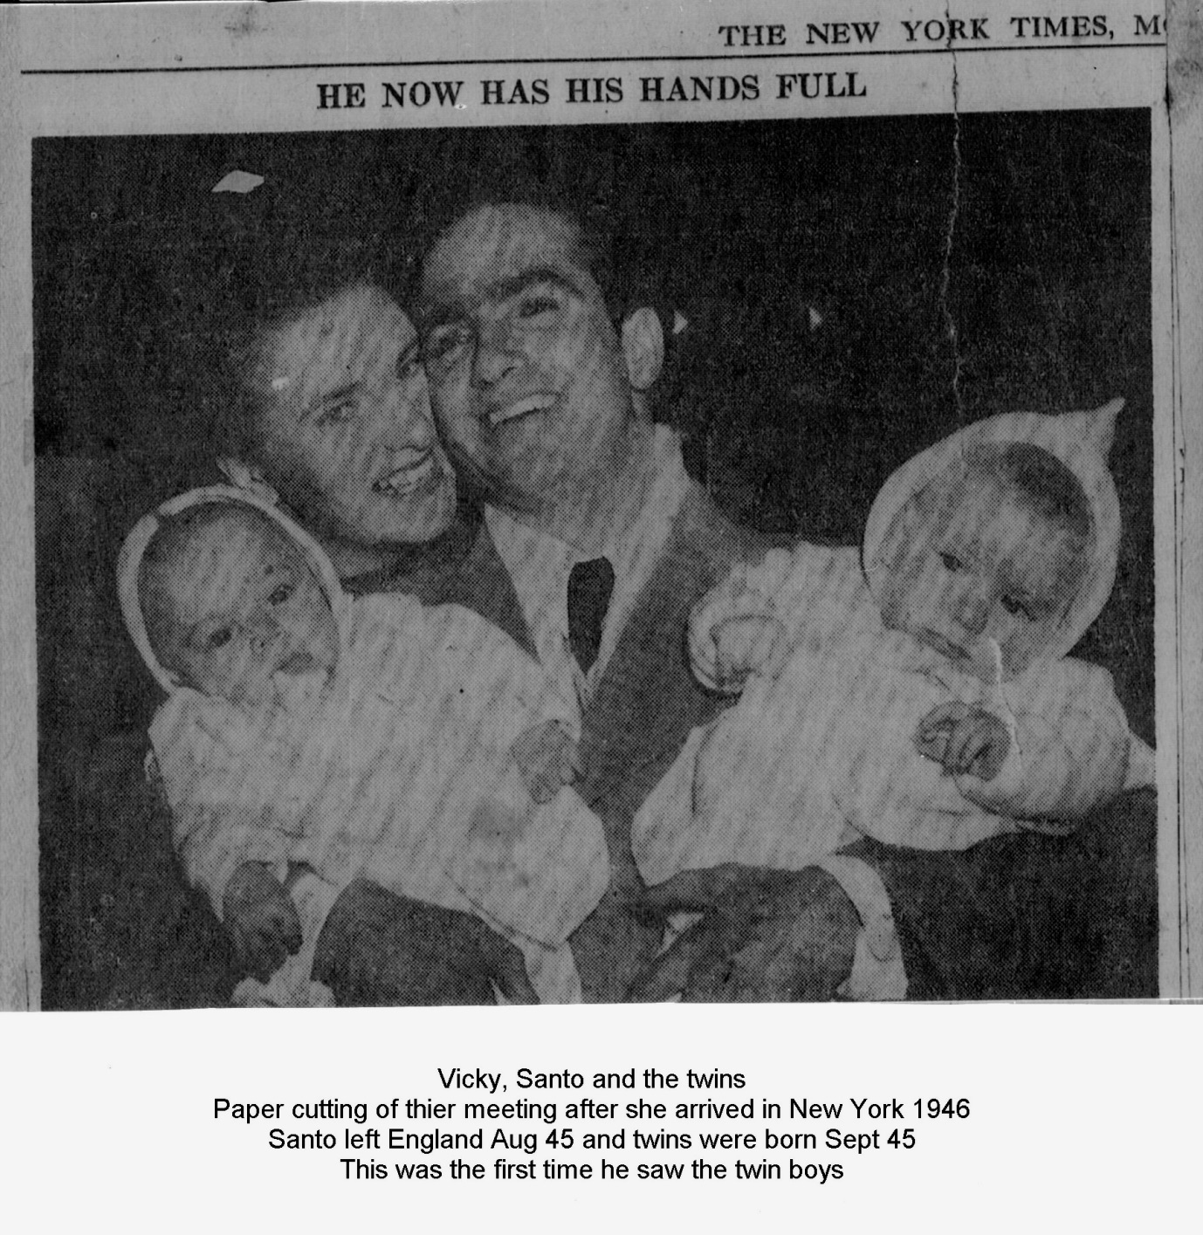
But in the US there was a housing shortage and for the next four years the young couple lived with Santo’s parents. “They were wonderful to us, but it was crowded.”
Vicky and Santo decided to build their own home. For the next few years Vicky worked hard at house cleaning, earning extra money they needed and even harder at weekends and evenings helping Santo build their home.
Vicky become an American citizen in 1956 and in 1985 The DiNaros were still living in the East Patchgogue house they built. Though she loved the US she would still get homesick for England and visited her 87-year-old mother every year. “Even after 42 years, I sometimes think about home and shed a few tears”.
But Vicky never regretted marrying Santo. From their first encounter over a temperamental cow, Vicky knew she could count on his love for her, for their twin boys and later for their two younger daughters.’

8 The end of the war
Photograph: Eye in May 1945
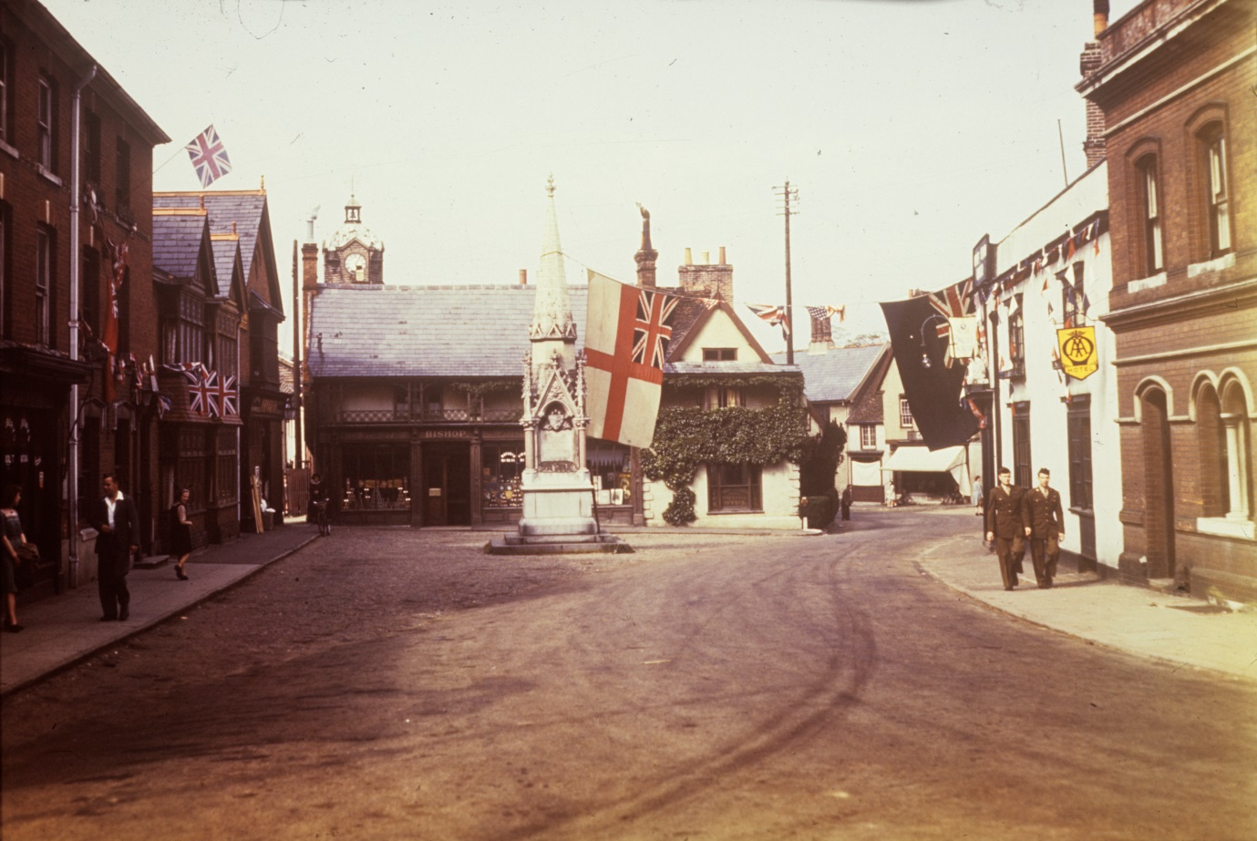

The end of hostilities in May 1945 brought relief and celebrations at having survived and saved democracy. But there still remained humanitarian work for the aircrews over areas across the channel devastated by war.
Crews from the 490th flew food missions to relieve the famine in Holland and revival missions to pick up prisoners of war. In his diary, Norman C. Borgman recorded uncertainty as to whether such a mission would count towards his tally:
“April 25th 1945: Destination is Amsterdam where we were to drop 90 cases of K rations from 500 feet. A temporary truce had been made in order to accomplish the mission. We were not to fire at any plane or ground target. It was questionable whether we would or would not have gotten credit for a mission.”
James Lee Hutchinson recalls another mission carried out on 2 May:
“We dropped large waterproof food cartons which could float in the flooded fields and canals until they could be retrieved … For a time we wondered if the Germans would continue to honour the truce. The hundreds of Flying Fortresses at such a low altitude must have been a terrible temptation for the flak gunners to resist. However the occupying troops realized the war was over and stood by and watched as we dropped our food cartons. The townspeople stood on the rooftops and in the streets and fields waving and cheering. It was a great sight and it felt good to be dropping food instead of bombs.”
After this particular mission the crew went into Diss for a celebratory supper:
“and as we were walking back to the base, the sky was lit up with flares of all colours … Everyone back at the base was firing Vary pistol magnesium flares that bombers used in flight. It was like the Fourth of July as all four squadrons engaged in mock combat. Airbases all over East Anglia joined the celebration and the dark sky was filled with red green and yellow streaks of fire”.

Photograph: Flares at Eye, VE Day
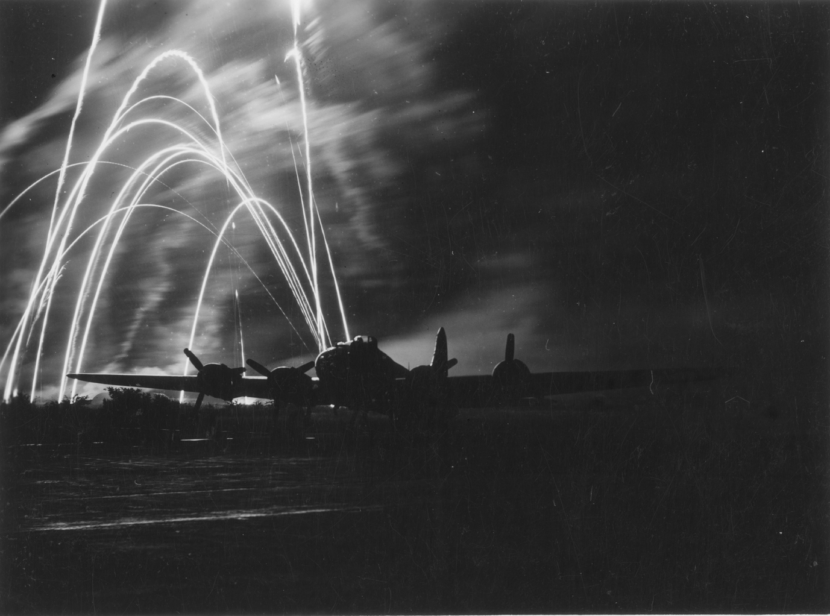

Hutch records that he had been in gunnery school in Yuma on his nineteenth birthday, whereas “my twentieth birthday occurred in a peaceful England on June 12 1945 and was much more enjoyable” .
The 490th air crews finally flew out of Eye on 6th and 8th July 1945; local residents turned out to wave them off and wish them well.
Photograph: The last goodbye from Eye
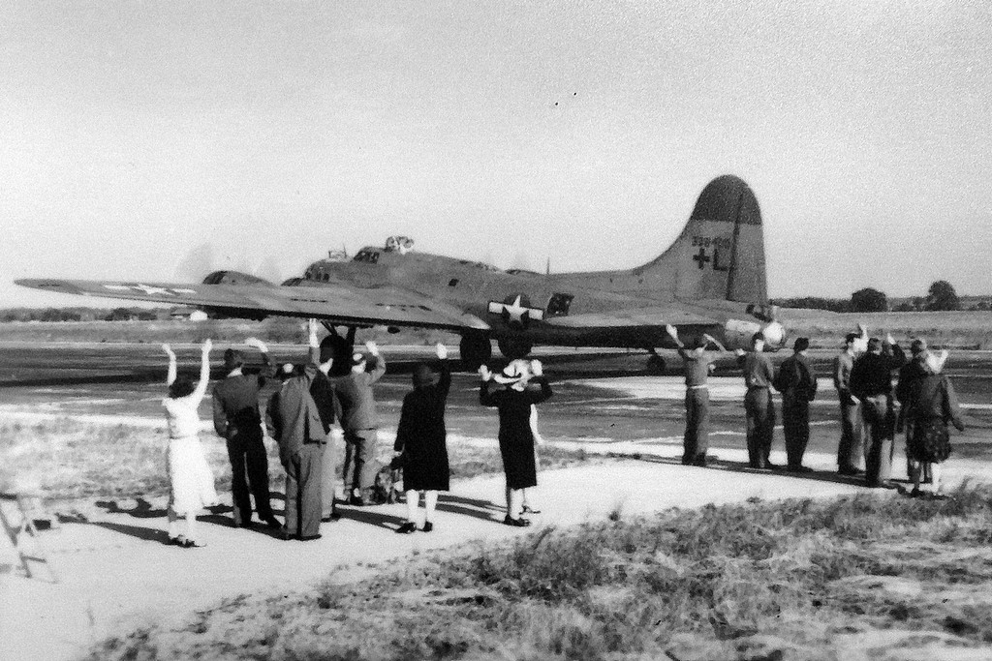

Local boy Peter West recalls: “Almost immediately, civilian contractors moved in with orders to demolish all empty buildings, which were mostly Nissen huts. Housing was in very short supply at the time and quite a few families decided to squat in the best huts.”
Support and ground crews followed the airmen at a more leisurely pace by ship across the Atlantic and home.

Epilogue
Today the Suffolk countryside epitomises peace and tranquillity. It needs effort to imagine that the gentle rural scenery would have been riven by the sounds and sights of war. The roar of bombers, the countless supporting vehicles on the roads and the sheer numbers of our American allies all caused to alter dramatically the character and nature of the land around them. Some of the changes came to stay, but the villages and the surrounding countryside have largely reverted to the land that has always been.
It is often possible to pass a once vibrant bomber airfield and not realise what it used to be. The beds and huts occupied by so many brave airmen are now only a distant memory. In some cases the tarmac runways have been pulled up and the buildings have been taken down or allowed to decay into the undergrowth. Eye airfield is now a thriving industrial estate.
Soon the immeasurable American support for the struggle against tyranny will pass from living memory. The youth and cheerful courage of these GIs must never be forgotten. It is the authors’ hope that this book, together with the memorial installed on the airfield in May 2016 and the roll of honour unveiled in Eye Town Hall in August 2015, will help to ensure that our gratitude for all that they gave will survive.
Photograph: The Memorial on Eye Airfield
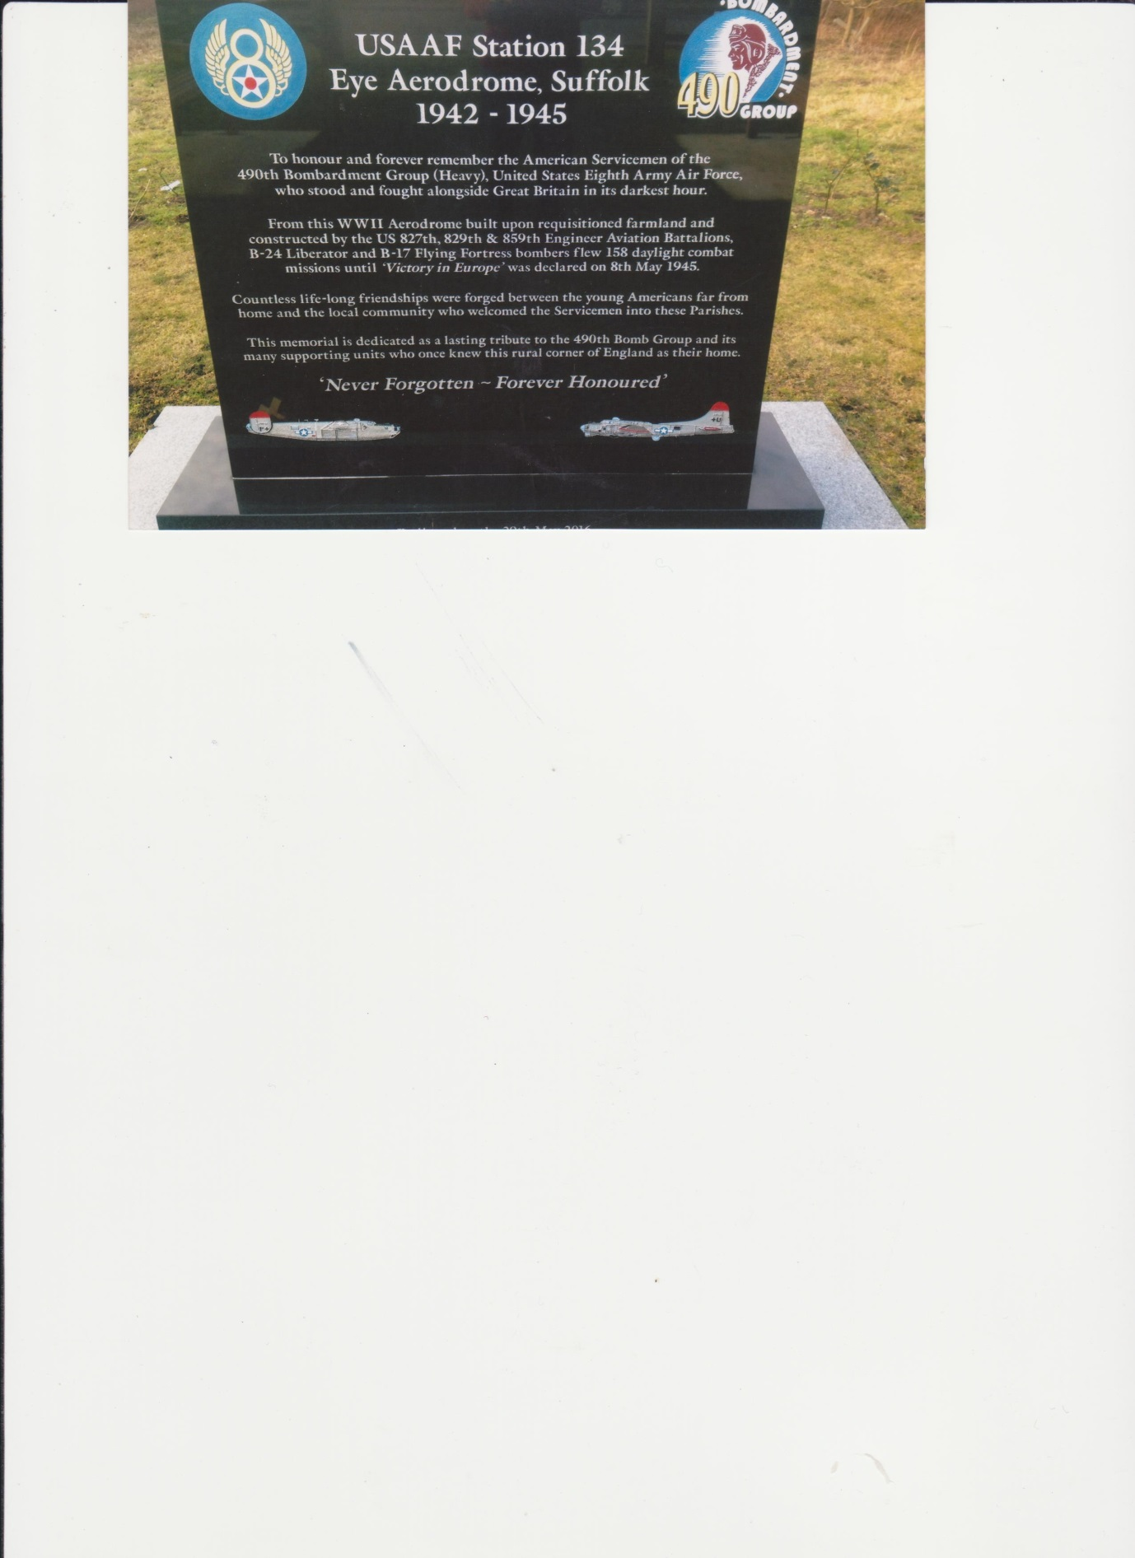

Winston Churchill wrote: “To those who did not return the best memorial is the fellowship of our two countries, which by their valour they created and by their sacrifice they have preserved”.

Photograph: The lych gate memorial at Brome
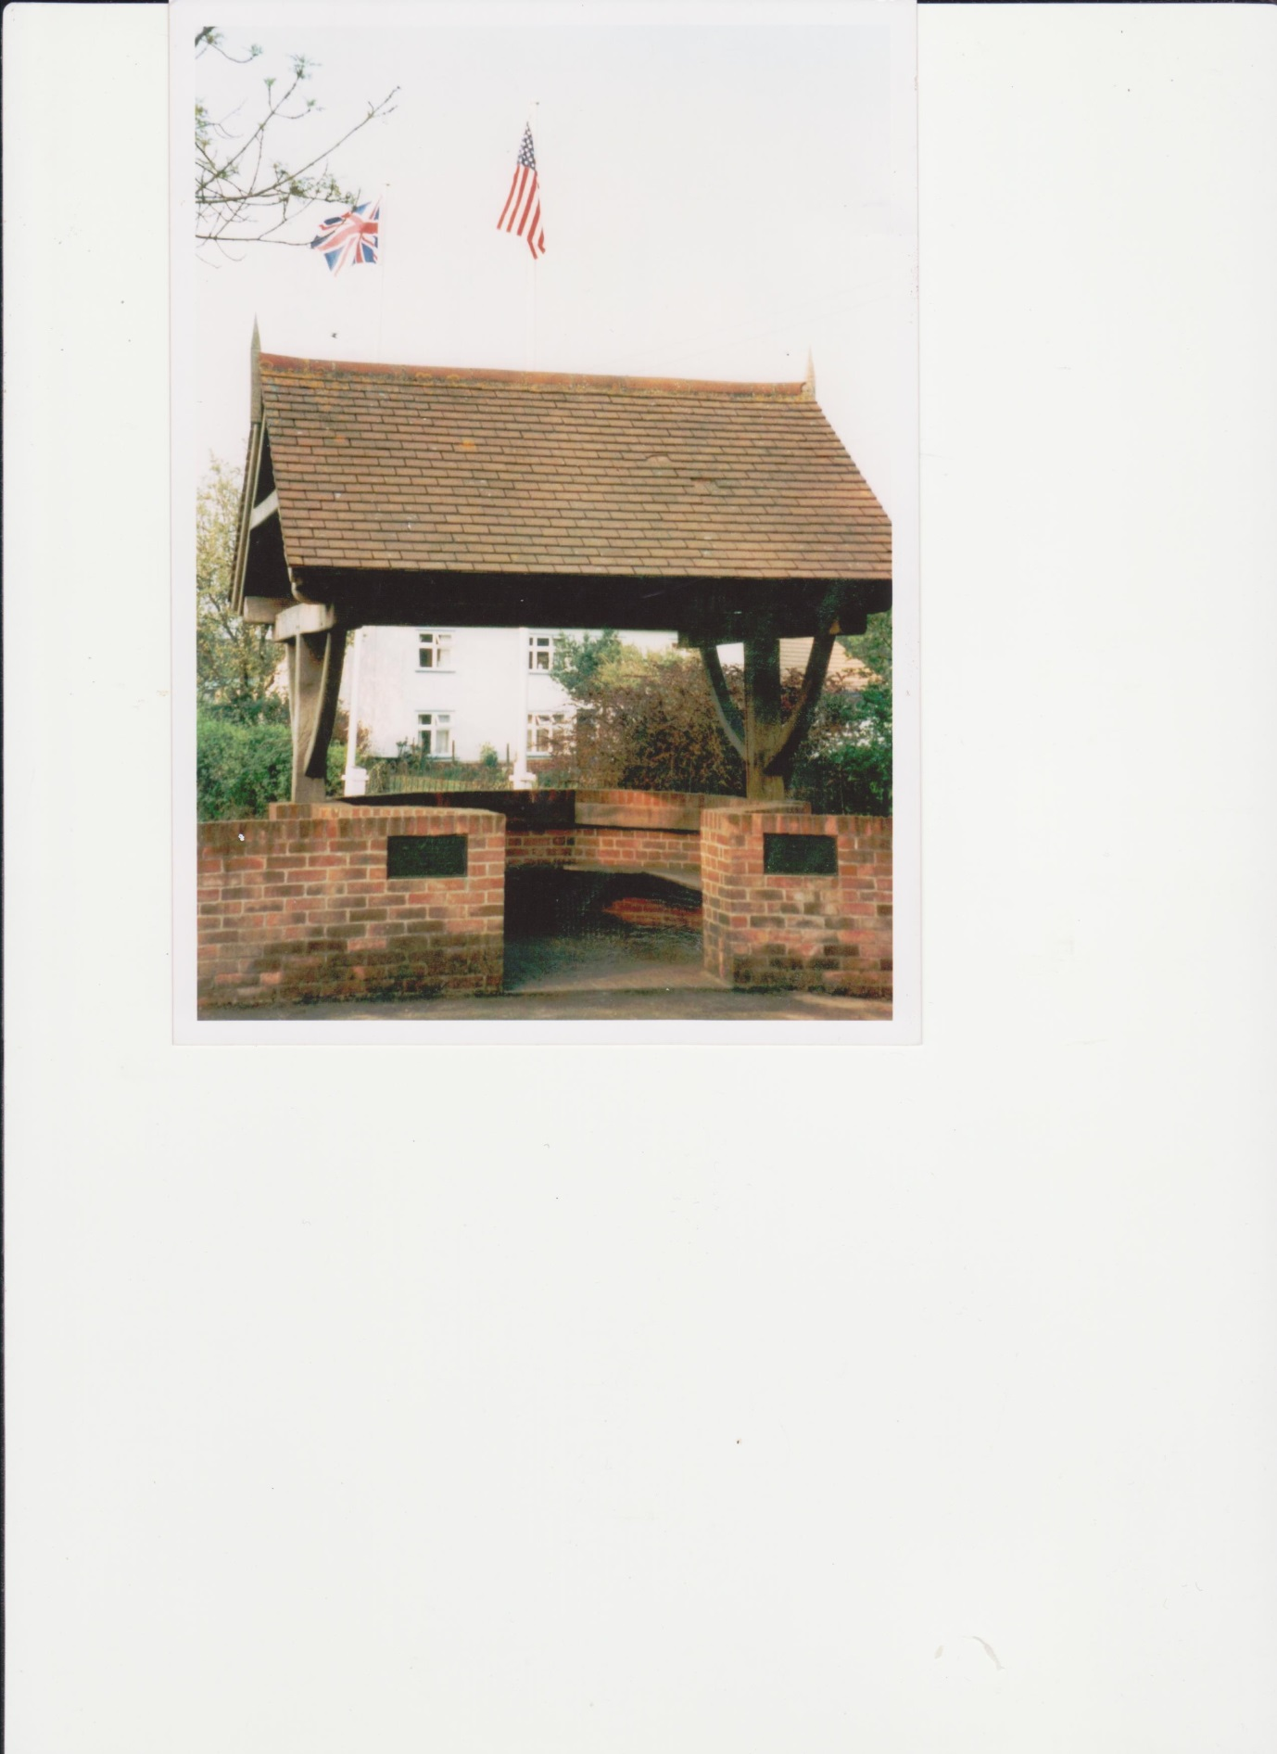
Appendix 1: Casualties of war

Brome cross roads
Local workmen:
Eric Barker
Charlie Burridge
Walter Clarke
William Dixon

Aircrew:
Lt. Arthur J. Reynolds Pilot
Lt. John J. Russell Co- pilot
M/Sgt Robert G. Levi Technician
Lt. Sheldon V. McCormick Navigator
T/Sgt. Amos H. Behl Top turret gunner
Lt. Alfred L. Rolnick Bombardier
Sgt Laurie C. Evans Gunner
Sgt Leslie N. Boling Gunner
Sgt William H. Landers Gunner
Sgt Andrew J. Allison Gunner
Sgt John D. May Gunner
T/Sgt Robert B. Holmes Radio operator
Cpl Herman J. Kolousek Radar mechanic

490th Bomb Group: Killed in Action / in Service
234 American servicemen of the 490th were killed in action, in service, or while taken POW – see Book of Remembrance (add link) which gives their details.

References

American Air Museum, www.americanairmuseum.com
Clive Paine, The History of Eye, 1993, [Benyon de Beauvoir]
Nikolaus Pevsner, The Buildings of England, Suffolk, 1961, [Penguin Books]
923rd Engineer Aviation Regiment: Workin’ on Those Airdromes: An Overseas Report from the 923rd Engineer Aviation Regiment: 827th Engineer Battalion, 829th Engineer Battalion, 847th Engineer Battalion; 859th Engineer Battalion,1945
Peter West, Memoirs of a Farmer, 2010, [John Nickalls Publications]
Russell N Knott, squadron historian, History of 850th Bomb Squadron, contemporary account [transcribed from microfilm at Maxwell AFB, 1997]
West, op.cit.
Dorothy Presswell, A Sparrow in the Meadow, 1985, [Merlin]
Ibid.
James Lee Hutchinson, Through these Eyes, 2005, [AuthorHouse]
Ibid.
Rapid City Journal, 2 June 2013, [BellerFourchecommunity.com]
Hutchinson, op.cit.
Boeing B-17 Flying Fortress Free Encyclopaedia, B-17 Flying Fortress, [History Learning Site]
Hutchinson, op.cit.
Ray Hann, Diary, 849th Squadron, USAAF 490th Bomb Group [490th Bomb Group archives, via Eric Swain]
Hutchinson, op.cit.
Charles Baffo, Video interview, 13 August 2013, [Central Connecticut State University, ccsu.edu/vhp. VHP2010/10]
Kendra Baker, WiltonBulletin.com, 5 February 2015
Hann, op. cit.
Wikipedia- Free Encyclopaedia 8.8 CM Flak 18/36/37/47; WW2 German 88mm AA Artillery Gun
Hann, op.cit.
Norman C. Borgman, Diary [490th Bomb Group archives, via Eric Swain]
Wikipedia, History Learning Site: Images Messerschmitt 109; Messerschmitt BF109, multi role fighter
Clyde W Thompson, Video presentation to Eighth Air Force Historical Society, Minnesota, September 2001 [8th AFHS-MN]
Wikipedia Free Encyclopaedia: North American P-51 Mustang; North American P-51 Mustang variants. Aircraft Wiki: North American P-51 Mustang; P – 51 Mustang
West, op.cit.
Ian McLachlan and Russell J. Zorn, Eighth Air Force Bomber Stories, 2012, [Haynes Publishing]
Thomasville, G.A. Times-Enterprise paper, [490th Bomb Group archives, via Eric Swain]
Klaus Zimmer, WWII plane crashes in Saarland and its neighbouring areas, 1999 [presentation in Gettysburg City Hall]
Memoir of Lt. Gerald W. Lay [490th Bomb Group Archives, via Eric Swain]
Ibid.
Dave Osborne, Get One Aircraft Group, [490th BG B-17 Master Log]
Diary of S/Sgt Edison Ray ‘Pete’ Edwards, [details posted by his son Winston Edwards, on armyairforces.com forum, 18/10/2008]
Charlie Gaylor, [posted on armyairforces.com forum, 21/12/2009 in response to S/Sgt Daniel B Breckenridge]
Letters from 1st Lt Martin Meadows to his mother, 10th & 25th November 1944, [490th Bomb Group Archives, via Eric Swain]
Newspaper cutting (check title and date) held in 490th Bomb Group Archives, via Eric Swain]
Women’s World, August 1985, [490th Bomb Group Archives, via Eric Swain]
Borgman, op.cit.
Hutchinson, op.cit.

